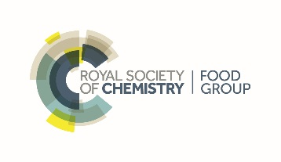

**Issue 3**

**2021**

**Welcome to the Food Group Newsletter**

Welcome to the second issue of the RSC Food group newsletter.

Welcome to this year’s newsletter, I think we can all agree that we have some interesting times since our last newsletter, leading to many postponed meetings and events. 2021 is seeing some interesting online conferences and events, and hopefully we will be meeting at real events come 2022!

Long standing committee member Mike Saltmarsh has stood down from the committee after over 30 years service. We would all like to thank him for his efforts over the years!

Regards,

Alan on behalf of the RSC Food Group

Page 2:

Awards and Recognitions

Page 4:

Meetings and Events

Page 5:

Upcoming Events

Page 7:

Just for Fun

Contact:

Alan.cross@rssl.com

**Contents**

**Awards and Recognitions**

RSC Food Group Junior Medal

Martin Rose, representing the RSC Food Group committee was very pleased to present Dr Anwesha Sarkar of The University of Leeds with her Food Group Junior Medal 2019. Her research has led to scientific breakthroughs in designing novel food structures with targeted oral lubrication. Based on step change research, it’s believed that this work could lead to multiple health related food solutions. It is planned that Anwesha will present at a meeting in 2021 when events can be confirmed.

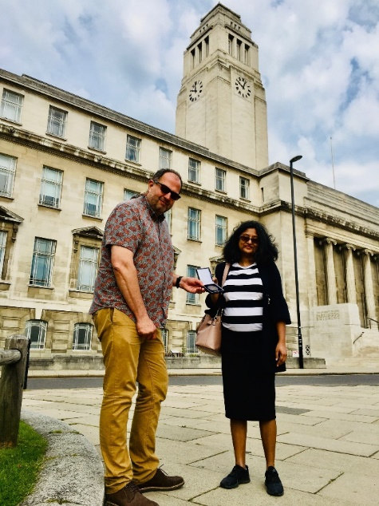

The 2021 nominations for the Food Group Junior Medal are now open please see below for more details.

**Awards and Recognitions**

Food Group Junior Medal

We are pleased to announce this year’s winner of the RSC Food Group Junior Medal is Dr Joanne Gould, based on her contribution to food chemistry, particularly in relation to her research on sustainable and renewable ingredients. Joanne is currently an Assistant Professor at The University of Nottingham and is continuing her work in chemical sciences focused on renewable proteins.

We received some excellent and diverse nominations this year and the panel found it difficult to select just one winner. We would like to thank all this years’ nominators for supporting and encouraging early career chemists and all the nominees should be proud of their achievements to date.

The medal will be presented at our next meeting and AGM in February, when there will be an opportunity for the winner to present during our afternoon event.

Food Oral Processing Poster Prize

This year, two posters from the Food Oral Processing Conference Poster competition were chosen to win a prize. The winners were:

Mr. Jumpei Okawa from Niigata University Graduate School of Medical and Dental Sciences for his poster presentation titled as “Impact of Masticatory Performance and Chewing Stokes on Retro-Nasal Aroma”

And

Ms. Katherine Hurst from University of Nottingham for her poster titled “Impact of structural properties of solid snack food matrices on salt dissolution and salt delivery during food oral processing”

Congratulations to the winners, who were selected from 26 entrants, beating off some tough competition to win this accolade.

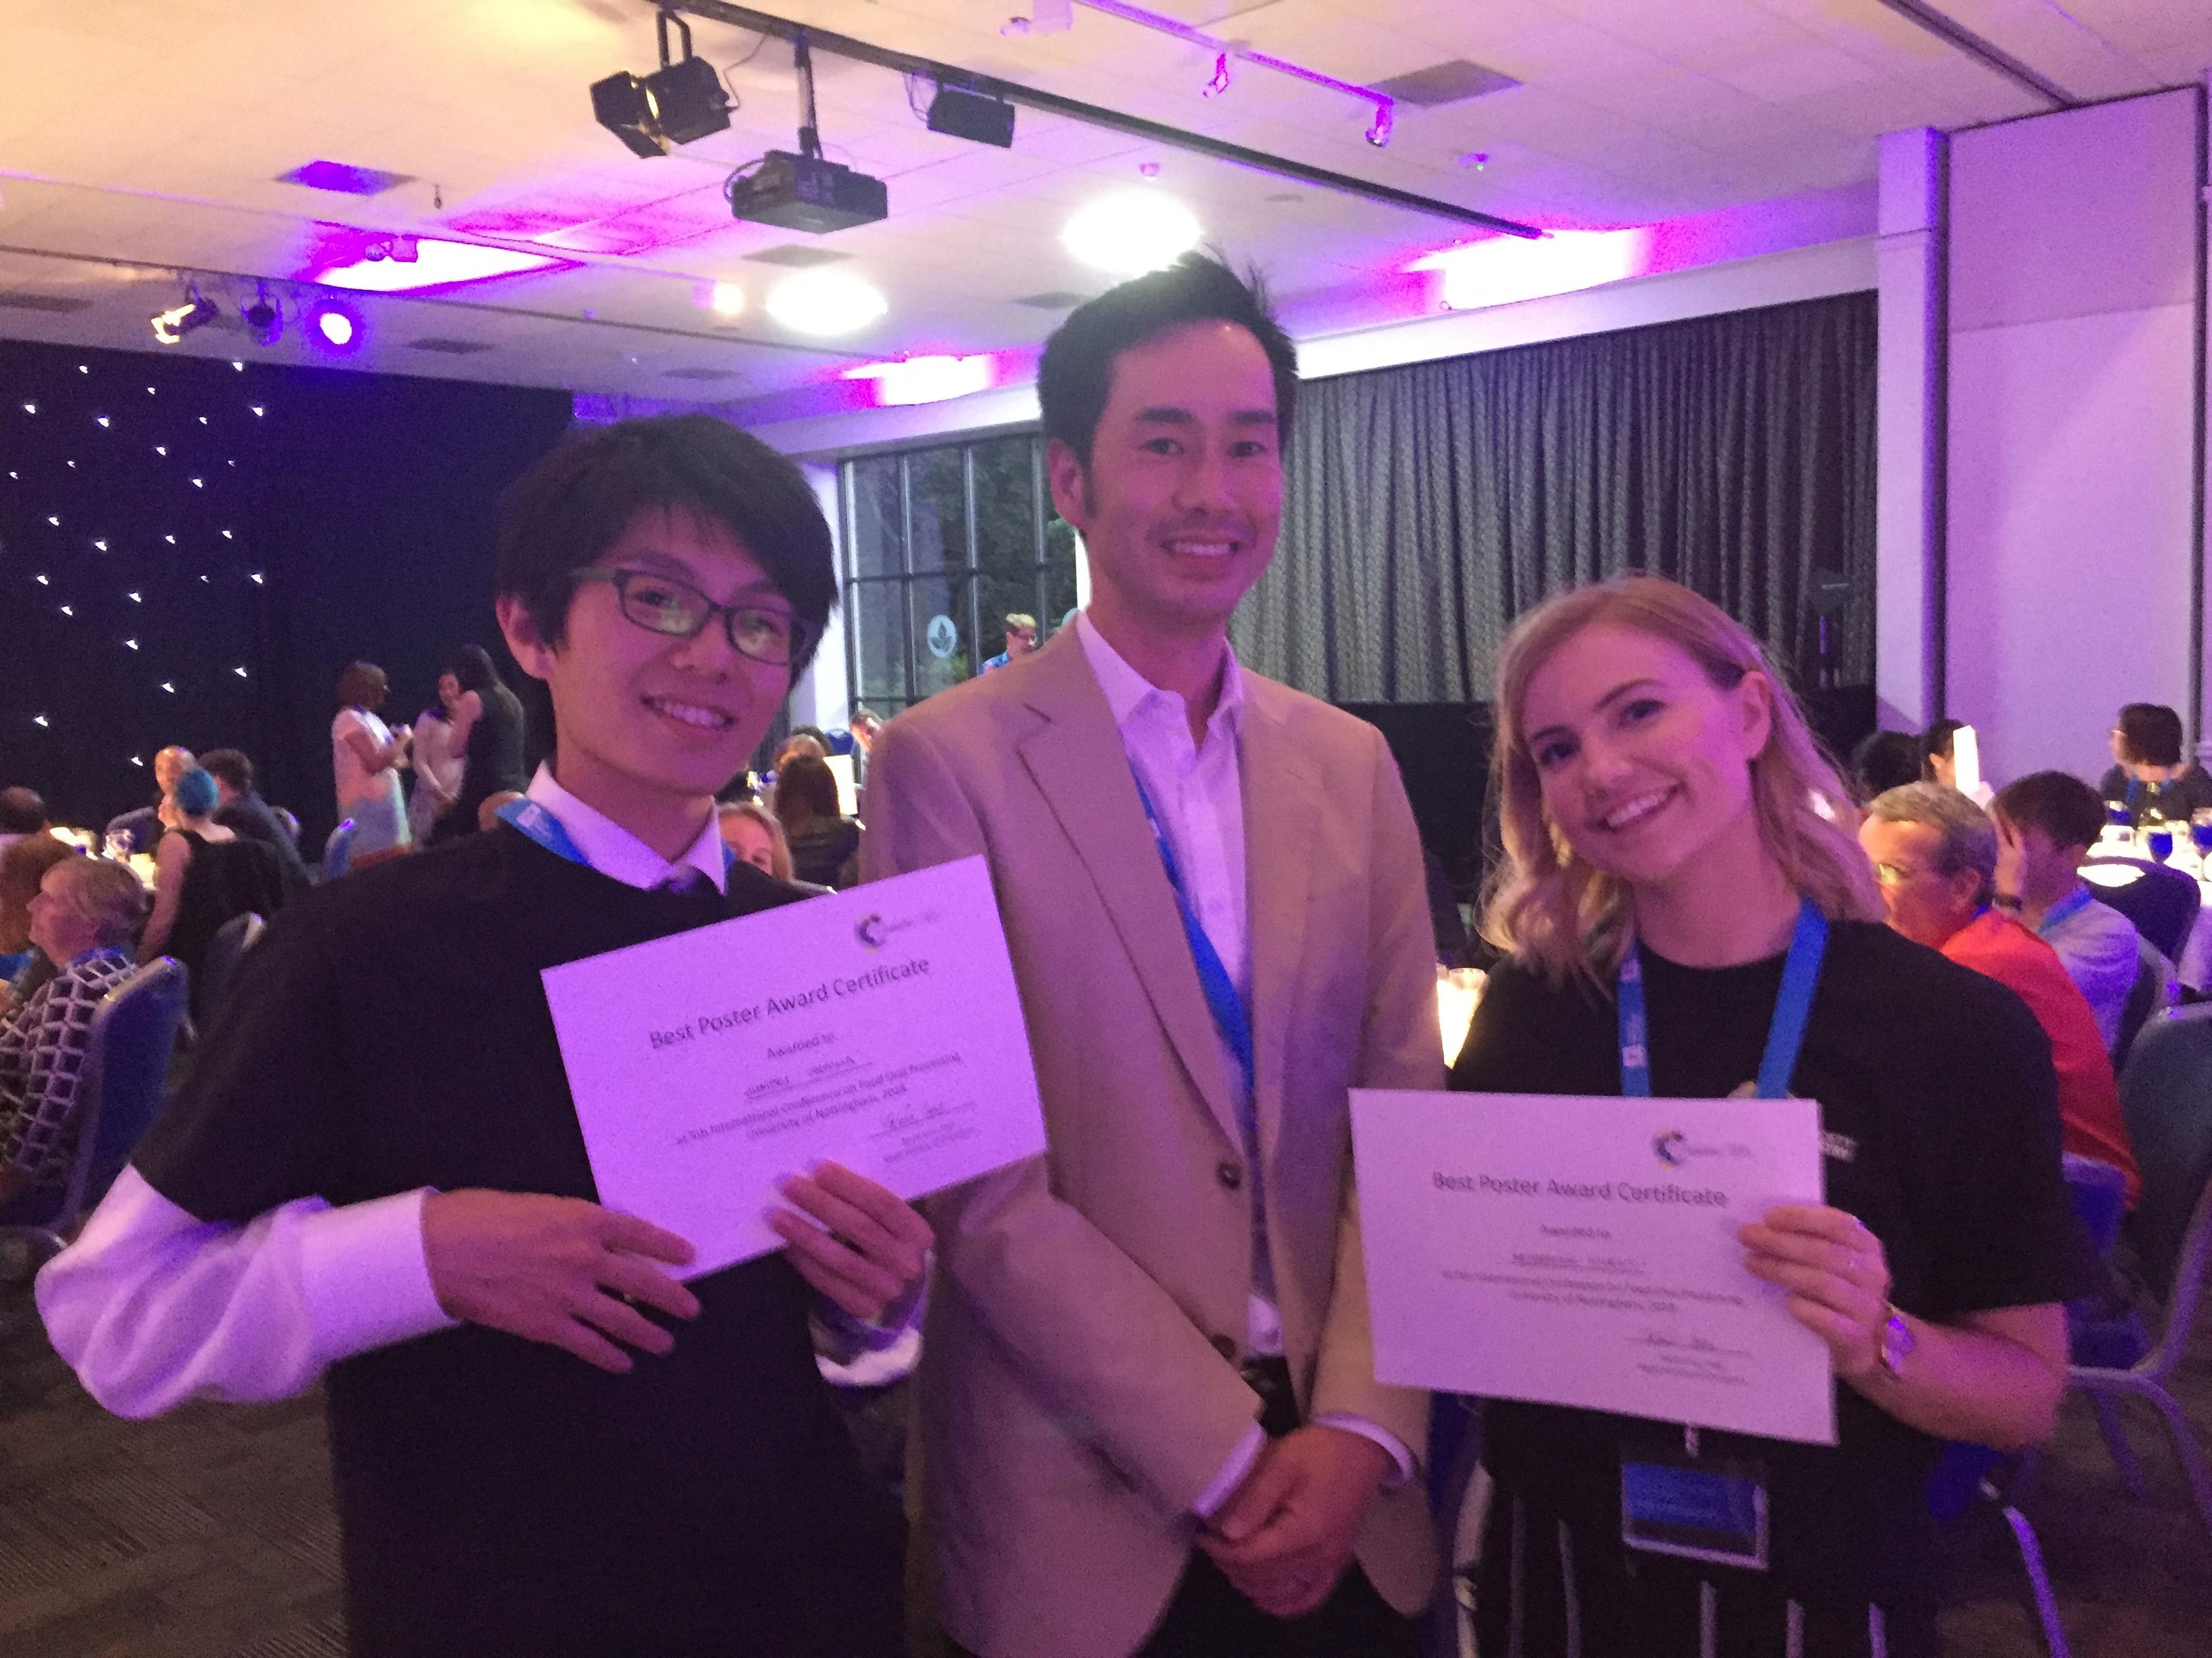

Abstracts available here:

<https://www.nottingham.ac.uk/conference/fac-sci/biosciences/fop18/documents/fop-2018-book-of-abstracts.pdf>

**Awards and Recognitions**

**Inspirational Committee Award Winners 2020**

We are delighted to announce that the Food Group Committee have been selected for the RSC Inspirational Committee Award 2020.

To celebrate IYPT the Committee developed and published a unique Food Chemistry Periodic Table and has been active in promoting it at external events such as the 2nd Food Chemistry Conference in Seville and at RSC outreach events e.g. IYPT Early careers event, also encouraging Chemists to consider opportunities in the Food Industry. This project continues to develop and it is hoped that RSC Education department will support alignment to the school curriculum for wider application in schools. Some teachers have already started to use this new tool in their lessons in the UK and internationally.

The group also organised unique events focusing on global challenges, including on Plastics (“from Cradle to Grave and Re-resurrection”) and Sustainability and is actively involved in the Total Food conference, which is now an established bi-annual event focused on tackling the challenges in a sustainable food chain.

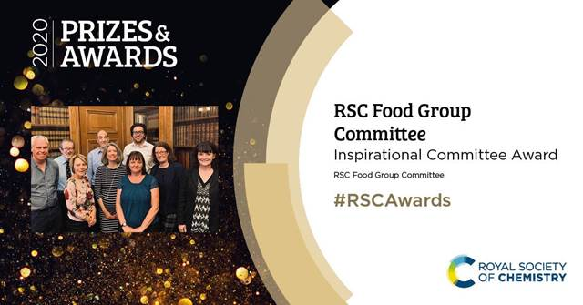

**Awards and Recognitions**

**RSC Food Group Early Career Medal 2021 (previously the Junior Medal) - Call for Nominations**

The RSC Food Group Early Career Medal is open for nominations The aim of this award is to encourage and recognise excellence in early career scientists in the application of chemical sciences to the study of all aspects of food, drawing attention to the challenges for chemistry in the food industry and encouraging first class scientists to enter the field of food chemistry.

The award will be made for the most meritorious contributions to food chemistry on the basis of published papers and/or other documentary evidence, including contributions to conferences over the preceding 5 years. We encourage proposals from Industry and accept supporting evidence from more than one person, if the candidate has not been able to publish confidential work. It is open to all early career scientists, whether or not members of the Royal Society of Chemistry. For more details and to download a nomination form please go to:

<https://www.rsc.org/membership-and-community/connect-with-others/through-interests/interest-groups/food-group/awards/>

**Awards and Recognitions**

**RSC Long Service Medal Awarded to Mike Saltmarsh**

The Food Group Committee were delighted to present (virtually) an RSC Long Service award to Mike Saltmarsh in recognition of his many years of active support for the RSC and RSC Food Group.

Mike Saltmarsh joined the Food Group committee in the late 1980s and stood down from the Committee during the challenges of 2020, and we are grateful for all his efforts and particularly for his encouragement of early career food chemists. The RSC has also just published his latest Food Additives book, which has been an excellent reference to many in the food industry.

**Meetings and Events**

**CHEMICAL AND PHYSICAL MODELLING OF FOOD**

On 24 and 25 November, the RSC Food Group, in conjunction with the IOP's Food Physics group, held the 1st Chemical and Physical Modelling of Food conference. The decision to hold the conference jointly was to highlight the interdisciplinary nature of food research, as well as to foster links between the sciences. The conference was held online, with 15 speakers from 7 different countries (US, Canada, UK, France, Netherlands, Italy and Australia) from academia and industry, and attracted the interest of 230 registered attendees from over 27 different countries. The topics covered spanned a lot of different areas, including the Maillard reaction, food digestion, chocolate praline shell forming, microwave/convection oven cooking, and food emulsifiers, among others. Feedback from the conference was very positive, with attendees interacting with the speakers and asking questions all throughout.

A special congratulations goes to Archana Bista from Teagasc in Ireland who won the best Twitter poster prize.

**Meetings and Events**

**Nursten Flavour Symposium**

The Nursten Flavour Symposium (named after the late Professor Harry Nursten) is an annual event specifically dedicated to postgraduate students in the area of food and flavour science in the UK in order give them early experience in presenting scientific findings to an academic audience.

Svenja Schmidt, winner of the RSC Food Group Prize writes:

At this year’s symposium, hosted by the University of Nottingham, around 30 MSc and PhD students participated, presented, and discussed pressing issues such as salt reduction, sustainable diets and new technologies in food production. I myself shared the insights and experimental results I gained during the first year of my PhD project, which aims to develop a microfluidic device that offers personalised beverage options for space exploration. Ideally, the beverages’ taste and nutrient content will be adjusted to individual taste and needs, with the possibility to include hydrophobic (micro)nutrients and flavour components by basing the formulation on beverage nano-emulsions. Also, for me, the symposium was one of the first opportunities to present at a conference-like setting and therefore I feel very honoured that my research and presentation skills were recognised with the RSC award for the best presentation in flavour chemistry. I am very excited to participate at the Nursten Symposium in the years to come to build a network among like-minded PhD students and to see the progress of the participant’s research projects!

**Upcoming Events**

**6TH INTERNATIONAL CONFERENCE ON FOOD ORAL PROCESSING (FOP) 12-14th July 2021, NOW ONLINE!**

The RSC Food Group has a long history of involvement with this bi-annual conference and will be supporting it again through abstract prizes. It is aimed at deepening the understanding and interplay of food structure, oral breakdown, in-mouth food trajectory and human perception. It offers an excellent opportunity for industrial researchers and academics to meet and collaborate.

Food Oral Processing (FOP) is one of the hottest topics in Food Science. Its development in recent years has been dramatic because it involves multiple and interrelated disciplines as oral activity, sensory perception, nutrition and metabolism, oral physiology, food structure and design through in-vivo, in-vitro, and in-silico approaches.

In addition, the Conference will provide an excellent opportunity for industrial researchers to meet with academics from different disciplines for knowledge transfer and to establish research collaborations.

<https://congresos.adeituv.es/FOP_2020/ficha.en.html>



**Upcoming Events**

**2nd CHEMICAL AND PHYSICAL MODELLING OF FOOD CONFERENCE**

**12th-13th October 2021 – Online Event**

Following from last year's successful conference, the RSC's Food Group and the IOP's Food Physics group are pleased to be organising the second Chemical and Physical Modelling of Food conference. This conference will be covering topics related to chemistry and physics (and anything in between) of food manufacture, preparation and consumption, including measurement, model building and model validation.

Anyone interested in submitting an oral abstract to present at the conference, or a poster abstract to present the poster virtually, need to do so via this website. All posters will be presented in virtual meeting rooms, with the delegates being able to ask any questions to the poster author(s). A prize for best poster will be awarded at the end of the conference. Please see the relevant guidelines for submitting an abstract for either a presentation or a poster in the Downloads section.

This conference is aimed at academics, university students and people working in industry, although anyone will be able to register. As last year, the conference will be held fully online in two sessions on 12 and 13 October 2021. There will also be opportunities for online networking between delegates, and asking further questions to the speakers and poster presenters, including video chats. For further details please see:

<https://www.rsc.org/events/detail/47066/2nd-chemical-and-physical-modelling-of-food>

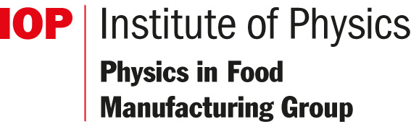

**Just for Fun!**

**ELEMENTAL Patterns**

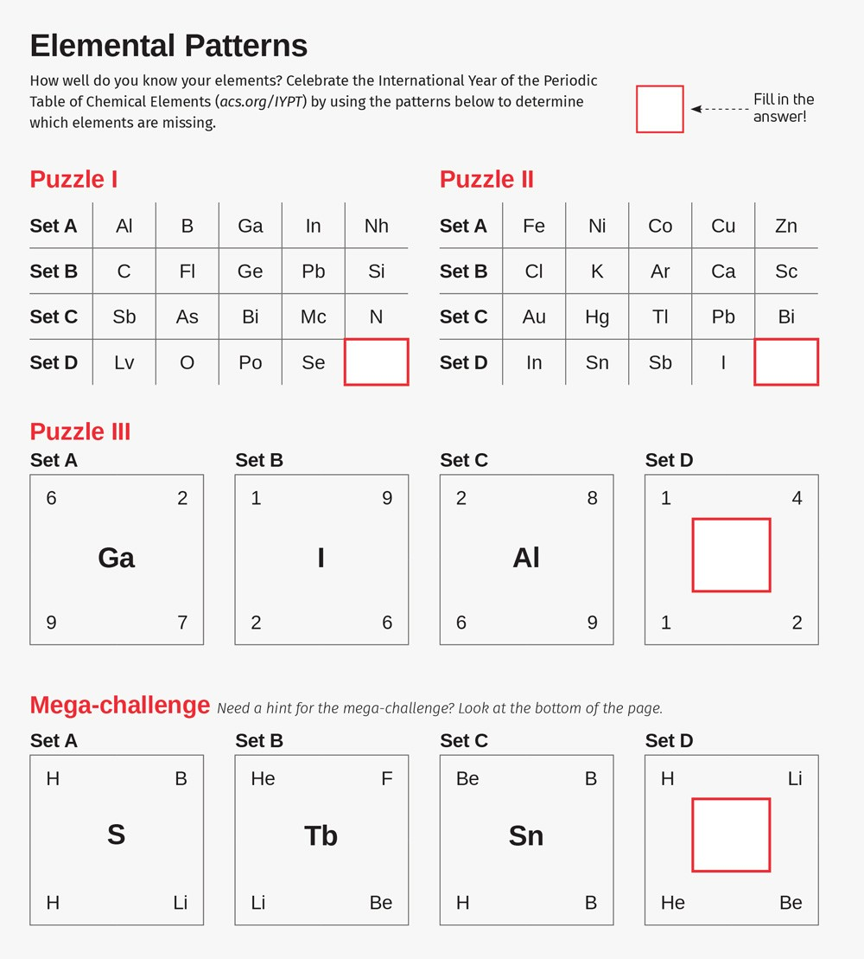

Answers: [Puzzle: Elemental Patterns - inChemistry (acs.org)](https://inchemistry.acs.org/atomic-news/elemental-patterns-puzzle.html)

**Just for Fun!**

**all a matter of taste!**

**We may like to think that food science is relatively new discipline and the fifth basic taste was only recognised recently.  However, pliny, who died in the eruption of vesuvius in ad 79 lists 10 basic tastes in his monumental work naturalis historia.  They are dulcis, suavis, pinguis, amarus, austerus, acer, acutus, acerbus, acidus and salsus which the translator of the loeb edition of the natural history translates as sweet, luscious, unctuous, bitter, rough, acrid, sharp, harsh, acid and salt.  It interesting how many of these words are used today, with perhaps slightly different meanings.  The most recent translation of the work was by rackham in 1945 and we would not use “unctuous” now, preferring to call something “greasy”.  Most of pliny’s terms are still used in tasting sessions today**

**Thanks to Mike saltmarsh for this interesting article!**

