DISCOVERY OF A SMALL, NON-PEPTIDYL MIMIC OF GRANULOCYTE COLONY-STIMULATING FACTOR

A.B. Jonesª and C. Smith^{b}

ª Department of Chemistry, The University, Cambridge, CB4 0BN, UK
^{b} Royal Society of Chemistry, Thomas Graham House, Science Park, Milton Road, Cambridge, CB4 0WF, UK

1 INTRODUCTION

Granulocyte colony-stimulating factor (G-CSF) is a 21 kDa hematopoietic cytokine secreted by bone marrow stroma cells, macrophages, fibroblasts and endothelial cells. Recombinant human G-CSF, available in both glycosylated and non-glycosylated forms, has become an important therapeutic agent for the treatment of a variety of human neutropenias, including those resulting from chemotherapy, congenital defects and bone marrow transplantation.¹ Genetically engineered G-CSF, like any other recombinant growth factors, must be administered either subcutaneously or intravenously. Although other agents have been shown to activate cytokine receptors by oligomerization,² no smallmolecule cytokine mimics with potential for oral delivery have yet been reported.

2 METHOD AND RESULTS

2.1 Identification of a Suitable G-CSF Mimic

An assay was designed to identify non-peptidyl compounds that activate the G-CSF receptor based on activation of STATs, which are known to play a central role in the GCSF-mediated responses. From the drug resistant clones responsive to G-CSF, a single clone, which exhibited 20-fold induction of luciferase activity by G-CSF and the same pattern of JAK and STAT activation as the parental cells, was selected to screen a library of synthetic organic compounds. For the screen, the cells were incubated for 2.5 hours with individual compounds at a concentration of 10 μM in a 96 well plate format. Compound SB-247464 (Figure 1) was identified as a hit in the assay and showed a dose–response effect with a maximum efficacy of 30% that of G-CSF at 1 µM.
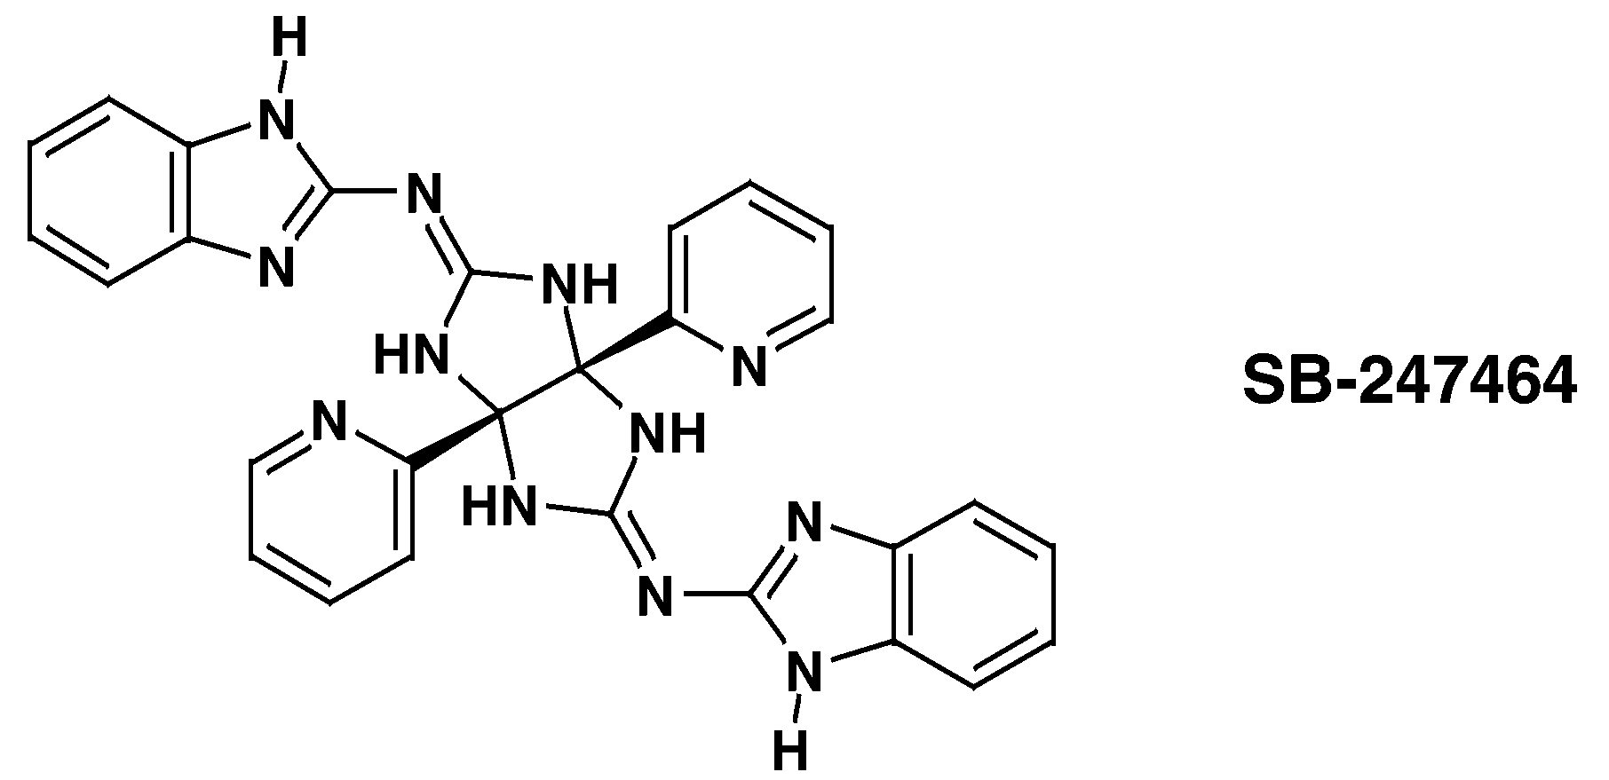

Figure 1 Structure of SB-247464.

As expected, SB-247464 induced activation of G-CSF signal transduction pathways, the efficacy being ca. 25–50% that of G-CSF, consistent with data from the luciferase assay.

2.2 Assessment of Activity of SB-247464

To assess SB-247464 in supporting the proliferation and differentiation of cells of the granulocytic lineage, colony-forming unit-granulocyte (CFU-G) assays from murine bone marrow were performed. SB-247464 stimulated the production of granulocytic colonies, with an efficacy 20–80% of that of G-CSF at 0.3–3 μM; the colonies appeared uniformly smaller than those promoted by G-CSF, but were consistently larger than 30 cells. Likewise, SB-247464 was able to mimic the activity of G-CSF in vivo (Figure 2): subcutaneous administration twice a day to normal mice caused a dose-dependent increase in peripheral blood neutrophils after 4 days. Efficacy at 30 mg/kg was comparable to that of 50 μg kg^{–1} of G-CSF, elevating the neutrophil counts to ca. 400% over baseline. The magnitude of the increase was equivalent to that effected by administration of 5–30 μg kg^{–1} day^{–1} of G-CSF to normal or neutropenic humans. Table 1 shows examples.
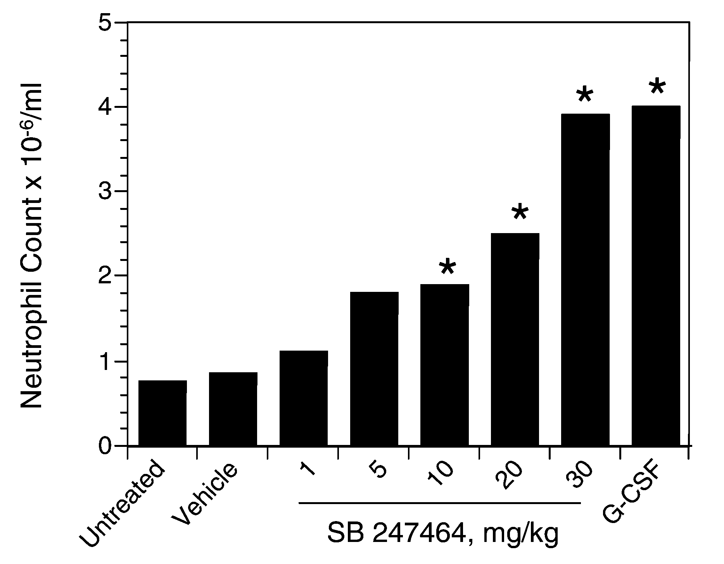

Figure 2 Granulopoietic activity in vivo; ∗ indicate neutrophil counts.
Table 1 Neutrophil count and granulopoietic activity.

Neutrophil count | Granulopoietic activity | Data
1 | 0.1 | Yes
2 | 0.2 | No
3 | 0.3 | No
4 | 0.4 | –
5 | 0.5 | Yes

3 CONCLUSION

The identification of SB-247464 as a G-CSF mimetic provides proof of principle for drug discovery using JAK/STAT-based assays, and shows for the first time that a small nonpeptidyl molecule can trigger the selective activation of a cytokine receptor. These findings may lead to the development of orally available G-CSF mimics for use in the treatment of neutropenia.

References

- K. Welte, J. Gabrilove, M.H. Bronchud, E. Platzer and G. Morstyn, Blood, 1996, 88, 1907.
- M. Fourcin, S. Chevalier, C. Guillet, O. Robledo, J. Froger, A. Pouplard-Barthelaix and H. Gascan, J. Biol. Chem., 1996, 271, 11756.

