Received 00th January 20xx,
- Address here.
- Address here.
- Address here.
† Footnotes relating to the title and/or authors should appear here.
Electronic Supplementary Information (ESI) available: [details of any supplementary information available should be included here]. See DOI: 10.1039/x0xx00000x
Accepted 00th January 20xx
DOI: 10.1039/x0xx00000x

Title (The title should accurately, clearly, and concisely reflect the emphasis and content of the work. Use of keywords and easily recognizable terms in the title will help increase the online discoverability of the article. Within 18 words/135 characters)
Author Full Name,*ª Author Full Name^{b} and Author Full Name^{c} (Full first and last names, star for corresponding author(s))

Abstract text goes here. The abstract should be a single paragraph (~150–250 words) that summarizes the key scientific points, significance, and impact of the research concisely. Avoid too many details on the experimental or theoretical methods. The abstract should not include reference citations. Be sure to define abbreviations and acronyms upon first usage.
Keywords: 4-6 words. Authors are required to include no fewer than 5 and no more than 7 keywords with their manuscript. These keywords will be associated with the paper for search and retrieval once the manuscript is published online.

The manuscript submitted by the author is not required to be in column format, but please submit the content according to the following requirements. Number the Introduction, Results and discussion, Conclusions and Experimental section, consecutively with Arabic numerals.

- Introduction
It should clearly explain both the nature of the problem under investigation and its background. It should start off general and then focus on the specific research question you are investigating. References should be superscripted and appear after punctuation. For example: Directly using natural seawater to produce hydrogen by electrolysis is an effective way to address the problem.¹⁻³
- Results and discussion
This is arguably the most important section of your article. Your results should be organised into an orderly and logical sequence. Only the most relevant results should be described in the text, to highlight the most important points. Figures, tables, and equations should be used for purposes of clarity and brevity. Data should not be reproduced in more than one form, for example, in both figures and tables, without good reason.
The purpose of the discussion is to explain the meaning of your results and why they are important. You should state the impact of your results compared with recent work and relate it back to the problem or question you posed in your introduction. Ensure claims are backed up by evidence and explain any complex arguments.
Equations should be inserted using the Equation Editor, not as graphics, in the main text.
Unit Format: m s⁻¹, mA cm⁻², mol L⁻¹, etc.
Fig.1 Note: Number the figures consecutively with Arabic numerals. Figures should be supplied as TIFF files, with a resolution of 600 dpi or greater. For clear printing, please provide the original figures in eps or pdf version after accepted. The font used in the figures is Arial. Figure panels should be labeled as: a b c (in bold), etc. on the top left hand corner; subpanels should be labeled as: i ii iii iv (in bold), etc. on the top left hand corner, as below.
Permission statement required for all figures reproduced or adapted from previously published articles/sources. For example: Reproduced with permission.¹ Copyright Year, Publisher.
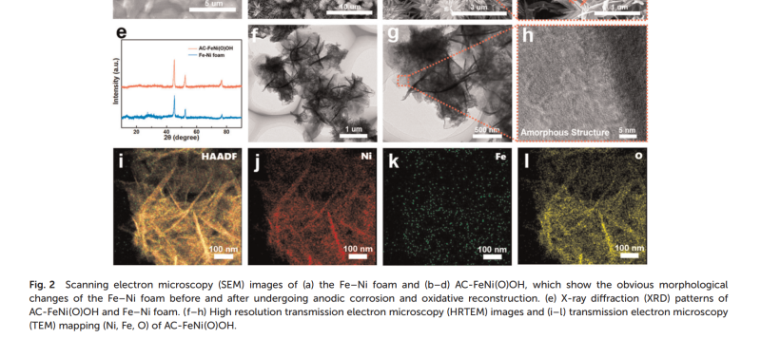
Table 1. (Note: Please do not combine table and caption in a textbox or frame and do not submit tables as graphics, please use Word’s “insert table” function.)
Head 1 [units]a | Head 2 | Head 3 | Head 4 | Head 5 [units]
Column 1 | Column 2 | Column 3b | Column 4 | Column 5
Column 1 | Column 2 | Column 3 | Column 4 | Column 5
ª(Table Footnote); ^{b}…
- Conclusions
This is for interpretation of the key results and to highlight the novelty and significance of the work. The conclusions should not summarise information already present in the article or abstract. You can also include any plans for relevant future work here.
- Experimental section (put after conclusions)
Provide descriptions of the experiments in enough detail so that a skilled researcher is able to repeat them. Standard techniques and methods used throughout the work should just be stated at the beginning of the section; descriptions of these are not needed. Any unusual hazards about the chemicals, procedures or equipment should be clearly identified. Authors are encouraged to make use of supplementary information (ESI) for lengthy synthetic sections.
Author Contributions (Optional)
We strongly encourage authors to include author contributions and recommend using CRediT for standardised contribution descriptions. Please refer to our general author guidelines for more information about authorship.
Conflicts of interest
In accordance with our policy on Conflicts of interest please ensure that a conflicts of interest statement is included in your manuscript here. Please note that this statement is required for all submitted manuscripts. If no conflicts exist, please state that “The authors declare no conflict of interest.”.
Acknowledgements
Financial and material support should be mentioned.
Contributors (those not already included as co-authors) may be acknowledged. Keep this section as brief as possible. Keep this section as brief as possible.
References
Citations should appear here in the format as below.

Reference to journals: all the authors, article title, journal abbreviation should be listed.
1. C. S. Smith, M. P. Castro and M. P. White, Anthocyanin extract from blackberry used as an indicator of hydrogen potential, J Mater. Sci., 1999, 22, 224-234.
2. C. S. Smith, M. P. Castro and M. P. White, Treatment of allergic rhinitis. J Mater. Sci., 2012, DOI:10.1016/S0002-9343(00)00545-3.

Reference to books:
3. C. S. Smith, M. P. Castro and M. P. White, Science of Chemistry, Royal Society of Chemistry(publisher), Cambridge (publisher location), 2000.

Reference to theses:
4. C. S. Smith, PhD thesis, University Name, year.

Reference to a lecture/meeting/conference:
5. C. S. Smith, presented in part at Conference Title, Place, Month, year.

Reference to Online resources (including databases, websites & wikis):
6. The Merck Index Online, http://www.rsc.org/Merck-Index/monograph/mono1500000841, (accessed October 2013).

Reference to patents:
7. J. C. Chung, US Pat., 20100105549A1, 2010

We encourage the citation of primary research over review articles, where appropriate, in order to give credit to those who first reported a finding. Find out more about our commitments to the principles of San Francisco Declaration on Research Assessment (DORA).

Table of Contents: (required and important)
The graphic should:
- Be simple, but informative and impressive (the use of colour is encouraged)
- Include a structure, scheme, graph, drawing, photograph or combination that conveys the message of the article. Please note, complex schematics or spectra should be avoided
- Be original, unpublished artwork created by the authors. Preferably, the graphic should not be reused and appear again within the article
- Not contain large amounts of text.
- The figure should be a maximum size of 8 cm wide x 4 cm high, supplied as TIFF files with a resolution of 600 dpi or greater.
The text should:
- Be concise and focus only on the key findings of the manuscript and their importance
- Avoid repeating or paraphrasing the title or abstract.
- 1-2 sentences, within 30 words

Multimedia files & video abstracts
We welcome the use of multimedia files (including videos and animations) as these can be an excellent medium to present elements of your work. Any videos of general interest can also be shared with the wider community through social media – an effective way to attract new audience groups to your work.

- Video abstracts offer an exciting opportunity to highlight the importance of a paper to the reader in a new and engaging way. Please notify the editorial team if you prefer for your video(s) not to be promoted in this way.
- If you submit a multimedia file alongside your paper, please refer to it within your paper to draw it to the reader’s attention. Please also provide a short descriptive title for the video.

For more detailed author guideline, please visit here.

