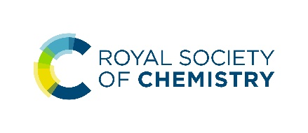
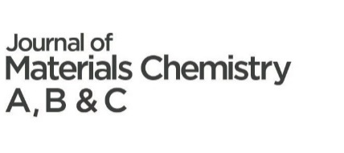
To submit a nomination for the 2023 Journal of Materials Chemistry Lectureship, please send this nomination form to the Editorial Office at materials-rsc@rsc.org alongside:
- A brief C.V. of the candidate (one page maximum)
- A supporting letter of recommendation
After nominations close, the Editorial Office will reach out to eligible candidates to request three recent publications representative of their research output.
Candidate/nominee details
Name
Email
Job title
Affiliation
Website
Which JMC journal does the candidate most identify with?

Please provide at least one of the following:
Year of PhD ………… Year of first independent position ………...
Additional eligibility details
Please include any additional details relevant to eligibility, for example, career breaks, additional details around first independent position (e.g., difference to previous positions) etc.
Please note that we do not require extensive details of career breaks or any proof of absence.
Research interests
Please select the categories (3 maximum) that best describes the candidate's subject area:

☐ Antifouling coatings | ☐ Electrocatalysis | ☐ Regenerative medicine & tissue engineering
☐ Batteries | ☐ Ferroelectrics | ☐ Scaffolds
☐ Biocompatible materials | ☐ Fuel cells | ☐ Self-cleaning/self-healing materials
☐ Bioelectronics | ☐ Gas capture/ separation/ storage | ☐ Semiconductors
☐ Bioimaging | ☐ Gene delivery | ☐ Sensors
☐ Biomimetics | ☐ Immunobiology | ☐ Single molecule conductors
☐ Biomineralisation | ☐ Lasers | ☐ Soft robotics
☐ Bionics | ☐ Lighting | ☐ Spintronics
☐ Biosensors | ☐ Liquid crystals | ☐ Stem cells
☐ Catalysis | ☐ Memory | ☐ Supercapacitors
☐ Conductors | ☐ Metamaterials | ☐ Superconductors
☐ Detectors | ☐ Multiferroics | ☐ Therapeutic devices
☐ Diagnostics | ☐ Nanomedicine | ☐ Thermoelectrics
☐ Dielectrics | ☐ Photocatalysis | ☐ Topological insulators
☐ Displays | ☐ Photonics | ☐ Transistors
☐ Drug delivery | ☐ Photovoltaics | ☐ Water treatment

Community service statement
Max 350 words, more details on what to include can be found here: https://www.rsc.org/journals-books-databases/about-journals/materials/journal-of-materials-chemistry-lectureship/#process

