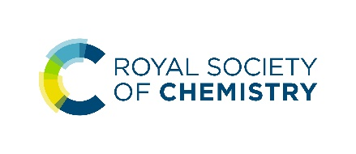
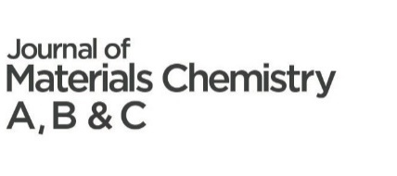
To be eligible for the Journal of Materials Chemistry Lectureship, the candidate must:
- Be an independent researcher. PhD students and post-doctoral research associates are not eligible.
- Be actively pursuing an independent research career within materials chemistry and have made a significant contribution to the field.
- Be at an early stage of their independent career (typically this will be within 10 years of completing their PhD OR within the first five years of their independent career, but appropriate consideration will be given to those who have taken a career break, for example for childcare leave, or followed a different study path). The Editorial Office will respond rapidly to any eligibility queries.
To submit a nomination for the 2024 Journal of Materials Chemistry Lectureship, the nominator should send this nomination form to the Editorial Office at materials-rsc@rsc.org alongside:
- A brief C.V. of the candidate (one page maximum)
- A supporting letter of recommendation from the nominator (one page maximum)
- An additional supporting letter of recommendation from a referee who is able to comment in detail on the specific contributions, achievements or potential of a nominee – this could be, for example, the nominee’s post-doc or PhD supervisor, or academic mentor (one page maximum)
- Three recent publications representative of the nominee’s research output
Candidate/nominee details
Name
Email
Job title
Affiliation
Website
Which JMC journal does the candidate most identify with?

Please provide at least one of the following:
Year of PhD ………… Year of first independent position ………...
Additional eligibility details
Please include any additional details relevant to eligibility, for example, career breaks, additional details around first independent position (e.g., difference to previous positions) etc.
Please note that we do not require extensive details of career breaks or any proof of absence.

Research interests
Please select the categories (3 maximum) that best describes the candidate's subject area:

☐ Antifouling coatings | ☐ Electrocatalysis | ☐ Regenerative medicine & tissue engineering
☐ Batteries | ☐ Ferroelectrics | ☐ Scaffolds
☐ Biocompatible materials | ☐ Fuel cells | ☐ Self-cleaning/self-healing materials
☐ Bioelectronics | ☐ Gas capture/ separation/ storage | ☐ Semiconductors
☐ Bioimaging | ☐ Gene delivery | ☐ Sensors
☐ Biomimetics | ☐ Immunobiology | ☐ Single molecule conductors
☐ Biomineralisation | ☐ Lasers | ☐ Soft robotics
☐ Bionics | ☐ Lighting | ☐ Spintronics
☐ Biosensors | ☐ Liquid crystals | ☐ Stem cells
☐ Catalysis | ☐ Memory | ☐ Supercapacitors
☐ Conductors | ☐ Metamaterials | ☐ Superconductors
☐ Detectors | ☐ Multiferroics | ☐ Therapeutic devices
☐ Diagnostics | ☐ Nanomedicine | ☐ Thermoelectrics
☐ Dielectrics | ☐ Photocatalysis | ☐ Topological insulators
☐ Displays | ☐ Photonics | ☐ Transistors
☐ Drug delivery | ☐ Photovoltaics | ☐ Water treatment

Community service statement*
Max 350 words, more details on what to include can be found here: https://www.rsc.org/journals-books-databases/about-journals/materials/journal-of-materials-chemistry-lectureship/#process
*We define community service as any voluntary work that the candidate has taken part in that has benefitted at least one other member of the materials chemistry community.
The nominator may consider including the following information in the citation of community service:
- Details of how the nominee has made a personal impact and stands out through volunteering for the materials chemistry community
- Details of how the nominee personally contributed to the implementation and outcomes of the community service activity
- Details of how the nominee engaged others in their community service activities
- Details of the impact on the community of their activities
- Details of how the nominee promoted a positive work-life balance
- Examples of service to the materials chemistry community might include, but are not limited to, education, public outreach, research advocacy, leadership and mentoring

