Supplementary material for the paper:

Do the discrete dianions C₂B₉H₁₁²⁻ exist? Characterisation of alkali metal salts of the 11-vertex nido dicarboranes, C₂B₉H₁₁²⁻, in solution.

Mark A. Fox,* Andrew K. Hughes,* Andrew L. Johnson and Michael A. J. Paterson

Chemistry Department, Durham University Science Laboratories, South Road,
Durham, UK DH1 3LE.

Comprising:

Table 1. Bond lengths of the optimised model geometries H and I and of the experimental geometries 10 and 11.

Figure 1. The 96.2 MHz ¹¹B-¹¹B COSY spectrum of Li₂7,9-C₂B₉H₁₁ 4 in THF / 10%C₆D₆.

Table 2. Observed (in bold) and computed (GIAO-6-311G*//MP2/6-31G*) NMR data for 7,8-Me₂-7,8-C₂B₉H₁₀⁻

Table 3. Cartesian coordinates for MP2/6-31G* geometry of 7,8-Me₂-7,8-C₂B₉H₁₀⁻

Table 1. Bond lengths of the optimised model geometries H and I and of the experimental geometries 10 and 11.
 | H | 10 | I | 11
B1-C2 | 1.684 | 1.711(6) | 1.688 | 1.705(7)
B1-C3 | 1.700 | 1.702(6)
B1-B3 |  |  | 1.783 | 1.771(8)
B1-B4 | 1.798 | 1.787(8)
B1-C4 |  |  | 1.690 | 1.708(7)
B1-B5 | 1.809 | 1.800(8) | 1.794 | 1.767(8)
B1-B6 | 1.801 | 1.799(8) | 1.789 | 1.760(8)
C2-C3 | 1.490 | 1.509(6)
C2-B3 |  |  | 1.555 | 1.548(7)
C3-B4 | 1.561 | 1.560(6)
B3-C4 |  |  | 1.555 | 1.528(7)
B4-B5 | 1.657 | 1.637(7)
C4-B5 |  |  | 1.567 | 1.566(7)
B5-B6 | 1.668 | 1.637(7) | 1.664 | 1.626(8)
C2-B6 | 1.556 | 1.559(6) | 1.567 | 1.560(7)
ap-Li-C2 | 2.316 | 2.367(9) | 2.326 | 2.295(9)
ap-Li-C3 | 2.269 | 2.295(9)
ap-Li-B3 |  |  | 2.337 | 2.318(10)
ap-Li-B4 | 2.342 | 2.291(9)
ap-Li-C4 |  |  | 2.350 | 2.374(9)
ap-Li-B5 | 2.415 | 2.371(9) | 2.328 | 2.344(9)
ap-Li-B6 | 2.357 | 2.337(10) | 2.318 | 2.299(10)
exo-Li-B5 | 2.240 | 2.226(9) | 2.252 | 2.215(10)
exo-Li-B6 | 2.193 | 2.241(8) | 2.213 | 2.234(9)
ap-Li-N | 2.124 | 2.192(9) | 2.122 | 2.160(9)
ap-Li-N | 2.144 | 2.159(9) | 2.135 | 2.151(9)

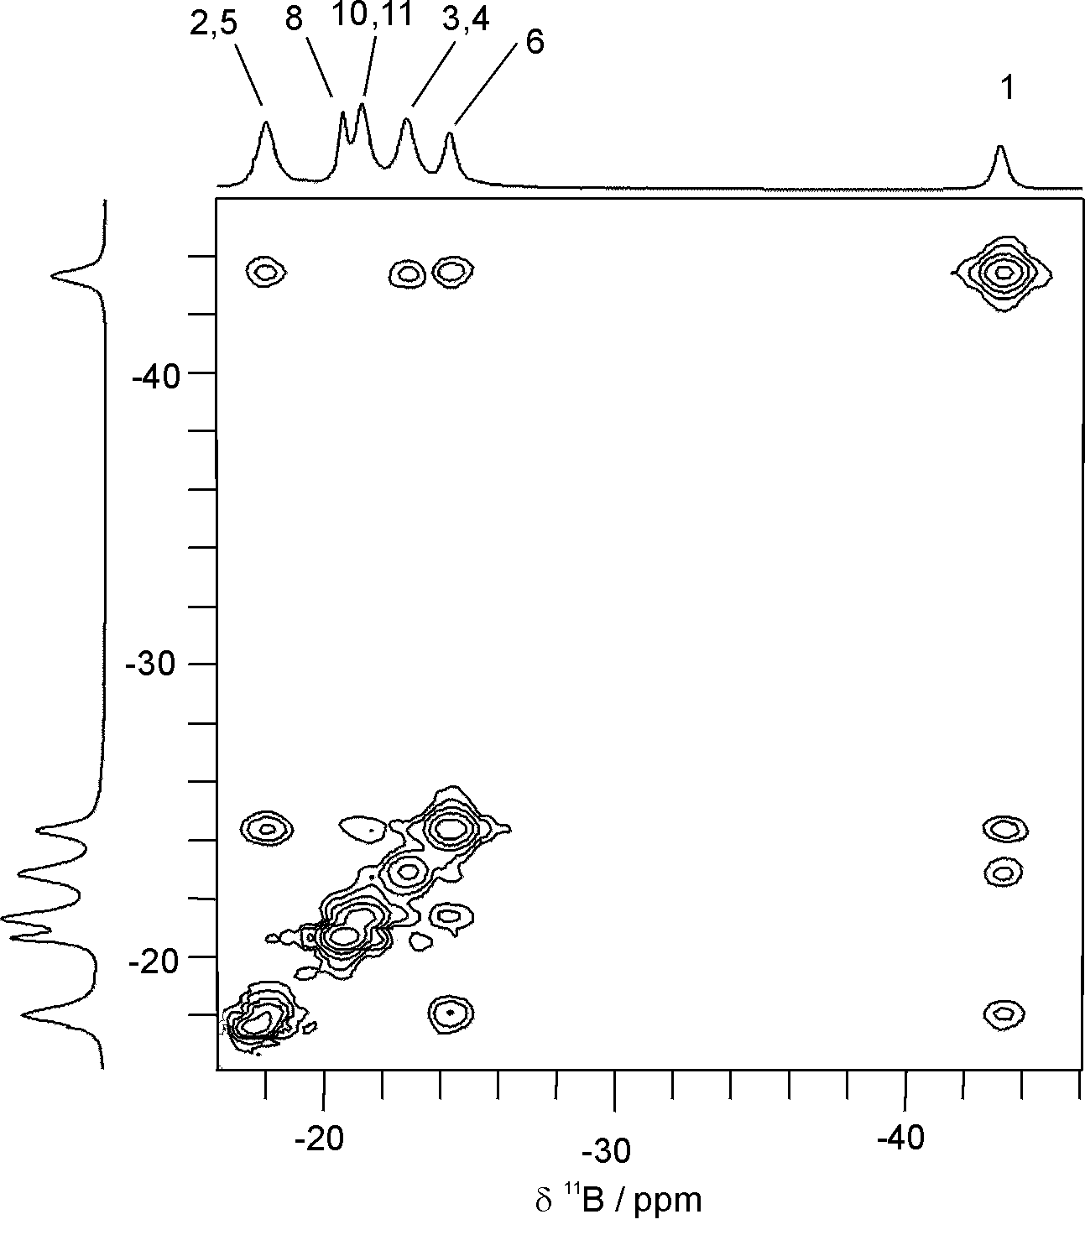

Figure 1. The 96.2 MHz ¹¹B-¹¹B COSY spectrum of Li₂7,9-C₂B₉H₁₁ 4 in THF / 10%C₆D₆.

Table 2. Observed (in bold) and computed (GIAO-6-311G*//MP2/6-31G*) NMR data for 7,8-Me₂-7,8-C₂B₉H₁₀⁻

¹¹B and ¹³C NMR

(HNMe₃)(7,8-Me₂-7,8-C₂B₉H₁₀)  in CD₃CN | -9.2  (B3) | -9.2  (B9,11) | -18.4  (B5,6) | -18.4  (B2,4) | -34.9  (B10) | -36.9  (B1) | 57.3  (C7,8) | 22.1  (CH₃)
7,8-Me₂-7,8-C₂B₉H₁₀⁻ | -10.1  (B3) | -12.0  (B9,11) | -17.7Error: Reference source not found  (B5,6) | -18.5Error: Reference source not found  (B2,4) | -35.5  (B10) | -37.7  (B1) | 60.0  (C7,8) | 24.9  (CH₃)

¹H NMR

(HNMe₃)  (7,8-Me₂-7,8-C₂B₉H₁₀)  in CD₃CN | 1.82  (B9,11H) | 1.46  (B3H) | 1.34  (B2,4H?) | 1.34  (CH₃) | 1.03  (B5,6H?) | 0.36  (B1H) | -0.13  (B10) | -2.68  (Hμ)
7,8-Me₂-7,8-C₂B₉H₁₀⁻ | 2.26  (B9,11H) | 2.06  (B3H) | 1.97  (B2,4H) | 1.35  (CH₃) | 1.79  (B5,6H) | 0.97  (B1H) | 0.49  (B10H) | -2.97  (Hμ)

Table 3. Cartesian coordinates for MP2/6-31G* geometry of 7,8-Me₂-7,8-C₂B₉H₁₀⁻

29
C4H16B9(1-) << C1 >>
C -0.768561 0.796778 -0.155134
C -0.829320 -0.768339 -0.124023
B 0.513629 1.426570 -0.910071
B 0.480633 1.415494 0.864565
B -0.441500 0.004044 1.349137
B 0.421519 -1.396429 -0.969340
B 1.472526 0.018313 -1.492684
B 1.902706 0.874363 0.003796
B 1.318908 -0.047942 1.418069
B 0.413510 -1.425337 0.833400
B 1.870005 -0.938479 -0.042345
C -2.095163 1.533834 -0.236305
C -2.185880 -1.447086 -0.179479
H 0.434678 2.501369 -1.441361
H 0.326686 2.418898 1.498962
H -1.255902 0.010413 2.224695
H 0.328742 -2.458590 -1.520707
H 2.250949 -0.024934 -2.403207
H 2.948886 1.459348 0.019808
H 1.912002 -0.092513 2.455557
H 0.230678 -2.470496 1.386698
H 2.863745 -1.604986 -0.000149
H -2.781335 1.273741 0.577261
H -1.906279 2.609900 -0.195026
H -2.594412 1.318530 -1.188771
H -2.695612 -1.218208 -1.123134
H -2.043190 -2.530455 -0.131497
H -2.843246 -1.153213 0.645868
H 0.337474 -0.382920 -1.907985

Computed shifts averaged.

