Hydrophilic interaction chromatography coupled matrix assisted laser desorption/ionization mass spectrometry for molecular analysis of organic compounds in medicine, tea, and coffee
Ren-Qi Wang^{1,*}, Kai Bao², Jean-Philippes Croué³ and Siu Choon Ng^{4,**}
1, College of Chemistry and Chemical Engineering, Lanzhou University, Lanzhou 730000, China
2, Division of Mathematics and Computer Science and Engineering, King Abdullah University of Science and Technology, Thuwal 23955-6900, Saudi Arabia
3, Water Desalination & Reuse Center (WDRC), 4700 King Abdullah University of Science and Technology, Kingdom of Saudi Arabia
4, School of Chemical and Biomolecular Engineering, Nanyang Technological University, 62 Nanyang Drive, Singapore 637459, Singapore

HILIC-MALDI-MS spectra of active ingredients in Panadol, Compound Pseudoephedrine Hydrochloride Sustained Release Tablet (PHSR), Coffee, and Tea are illustrated as follows:

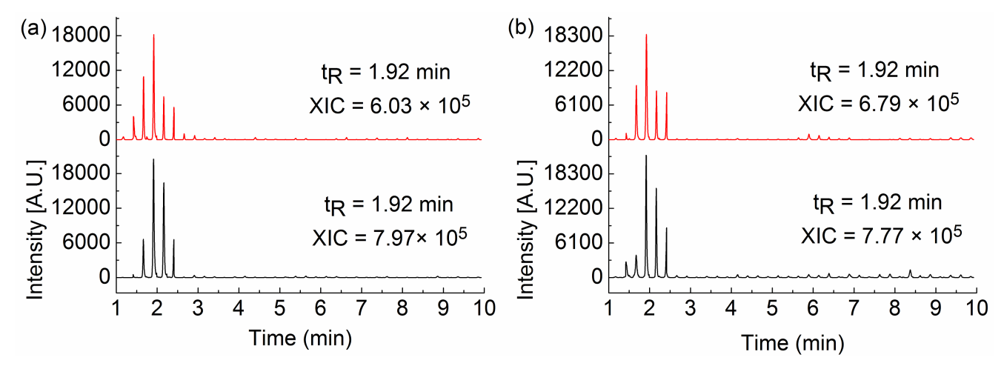
Figure SD1. Paracetamol in Panadol (a) and PHSR (b). Red spectra were collected in basic HILIC condition; black spectra were collected in acid condition.

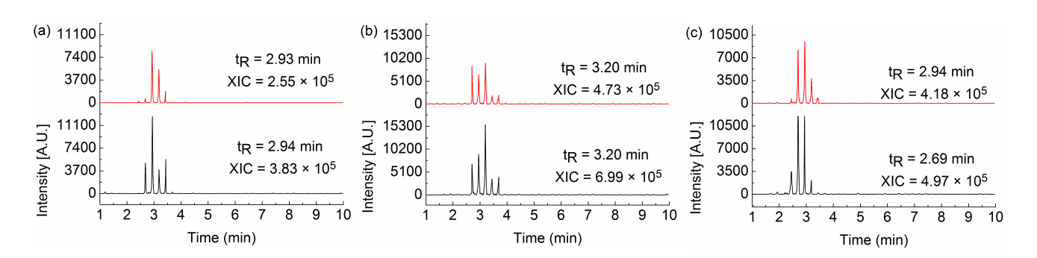
Figure SD2. Caffeine in Panadol (a) Coffee (b), and Tea (c). Red spectra were collected in basic HILIC condition; black spectra were collected in acid condition.

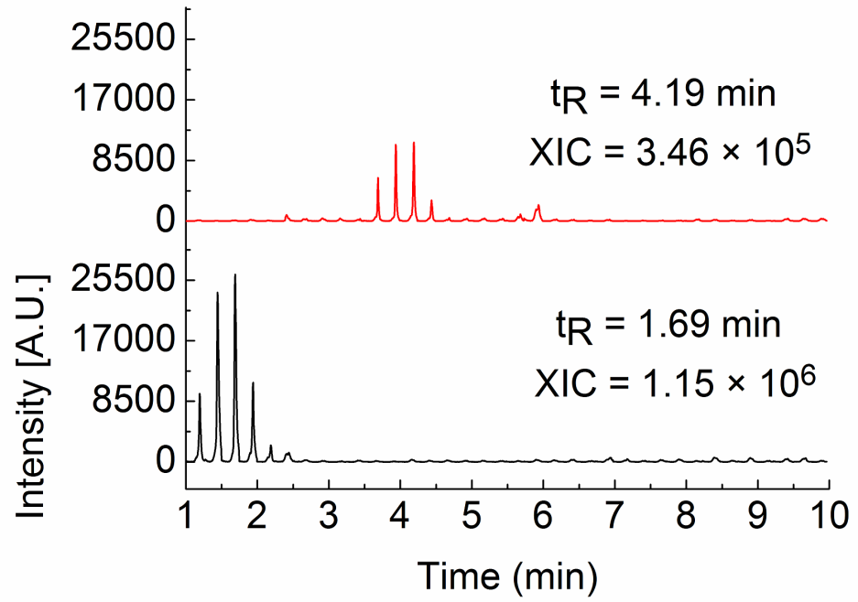
Figure SD3. Pseudoephedrine in PHSR. Red spectra were collected in basic HILIC condition; black spectra were collected in acid condition.

Typical HILIC/ESI-MS spectra of Pseudoephedrine in PHSR are illustrated as follows:
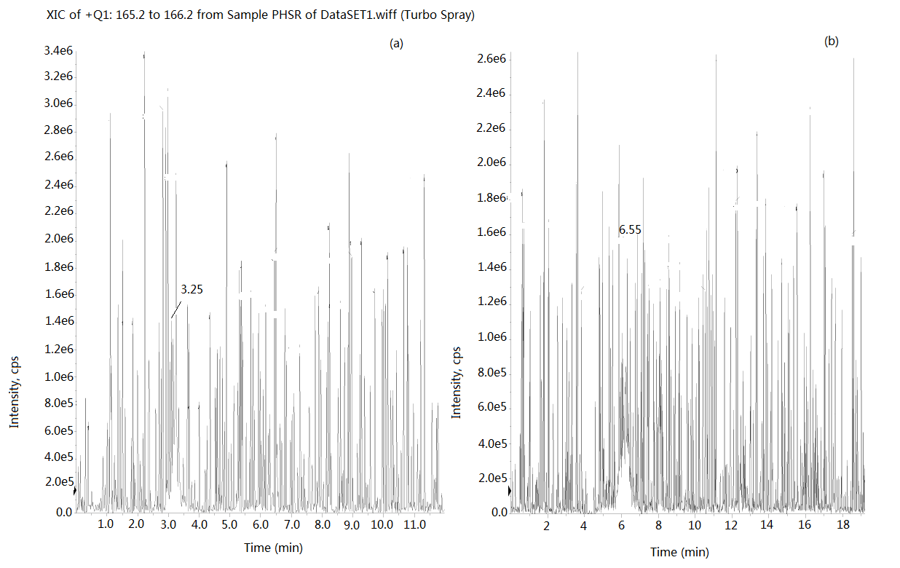
Figure SD4. Pseudoephedrine in PHSR. XIC spectra collected in HILIC/ESI-MS; (a) acid condition (b) basic condition.

