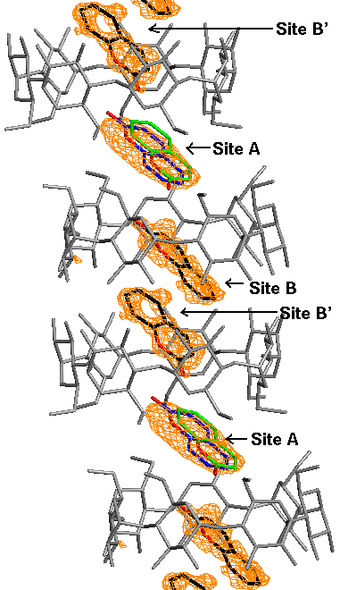
Fig. 1 Structure of the β-CD/coumarin "reaction nano-tube" with the difference electron density (F_{o}-F_{c}) in the CD overlaid. CDs are in gray while coumarin molecules are colored as follows: carbon = black; oxygen = red. Coumarin molecules at crystallographically disordered site A are colored with blue carbons for one orientation and green carbons for the other orientation. Waters of crystallization are omitted for clarity. The β-CD dimer stacks are roughly parallel to the crystallographic c-axis. See text for details.

