Supplementary Data

Porphodimethene-porphyrinogen relationship: the generation of unprecendented forms of porphyrinogen

Lucia Bonomo,ª Euro Solari,ª Rosario Scopelliti,ª Mario Latronico^{b} and Carlo Floriani*ª

ª Institut de Chemie Minérale et Analytique, BCH, Université de Lausanne, CH-1015 Lausanne, Switzerland
^{b} Dipartimento di Ingegneria e Fisica dell’Ambiente, Università della Basilicata, 85100 Potenza, Italy

Syntheses of 2, 3, 5, 6, 7 (Methods A and B) and 8

Procedure for 2. To a solution of 1 (4.08 g, 7.59 mmol) in THF (200 ml) was added, by dropping, a solution of LiNMe₂ (0.39 g, 7.59 mmol) in THF (100 ml) at 0 °C. The reaction mixture was warmed to room temperature and stirred for 2 h. The solution was evaporated to dryness. The red solid was collected with n-hexane (100 ml) and dried in vacuo (4.28 g, 82%) (Found: C, 69.93; H, 8.12; N, 7.97. C₄₀H₅₃LiN₄NiO₂ requires: C, 69.88; H, 7.77; N 8.15%); δ_{H}(Pyridine-d₅, 400 MHz, 298 K) 6.35 (d, J = 3.4 Hz, 1H; C₄H₂N), 6.34 (d, J = 2.9 Hz, 1H; C₄H₂N), 6.32 (d, J = 2.9 Hz, 1H; C₄H₂N), 6.31 (d, J = 2.9 Hz, 1H; C₄H₂N), 6.29 (d, J = 3.4 Hz, 1H; C₄H₂N), 6.27 (d, J = 3.4 Hz, 1H; C₄H₂N), 6.25 (d, J = 3.4 Hz, 1H; C₄H₂N), 6.11 (d, J = 2.9 Hz, 1H; C₄H₂N), 5.34 (q, J = 7.3 Hz, 1H; CH), 4.1 (dq, J_{gem} = 14.2 Hz, J_{vic} = 7.3 Hz, 1H; CH₂), 3.9 (dq, J_{gem} = 14.2 Hz, J_{vic} = 7.3 Hz, 1H; CH₂), 3.66 (m, 8H; THF), 3.41 (dq, J_{gem} = 14.2 Hz, J_{vic} = 7.3 Hz, 1H; CH₂), 3.33 (dq, J_{gem} = 14.2 Hz, J_{vic} = 7.3 Hz, 1H; CH₂), 2.5 (m, 4H; CH₂), 2.31 (q, J = 7.3 Hz, 2H; CH₂), 1.75 (d, J = 7.3 Hz, 3H; CH₃), 1.65 (m, 8H; THF), 1.41 (t, J = 7.3 Hz, 6H; CH₃), 1.2 (t, J = 7.3 Hz, 3H; CH₃), 1.1 (t, J = 7.3 Hz, 3H; CH₃), 1.05 (t, J = 7.3 Hz, 3H; CH₃). Reprotonation of 2 with 1 equiv. of PyH⁺Cl in toluene at room temperature gave back 1.

Procedure for 3. LiNMe₂ (0.74 g, 14.4 mmol) was added in one portion at room temperature to a stirred solution of 1 (3.84 g, 7.14 mmol) in THF (250 cm³). The reaction was monitored by NMR, and the mixture was stirred until the product 2 was entirely converted (≈ 60 h). The solution was evaporated to dryness. The violet solid was collected with n-hexane (100 ml) and dried in vacuo (4.28 g, 71%) (Found C, 68.54; H, 8.02; N, 6.83. C₄₈H₆₈Li₂N₄NiO₄ requires C, 68.80; H, 8.18; N, 6.69%); δ_{H}(Pyridine-d₅, 400 MHz, 298 K) 6.55 (m, 8H, C₄H₂N), 6.39 (d, J = 3.2 Hz, 2H, C₄H₂N), 6.38 (d, J = 3.2 Hz, 2H, C₄H₂N), 6.26 (d, J = 2.8 Hz, 2H, C₄H₂N), 6.25 (d, J = 2.8 Hz, 2H, C₄H₂N), 5.87 (q, J = 6.85 Hz, 2H, CH), 5.86 (q, J = 6.85 Hz, 2H, CH), 4.25–3.75 (m, 8H, CH₂), 3.58 (m, 32H, THF), 2.5 (m, 8H, CH₂), 2.18 (d, J = 6.85 Hz, 6H, CH₃ overlapping with d, J = 6.85 Hz, 6H, CH₃), 1.68 (m, 32H, THF), 1.5 (m, 12H, CH₃), 1.19 (t, J = 7.6 Hz, 12H, CH₃). Crystals suitable for X-ray diffraction were grown in DME and contain six DME molecules in the ion-separated form, the anion being shown in Fig. S1. Reprotonation of 3 with 2 equiv. of PyH⁺Cl⁻ in toluene at room temperature gave back 1.

Procedure for 5. A solution of LiNMe₂ (0.32 g, 6.28 mmol) in THF (50 cm³) was added, by dropping, at room temperature to a solution of 4 (2.0 g, 3.14 mmol) in THF (100 cm³). The reaction mixture was stirred for 2 h, and then was evaporated to dryness. The solid residue was triturated with n-hexane to give a light pink powder, which was collected and dried in vacuo (2.03 g, 73%) (Found: C, 70.62; H, 9.17; N, 9.35. C₅₂H₈₂Li₄N₆O₄ requires C, 70.73; H, 9.36; N, 9.52%); δ_{H}(Pyridine-d₅, 400 MHz, 298 K) 6.46 (d, J = 2.4 Hz, 4H, C₄H₂N), 6.27 (d, J = 2.4 Hz, 4H, C₄H₂N), 3.70 (m, 16H, THF), 3.25 (q, J = 7.3 Hz, 4H; CH₂), 2.99 (q, J = 7.3 Hz, 4H; CH₂), 2.17 (q, J = 7.3 Hz, 4H; CH₂), 1.93 (s, 12H, CH₃), 1.62 (m, 16H, THF overlapping with t, J = 7.3 Hz, 6H, CH₃), 1.05 (t, J = 7.3 Hz, 6H, CH₃), 0.83 (t, J = 7.3 Hz, 6H, CH₃).

Procedure for 6. LiNMe₂ (0.63 g, 12.3 mmol) was added at room temperature to a solution of 4 (3.93 g, 6.15 mmol) in benzene (300 cm³). After 1 h, the ¹H NMR spectrum showed that 4 was entirely converted into 5. The reaction mixture was then refluxed for 12 h and finally was evaporated to dryness. The light yellow solid residue was collected with n-pentane (60 cm³) and dried in vacuo (2.8 g, 70%) (Found C, 74.33; H, 8.13; N, 8.45. C₄₀H₅₂Li₄N₄O₂ requires C, 74.07; H, 8.08; N, 8.64%); δ_{H}(Pyridine-d₅, 400 MHz, 298 K) 6.91 (d, J = 2.45 Hz, 2H, C₄H₂N), 6.86 (d, J = 2.45 Hz, 2H, C₄H₂N), 6.74 (d, J = 2.45 Hz, 2H, C₄H₂N), 6.69 (d, J = 2.45 Hz, 2H, C₄H₂N), 6.47 (d, J = 2.45 Hz, 2H, C₄H₂N overlapping with d, J = 2.4 Hz, 2H, C₄H₂N), 6.36 (d, J = 2.45 Hz, 2H, C₄H₂N overlapping with d, J = 2.4 Hz, 2H, C₄H₂N), 5.95 (q, J = 6.85 Hz, 2H, CH), 5.88 (q, J = 6.85 Hz, 2H, CH), 3.70 (m, 16H; THF), 2.4–2.2 (m, 16H; CH₂), 2.15 (d, J = 6.85 Hz, 6H; CH₃ overlapping with d, J = 6.85 Hz, 6H, CH₃), 1.62 (m, 16H, THF), 1.00 (m, 24H, CH₃).

Procedure for 7
Method A: LiNMe₂ (0.21 g, 4.12 mmol) was added at room temperature to a solution of 4 (1.31 g, 2.06 mmol) in THF (150 cm³). After 1 h the ¹H NMR spectrum showed that 4 was entirely converted into 5. The reaction mixture was then refluxed for 12 h followed by evaporation to dryness. The solid residue was dissolved in n-pentane (100 cm³), and DME was added by dropping until a yellow microcrystalline solid precipitated. The product was then collected and dried in vacuo (2.0 g, 60%) (Found: C, 60.32; H, 10.13; N, 4.34. C₉₂H₁₆₃Li₄N₅O₂₄ requires: C, 60.39; H, 10.07; N, 4.29%); δ_{H}(Pyridine-d₅, 400 MHz, 298 K) 6.54 (d, J = 2.9 Hz, 1H, C₄H₂N), 6.52 (d, J = 2.9 Hz, 1H, C₄H₂N), 6.45 (m, 3H, C₄H₂N), 6.42 (d, J = 2.9 Hz, 1H, C₄H₂N), 6.39 (d, J = 2.9 Hz, 1H, C₄H₂N), 6.30 (d, J = 2.9 Hz, 1H, C₄H₂N), 5.41 (q, J = 7.3 Hz, 1H, CH), 3.49 (s, 48H, DME), 3.26 (s, 72H, DME), 2.9–2.68 (m, 2H, CH₂), 2.62 (m, 1H, CH₂), 2.57–2.33 (m, 4H, CH₂), 2.30 (m, 1H, CH₂), 2.26 (q, J = 7.3 Hz, 2H, CH₂), 2.02 (s, 3H, CH₃), 1.99 (s, 3H, CH₃), 1.75 (d, J = 7.3 Hz, 3H, CH₃), 1.33 (t, J = 7.3 Hz, 3H, CH₃ overlapping with t, J = 7.3 Hz, 3H, CH₃), 1.19 (t, J = 7.3 Hz, 3H, CH₃), 0.77 (t, J = 7.3 Hz, 3H, CH₃ overlapping with t, J = 7.3 Hz, 3H, CH₃). Crystals suitable for X-ray diffraction were obtained in a mixture of DME–n-heptane and contain only three molecules of DME in the ion-pair form shown in Fig. S2.
Method B: LiNMe₂ (0.10 g, 1.96 mmol) was added at room temperature to a solution of 8 (1.68 g, 1.96 mmol) in DME (100 ml). After 1 h stirring ¹H NMR showed that 8 was entirely converted into 7. The reaction mixture was concentrated, and n-pentane (100 ml) was added to give 7, which was collected and dried in vacuo (1.82 g, 57%).

Procedure for 8. LiNMe₂ (0.4 g, 7.84 mmol) was added at room temperature to a solution of 4 (2.50 g, 3.92 mmol) in DME (300 ml). After 1 h ¹H NMR showed that 4 was entirely converted into 5. The reaction mixture was then refluxed for 12 h. A white crystalline solid precipitated and n-pentane (200 ml) was added to completely eliminate the excess of LiNMe₂, which was filtered off. The solution was then cooled to −20 °C for 12 h and a red crystalline solid precipitated. The product was then collected and dried in vacuo (1.75 g, 52%). Crystals suitable for X-ray diffraction were obtained in a mixture of DME–n-pentane (Found: C, 67.28; H, 9.15; N, 6.74. C₄₈H₇₇Li₃N₄O₈ requires: C, 67.12; H. 9.03; N, 6.52%); δ_{H}(Pyridine-d₅, 400 MHz, 298 K) 7.25 (d, J = 3.2 Hz, 1H; C₄H₂N), 7.22 (d, J = 4.0 Hz, 1H; C₄H₂N), 6.89 (d, J = 2.8 Hz, 1H; C₄H₂N), 6.77 (d, J = 2.8 Hz, 1H; C₄H₂N), 6.66 (d, J = 4.0 Hz, 1H; C₄H₂N), 6.63 (d, J = 4.0 Hz, 1H; C₄H₂N), 6.61 (d, J = 4.0 Hz, 1H; C₄H₂N), 6.51 (d, J = 3.2 Hz, 1H; C₄H₂N), 5.65 (q, J = 6.85 Hz, 1H; CH), 3.49 (s, 16H; DME), 3.28 (s, 24H; DME), 2.83 (q, J = 7.6 Hz, 2H; CH₂), 2.50 (m, 4H; CH₂), 2.25 (m, 4H; CH₂), 1.95 (d, J = 6.85 Hz, 3H; CH₃), 1.23 (t, J = 7.6 Hz, 3H; CH₃), 0.85 (t, J = 7.3 Hz, 12H; CH₃).
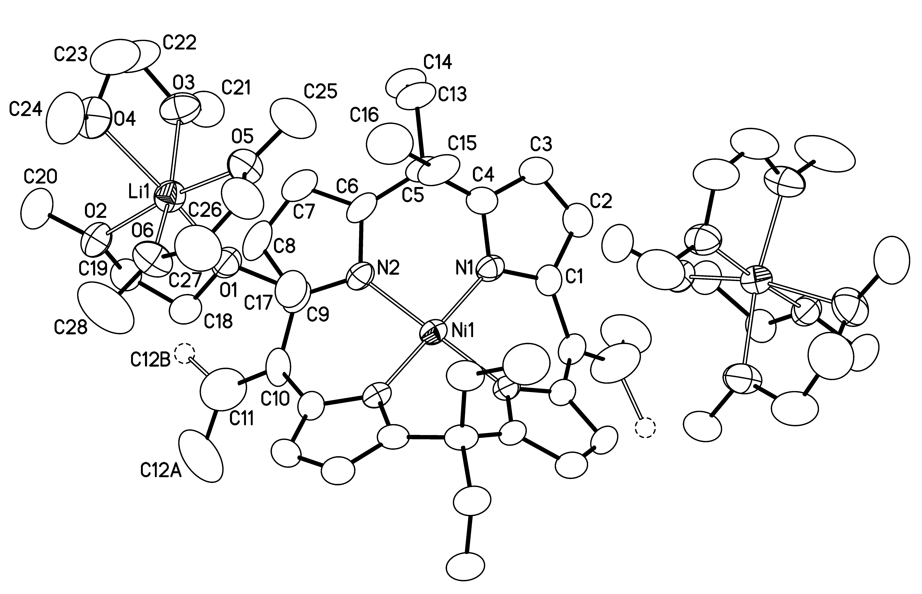
Fig. S1 An ORTEP drawing of complex 3 (25% probability ellipsoids).
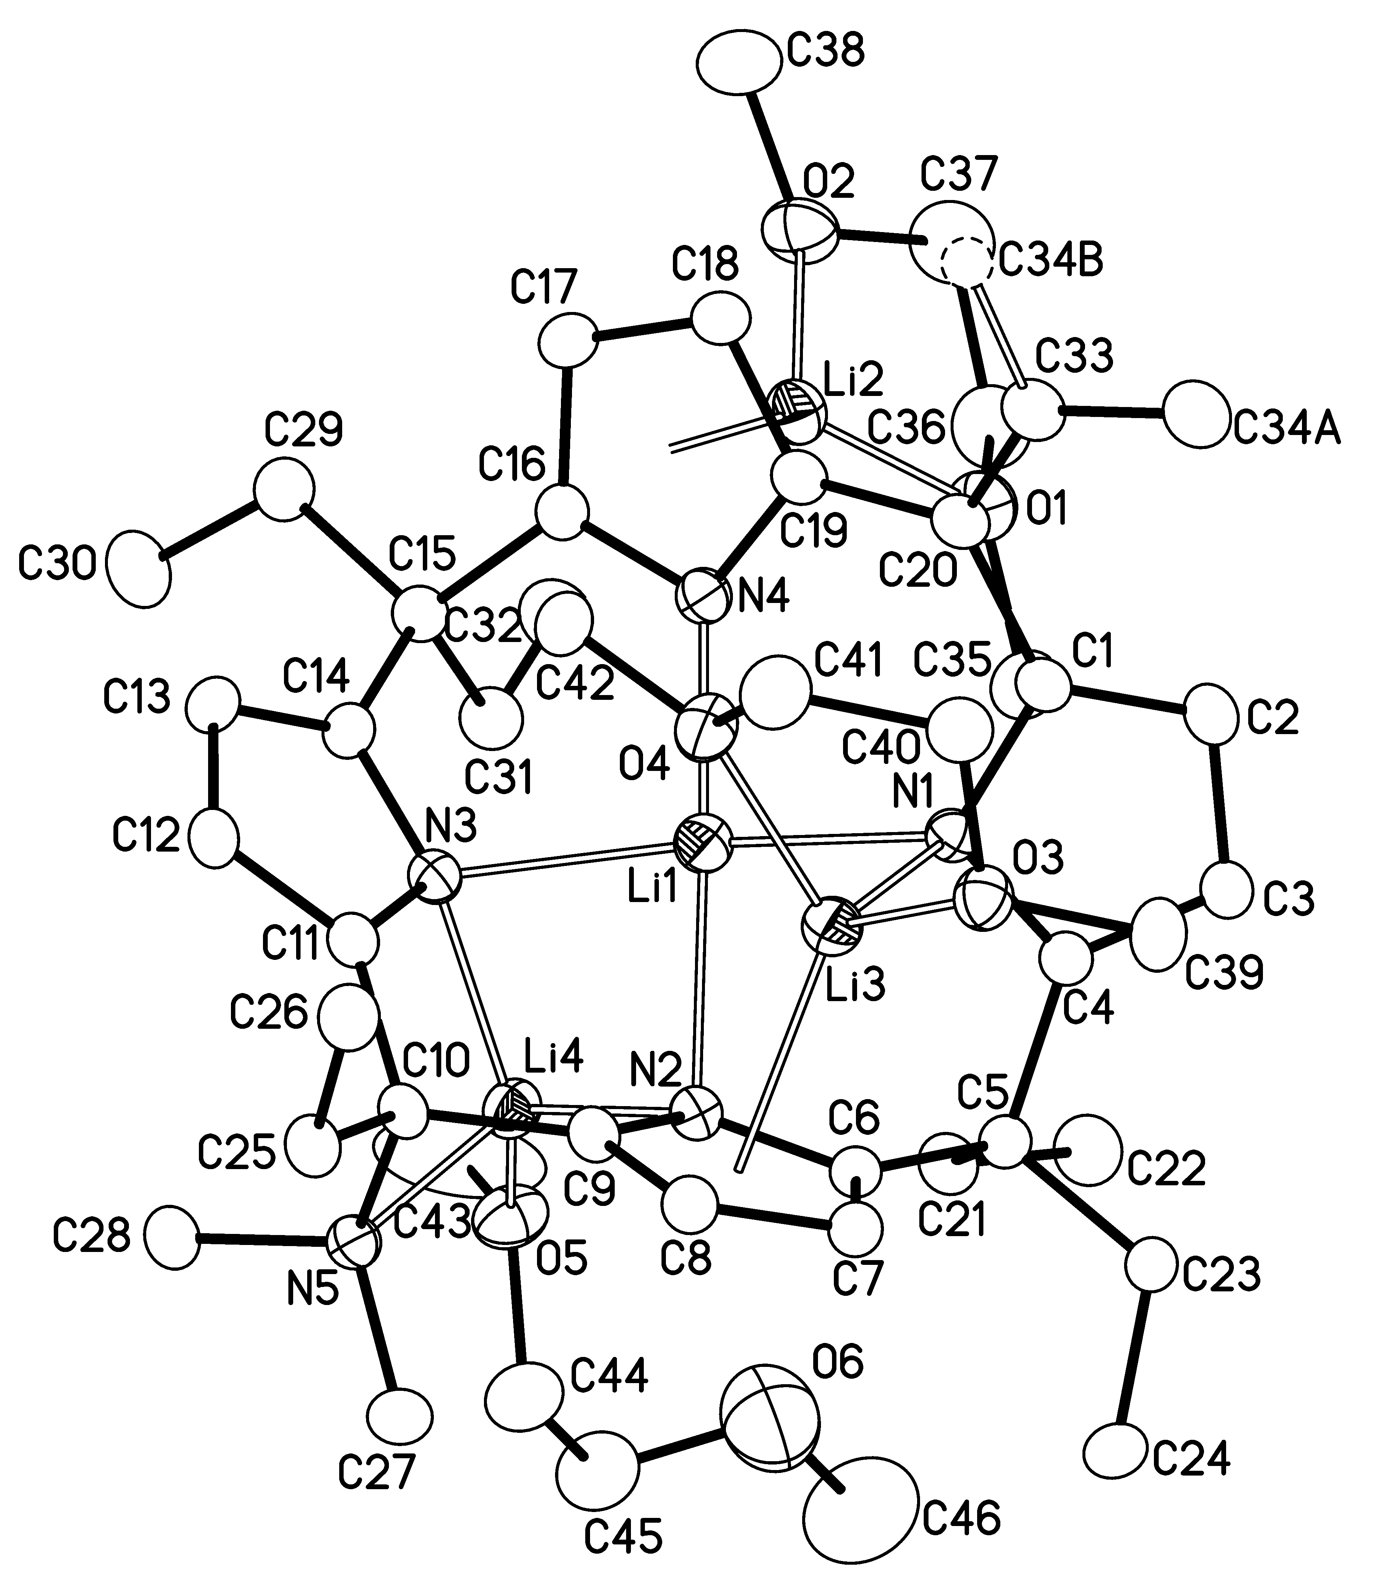
Fig. S2 An ORTEP drawing of complex 7 (25% probability ellipsoids).

