Supplementary Data

Mode of inclusion of 2-SP in α-, β- and γ-CDs using molecular modelling studies

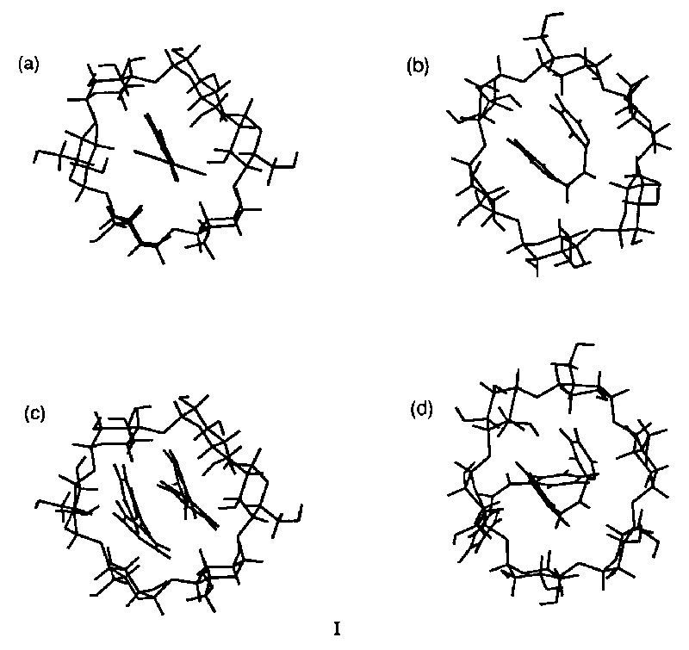

Fig. I (a) Inclusion of trans-2-SP in α-CD; (b) Inclusion of cis-2-SP in α-CD; (c) Inclusion of two molecules of trans-2-SP in α-CD and (d) Inclusion of two molecules of cis-2-SP in α-CD.
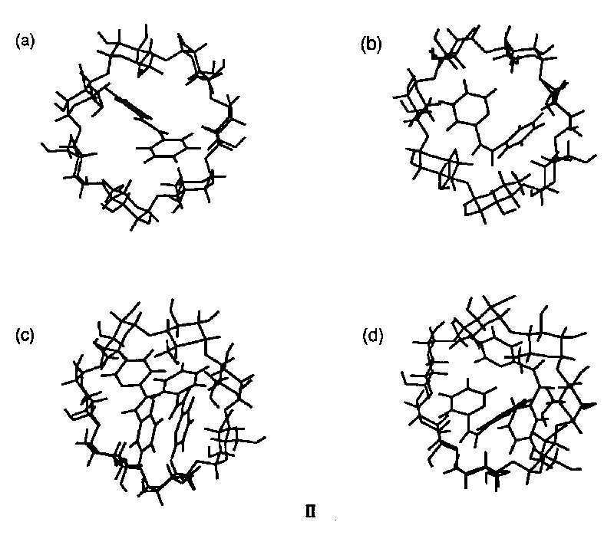

Fig. II (a) Inclusion of trans-2-SP in β-CD; (b) Inclusion of cis-2-SP in β-CD; (c) Inclusion of two molecules of trans-2-SP in β-CD and (d) Inclusion of two molecules of cis-2-SP in β-CD.
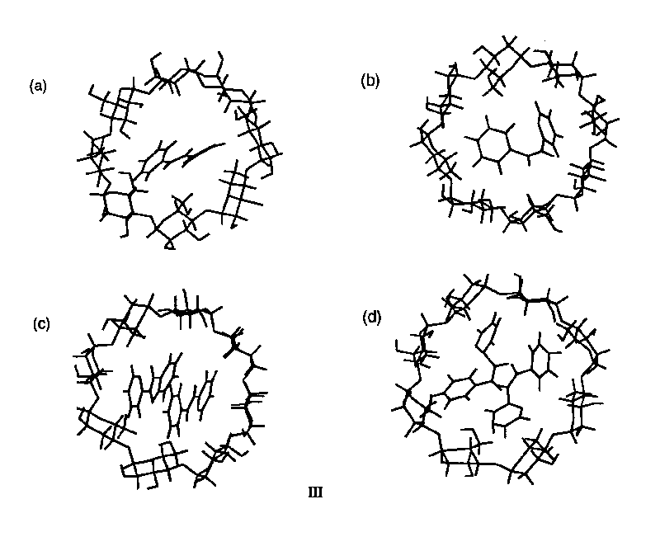

Fig. III (a) Inclusion of trans-2-SP in γ-CD; (b) Inclusion of cis-2-SP in γ-CD; (c) Inclusion of two molecules of trans-2-SP in γ-CD and (d) Inclusion of two molecules of cis-2-SP in γ-CD.

