Supplementary data

The first example of a substrate spanning the calix[4]arene bilayer: the solid state complex of p-sulfonatocalix[4]arene with l-lysine

Mohamed Selkti,ª Anthony W. Coleman,*^{b} Ioannis Nicolis,^{c} Nathalie Douteau-Guével,^{b} Françoise Villain,^{c} Alain Tomasª and Colette de Rango*ª

ª CNRS EP2075, Faculté de Pharmacie, Université Paris V, 75270 Paris Cedex 06, France
^{b} IBCP, CNRS UPR412, 7, Passage du Vercors, 69367 Lyon Cedex 07, France
^{c} Laboratoire de Physique, Centre Pharmaceutique, Université Paris-Sud, 92296 Châtenay-Malabry Cedex, France
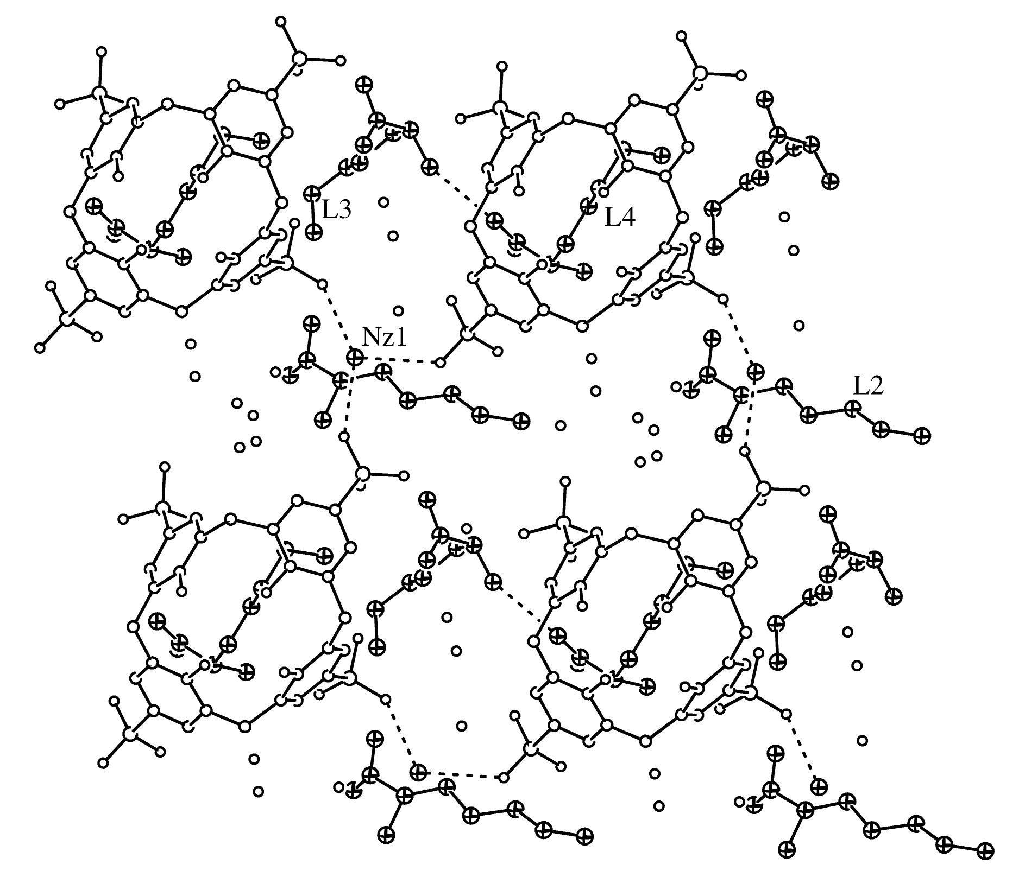
The arrangement of the three l-lysine molecules within the chiral layer, illustrating the packing of the dimers (L3 and L4) and of the monomers (L2), represented above the B calixarenes. The position of the ε-amino group of L1 (NZ1) also is shown; the contacts between NZ1 and the sulfonate groups of three B calixarenes are indicated in dashed lines.

