Supplementary Material: Colloid-catalysed arene hydrogenation in aqueous/supercritical fluid biphasic media

R. Jason Bonilla, Brian R. James, and Philip G. Jessop*

Experimental Details
[RhCl(COD)]₂ dimer (Pressure Chemical), ethane (Nellcor, 99.995% purity), CO₂ (Air Products, SFC grade without He head gas, 99.9999%), and H₂ (Praxair, 99.99%) were used without purification. 2-Methoxy-4-propylphenol^{S1} and [bmim]BF₄^{S2} were prepared as described in the literature, while the other arenes were commercially available. All liquids were degassed before use.
Under an inert atmosphere, 2-methoxy-4-propylphenol (170 mg), [RhCl(COD)]₂ (5 mg), THS (22 mg), aqueous buffer (pH 7.5, 1.5 mL) and magnetic stir bar were put inside a glass liner within a 31 mL vessel. The vessel was then sealed and placed in a water bath at 36°C. Immediately after H₂ (ca. 10 bar) was added, ethane was pumped into the vessel (240 bar total pressure) via a Jasco PU-980 pump. After 72 h, the vessel was placed in a dry ice/acetone bath to cool, and then vented and thawed slowly. A CDCl₃ solution of the organic products was filtered through diatomaceous earth and analysed by ¹H NMR spectroscopy. The spectral data have been published previously.^{S1} Experiments with liquid ethane, liquid CO₂ and scCO₂ were performed similarly.
The aqueous phase was a phosphate/boric acid/citric acid buffer with an initial pH of 7.5 (0.1 M Na₃PO₄), although under CO₂ pressure the pH drops significantly (line “c” in Figure 1). This pH drop could be ameliorated slightly by changing the buffer to a more concentrated phosphate buffer (line “a”) or to a 1 M MOPS buffer (3-[N-morpholino]propanesulfonic acid hemisodium salt, line "b") but there still was no significant catalytic activity.

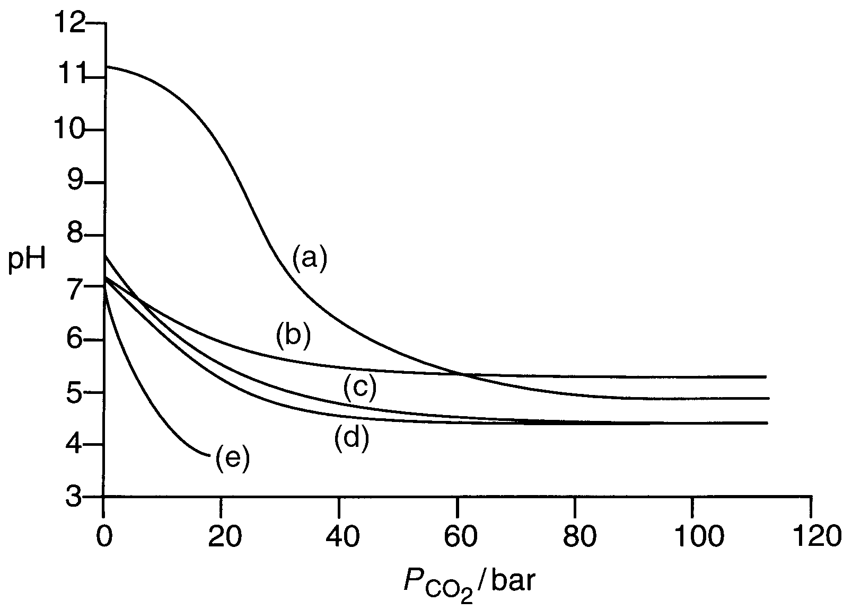

Fig. 1 Dependence of the pH of aqueous buffer solutions on the pressure of CO₂ at 36˚C in the presence of 9 bar H₂. The five buffer solutions are a) 11.2 buffer (0.5 M Na₃PO₄, 0.05 M citric acid, 0.2 M boric acid), b) concentrated MOPS buffer (1.0 M), c) 7.5 buffer (0.1 M Na₃PO₄, 0.05 M citric acid, 0.2 M boric acid), d) dilute MOPS buffer (0.1 M), and e) unbuffered water. The pH values, which are only approximate (estimated error ±0.3), were determined by visual observations of the buffer solutions, doped with various indicators, in a vessel with sapphire windows. The pH of unbuffered water at elevated pressures of CO₂ is 2.80-2.95.^{S3}

S1 T. Q. Hu, B. R. James, S. J. Rettig, and C.-L. Lee, Can. J. Chem., 1997, 75, 1234-1239.
S2 J. G. Huddleston, H. D. Willauer, R. P. Swatloski, A. E. Visser, and R. D. Rogers, Chem. Commun., 1998, 1765-1766.
S3 K. L. Toews, R. M. Shroll, C. M. Wai, and N. G. Smart, Anal. Chem., 1995, 67, 4040-4043.

