Characterisation of a triply thiolate-bridged Ni-Fe amine-thiolate complex: insights into the electronic structure of the active site of [NiFe] hydrogenase
Gunther Steinfeld and Berthold Kersting*
Institut für Anorganische und Analytische Chemie, Universität Freiburg, Albertstr. 21, D−79104 Freiburg, Germany. E-mail: kerstber@sun2.ruf.uni-freiburg.de

Supporting Information

Contents: Figures S1 - S4
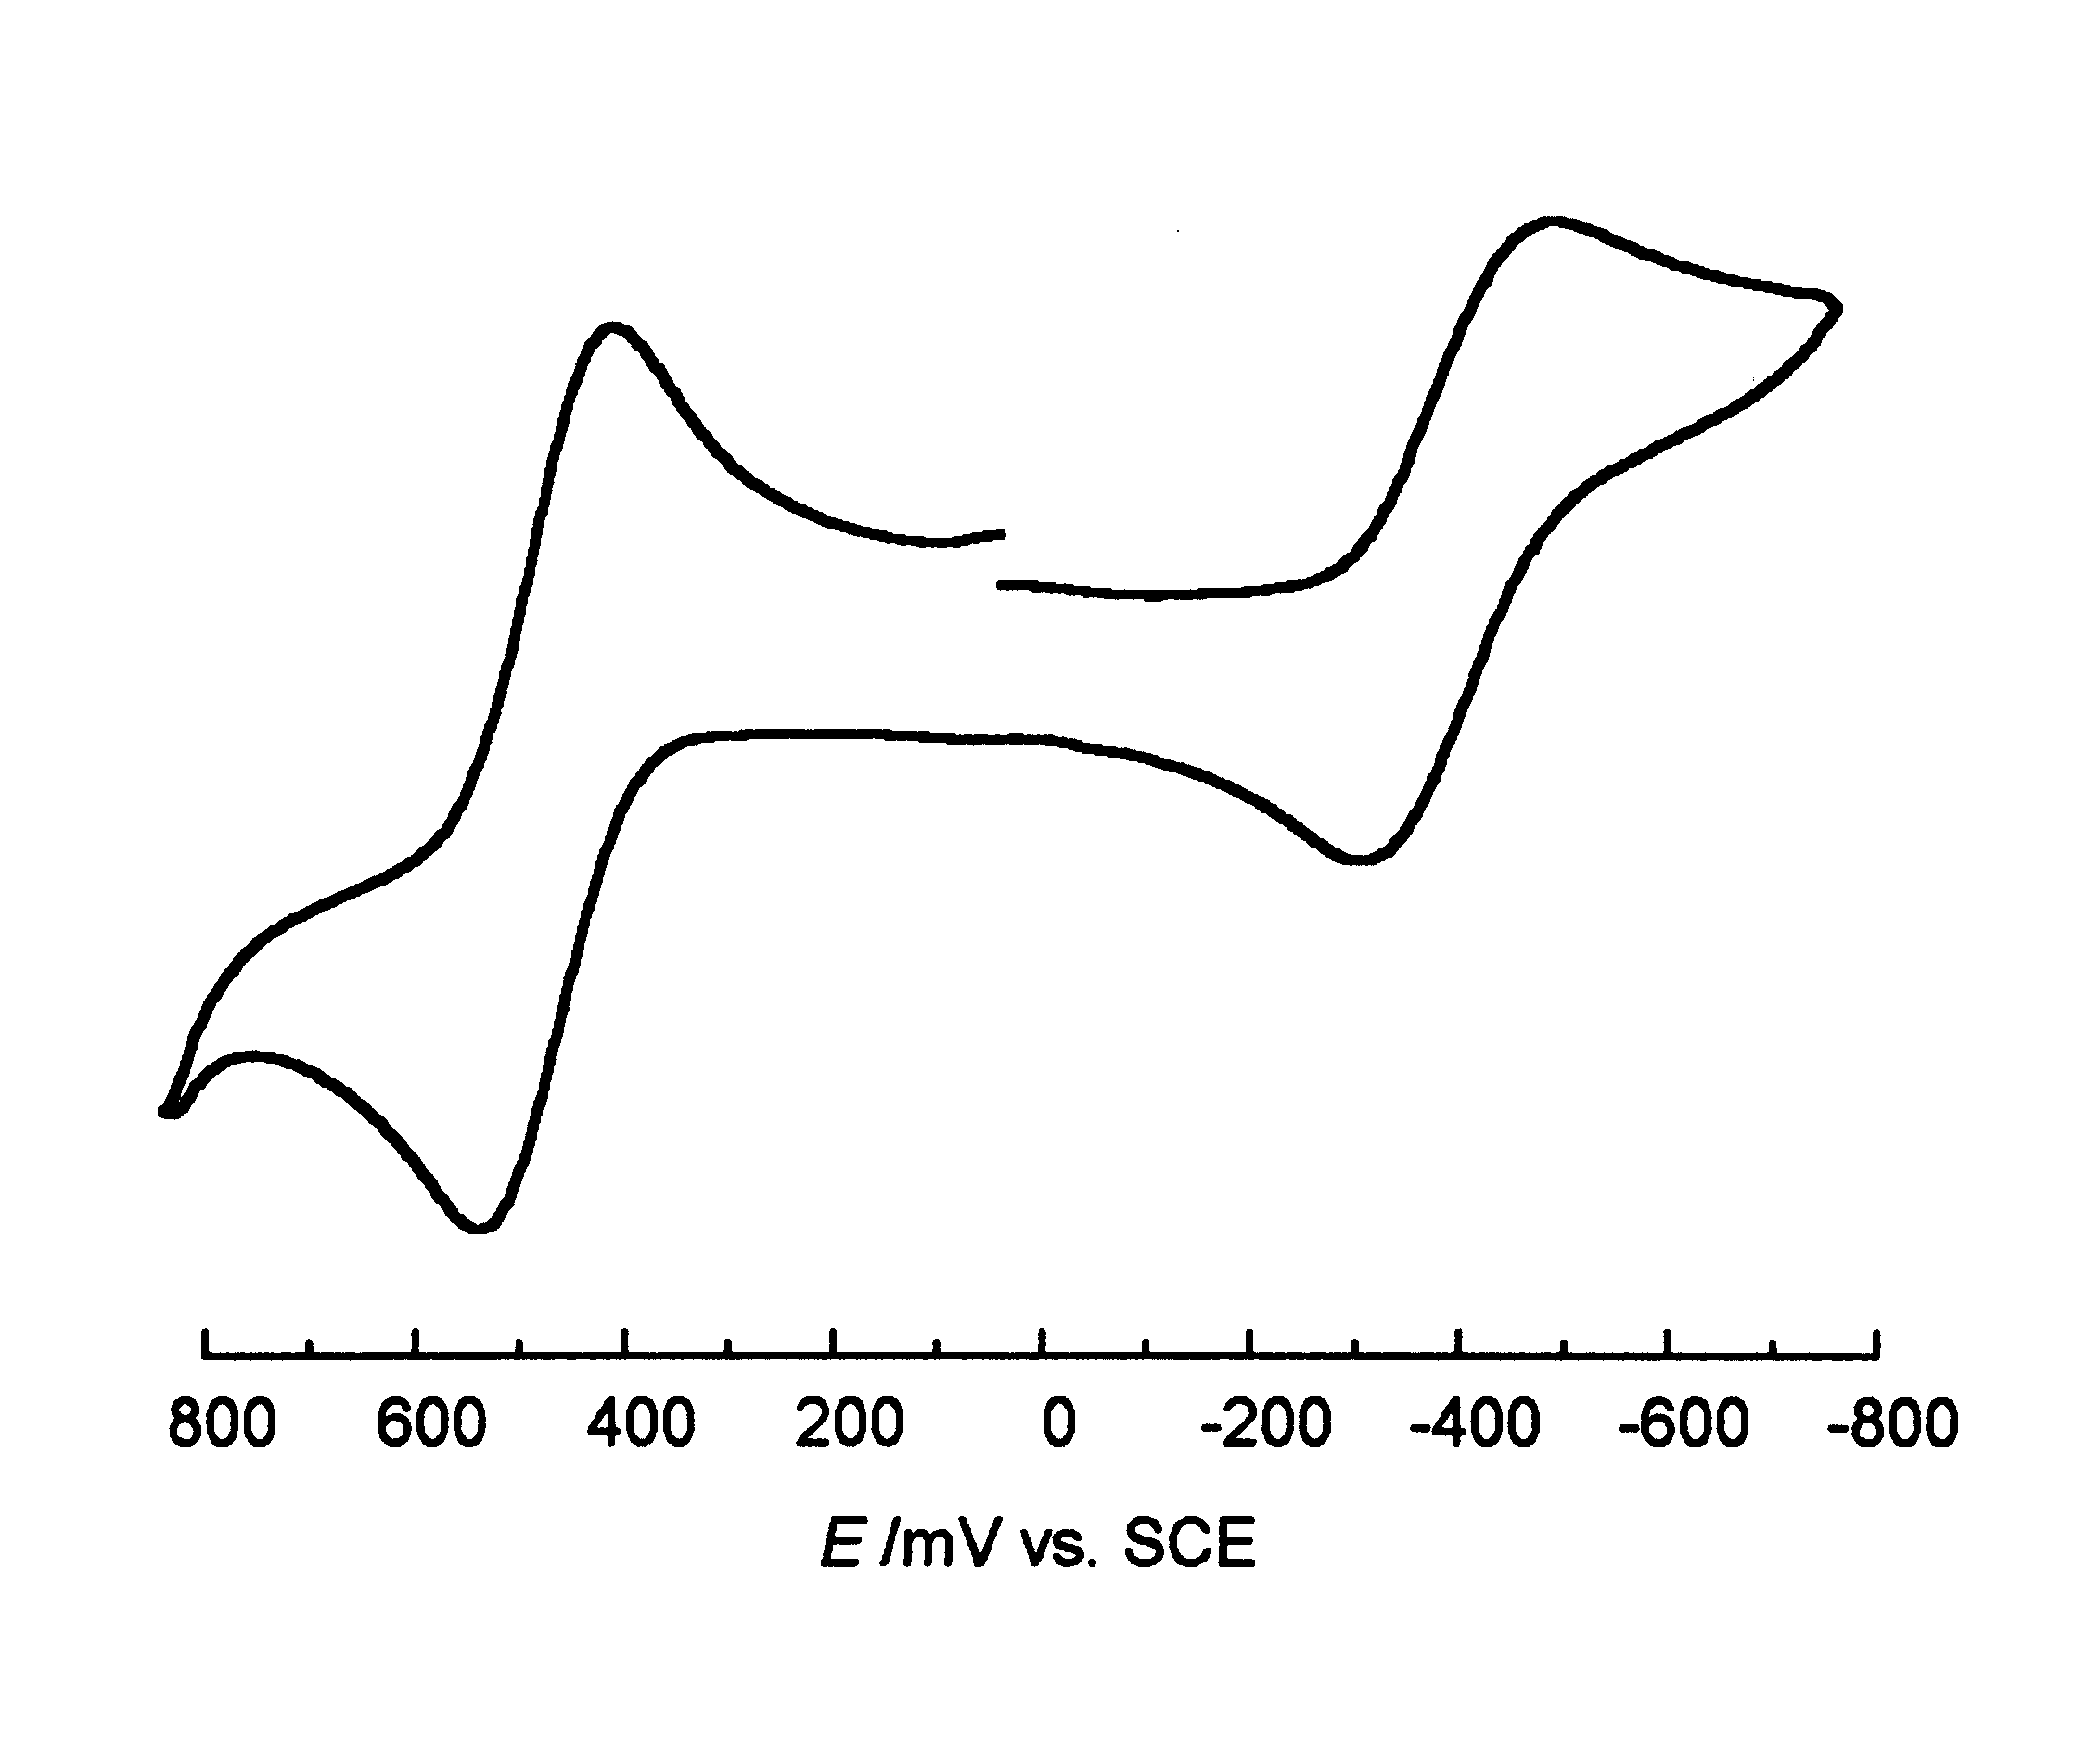
Fig. S1 Cyclic voltammogram of [NiFe(L)][BPh₄]₂ in DMF at 295 K. Experimental conditions: 0.1 M [Bu₄^{n}N][PF₆], ca. 1 × 10⁻³ M sample concentration, Pt disk working electrode, Ag wire reference electrode, scan rate = 100 mV⋅s⁻¹ (under our conditions, E_{1/2} (Fe(Cp)₂⁺/Fe(Cp)₂) is at +0.45 V vs Ag).
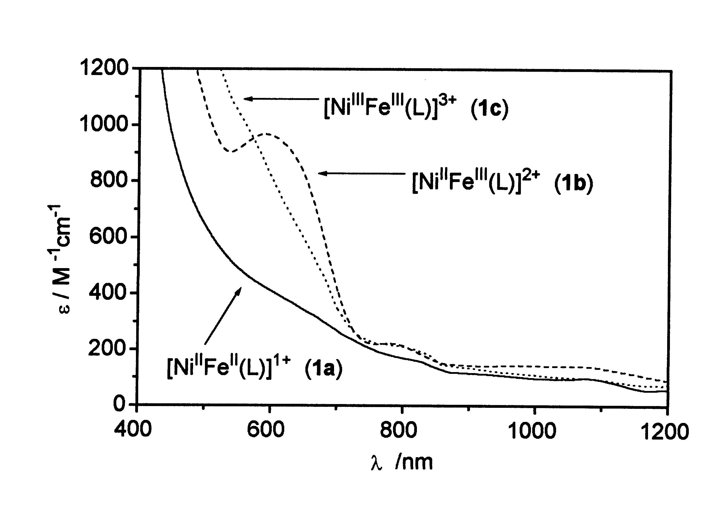
Fig. S2 Electronic absorption spectra of [Ni^{II}Fe^{II}(L)]¹⁺ (1a, solid line), [Ni^{II}Fe^{III}(L)]²⁺ (1b, dashed line) and [Ni^{III}Fe^{III}(L)]³⁺ (1c, dotted line) in DMF at 298 K (concentrations = 4.0 × 10⁻⁴ M). Compound 1a was prepared by chemical reduction (NaBH₄) of 1b, compound 1c by oxidation (Br₂) of 1b. λ_{max} (nm) (ε (M^{–1}cm^{–1})): (1a) 668sh (318), 928 (110), 1076 (100); (1b) 590 (967), 782 (222), 973 (144), 1054 (141); (1c) 579sh (963), 648sh (615), 794 (213). Similar spectra were obtained for electrochemically generated species.

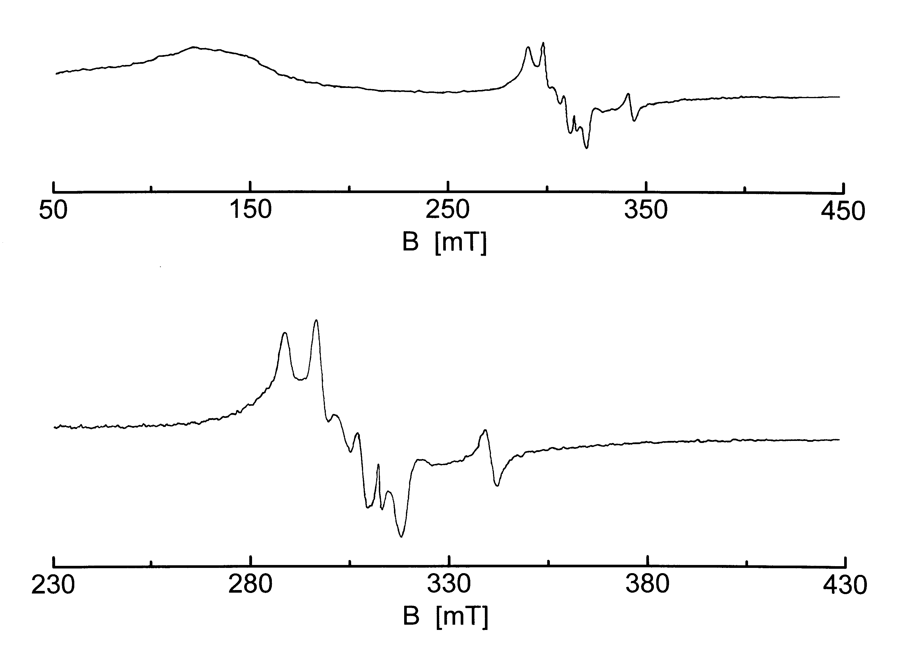
Fig. S3 EPR powder spectrum of [Ni^{II}Fe^{III}(L)][BPh₄]₂ (1b) at 77 K (a) in the range 50 - 450 mT and (b) 230 - 450 mT. Experimental conditions: microwave frequency, ν = 9.02 GHz; microwave power, 2 mW; modulation frequency, 100 kHz; modulation amplitude, 4 G.
Fig. S4 Zero-field ⁵⁷Fe Mössbauer spectrum of [NiFe(L)][BPh₄]₂ (1b) at 298 K.

