Supplementary data

A molecular colour sensor for monosaccharides

Christopher J Ward,ª Prakash Patel,^{b} Peter R Ashtonª and Tony D James*ª

ª The University of Birmingham, School of Chemistry, Edgbaston, Birmingham, UK B15 2TT. E-mail: tdjames@chemistry.bham.ac.uk
^{b} AVECIA Limited, Hexagon House, PO Box 42, Blackley Manchester, UK M9 8ZS

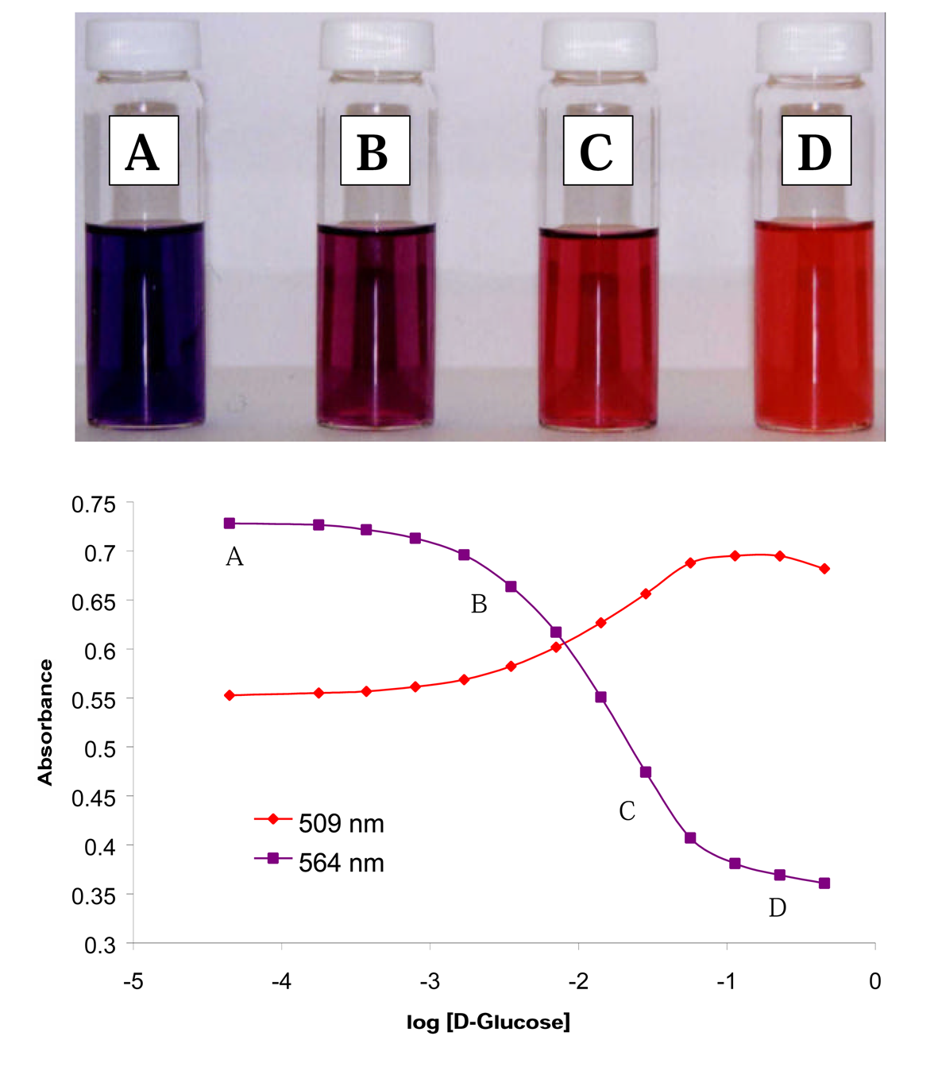

Fig. S1 (Top) Colour changes upon addition of d-glucose to dye molecule 2 (5.66 × 10^{–5} mol dm^{–3}) in a 0.05 mol dm^{–3} NaCl MeOH–H₂O (1:2) buffer: (A) with no saccharide, (B) with 0.339 × 10^{–2} mol dm^{–3} d-glucose, (C) with 1.66 × 10^{–2} mol dm^{–3} d-glucose and (D) with 22.7 × 10^{–2} mol dm^{–3} d-glucose. (Bottom) Plot of absorption vs. log concentration of d-glucose for dye molecule 2 at pH 11.32.

