Supplementary data

Hydrolysis of an N-methylcarbamate by a catalytic antibody
A. Nicole Dinaut,ª Mei-Jin Chen,ª Alex Marks,^{b} Robert A. Bateyª and Scott D. Taylor*^{ac}
ª Department of Chemistry, University of Toronto, 3359 Mississauga Rd. North, Mississauga, Ontario, Canada, L5L 1C6.
^{b} Banting and Best Department of Medical Research, University of Toronto, 112 College Street, Toronto, Ontario, Canada, M5G 1L6
^{c} Current address: Department of Chemistry, University of Waterloo, 200 University Avenue West, Waterloo, Ontario, Canada, N2L 3G1

Synthesis of 4
Scheme 1 Reagents and conditions: (a) p-nitrophenylchloroformate (1.0 equiv), Et₃N (1.25 equiv), THF, 5 h; (b) dimedone (1.7 equiv), Pd(PPh₃)₄ (10 mol%), CH₃CN, 4 days.

Compound 4 ¹H NMR (200 MHz, CDCl₃) δ 8.23 (d, 2H, J 8.80 Hz, ArH ortho to NO₂), 7.26 (bs, 6H, ArH), 3.41 (s, 3H, NCH₃), 3.02 (t, 2H, J 7.25 Hz, ArCH₂C), 2.74 (t, 2H, J 7.40 Hz, ArCCH₂); ¹³C NMR (50 MHz, CDCl₃) δ: 177.5 (d, J = 4.60 Hz), 156.3, 152.7, 145.08, 140.8, 139.4, 129.1, 125.9, 124.9, 122.0, 38.4, 35.1, 30.1.; EIMS: 206 (M⁺ - O₂NC₆H₄O, 100.0%), 344 (M⁺, 7.2%). HREIMS calcd for C₁₇H₁₆N₂O₆ 344.1008, found 344.1008.
Synthesis of hapten 5
Scheme 2 Reagents and conditions: (a) 30 psi H₂, 5% Pd/C, DMF, 18 h; (b) aq. (n-Bu)₄N⁺OH⁻ (1 equiv); (c) allyl chloride, DMF, rt, 6 h; (d) di-t-butyl dicarbonate (1.1 equiv), THF, rt, 26 h; (e) NaH (1.05 equiv), THF, 1 h, followed by iodomethane (1.1 equiv), 40 ºC, 24 h; (f) 25% TFA in CH₂Cl₂, rt, 2.5 h; (g) 2.2 equiv DIPEA, Et₂O, -78 ºC, 10 minutes; (h) p-nitrophenol (1.02 equiv), Et₂O, -78 ºC, 4 h followed by the addition of the N-methyl aniline derivative (1.02 equiv), Et₂O, -78 ºC, 4 h; (i) m-CPBA (1.7 equiv), CH₂Cl₂, -40 ºC-rt, 2h; (j) LiBr (1 equiv), butanone, reflux, 5 h; (k) LiOH monohydrate (1.0 equiv), THF/H₂O, rt, 4 h; (l) N-hydroxysulfosuccinimide (1.1 equiv), EDC (1.1 equiv), DMF (60% in water), rt, 3 h, followed by the slow addition of the crude succinimide ester to phosphate buffer (50 mM, pH 7.45) containing BSA or KLH. This solution was shaken gently for 12 h at 4°C.

Compound 5 ¹H NMR (200 MHz, CD₃OD) δ 8.14 (d, 2H, J 9.2 Hz, ArH ortho to NO₂), 7.29 (d, 2H, J 9.2 Hz, ArH meta to NO₂), 7.08-7.22 (m, 4H, ArH), 3.14 (d, 3H, J 8.4 Hz, NCH₃), 2.83 (t, 2H, J 7.4 Hz, ArCH₂C), 2.41 (t, 2H, J 7.4 Hz, ArCCH₂); ³¹P NMR (81 MHz, D₂O) δ −0.25; ¹³C NMR (126 MHz, D₂O) δ 183.6, 158.9, 144.6, 144.1, 137.6, 129.6, 126.7, 123.3, 121.3, 40.3, 37.8, 32.3; FAB⁻-MS: 379(M - 2Li⁺, 54%), 380 (M - 2Li⁺ + 1, 12%).

Synthesis of amide 6 and ester 7
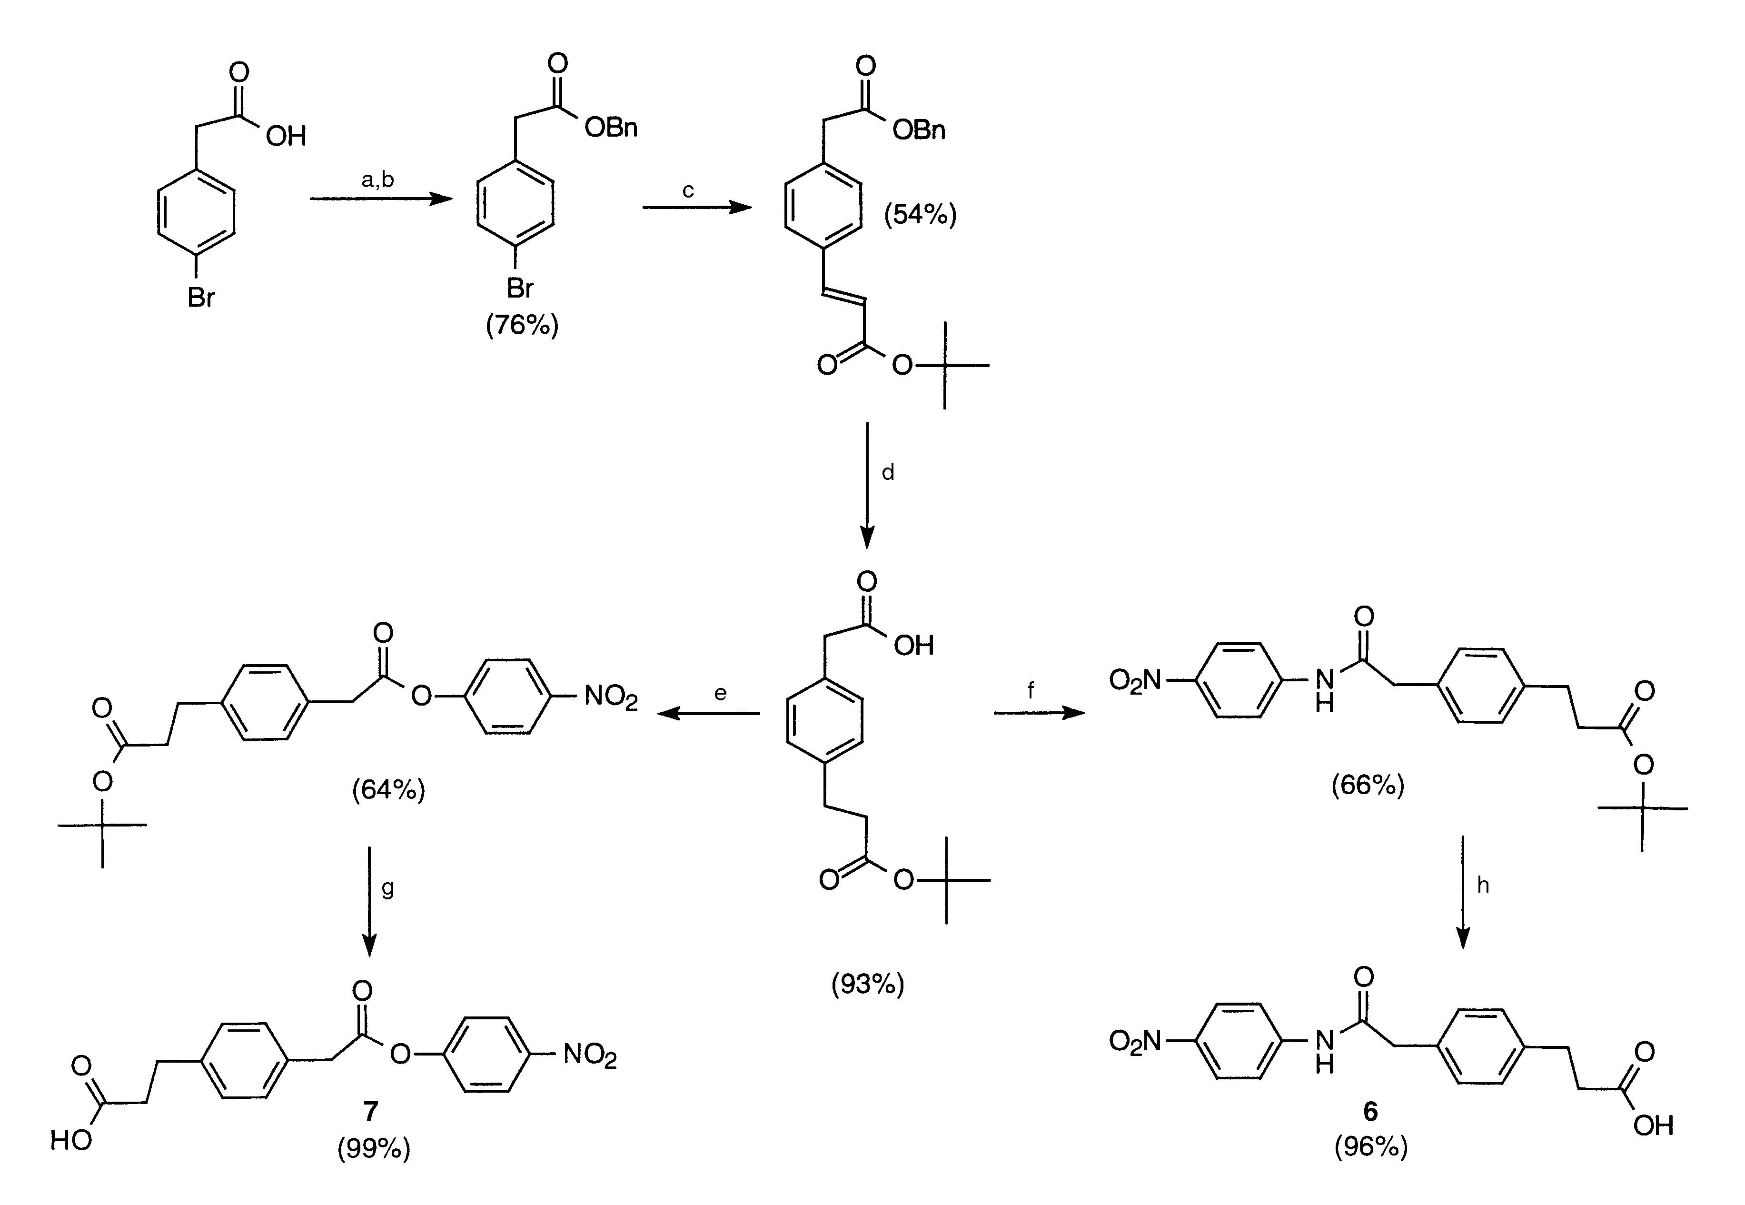
Scheme 3 Reagents and Conditions: (a) aq. (n-Bu)₄N⁺OH⁻ (1 equiv); (b) benzyl bromide, DMF, rt, 12 h; (c) t-butyl acrylate (2 equiv), NEt₃ (5.8 equiv), (Ph₃P)₂PdCl₂ (0.0754 equiv), DMF, 75°C, 12 h; (d) 30 psi H₂, 5% Pd/C, EtOH, 24 h; (e) DCC (1.3 equiv), HOBt (1.3 equiv), p-nitrophenol (1.3 equiv), CH₂Cl₂, rt, 12 h; (f) DIPC (1 equiv), p-nitroaniline (1.3 equiv), THF, rt, 12 h; (g) 30 % TFA in CH₂Cl₂, rt, 2 h; (h) 30 % TFA in CH₂Cl₂, rt, 2 h.

Compound 6 ¹H NMR (200 MHz, (CD₃)₂CO) δ 9.86 (s, 1H, NH), 8.19 (d, 2H, J 9.2 Hz, ArH ortho to NO₂), 7.89 (d, 2H, J 9.2 Hz, ArH meta to NO₂), 7.06-7.31 (m, 4H, ArH), 3.72 (s, 2H, C(O)CH₂Ar), 2.88 (t, 2H, J 7.4 Hz, ArCH₂C), 2.59 (t, 2H, J 7.4 Hz, ArCCH₂); ¹³C NMR (75 MHz, (CD₃)₂SO) δ 183.1, 179.9, 154.8, 151.6, 148.8, 142.4, 138.6, 137.7, 134.5, 128.2, 52.4, 44.7, 39.4; EIMS: 163 (M⁺ - C(O)NHArNO₂, 100%), 328 (M⁺, 31%). HREIMS calcd for 328.1059, found 328.1058.
Compound 7 ¹H NMR (200 MHz, (CD₃)₂CO) δ 8.30 (d, 2H, J 9.2 Hz, ArH ortho to NO₂), 7.25-7.45 (m, 6H, ArH), 3.97 (s, 2H, C(O)CH₂Ar), 2.92 (t, 2H, J 7.7 Hz, ArCH₂C), 2.60 (t, 2H, J 7.9 Hz, ArCCH₂); ¹³C NMR (125 MHz, (CD₃)₂SO) δ 174.06, 170.09, 156.65, 146.24, 140.99, 132.10, 130.34, 129.38, 125.86, 123.65, 40.85, 35.73, 31.05; EIMS: 163(M⁺ - C(O)NHArNO₂, 100%), 329 (M⁺, trace). HREIMS calcd for 329.0899, found 329.0909.

Antibody Production

Hybridoma cell lines were grown in RPMI (Sigma) which was supplemented with 15% fetal calf serum (Sigma) at 37 ºC in an atmosphere of 5 % CO₂. The desired cell lines were cloned by limiting dilution. Mabs were isolated from ascitic fluid and purified by affinity chromatography on a protein A-agarose column (Pierce). The purified antibody samples were then concentrated and dialyzed against bicine buffer (100 mM bicine, 100 mM NaCl, 0.01% NaN₃, pH 9). These antibody samples were >95% pure by SDS-PAGE analysis.

Fab Preparation

ST51 mAb was dialyzed extensively against a 20 mM phosphate/10 mM EDTA buffer at pH 7. This solution was concentrated and was subjected to papain digestion (Pierce Immunopure® Fab Preparation Kit) for 12 h at 37°C. The Fab fragments were purified by application of the digested mAb to a Protein A-agarose column (Pierce). The solution containing the Fab fragments was concentrated and dialyzed against Bicine buffer (100 mM Bicine, 100 mM NaCl, 0.01% NaN₃, pH 9). The ST51 Fab was >95% pure by SDS-PAGE analysis.

Antibody Kinetics

A 12.5 μL aliquot of a stock solution of substrate 4 (3 mM – 40 mM) in DMSO was added to buffer (100 mM bicine, 100 mM NaCl, 0.01% NaN₃, pH 9.0) and the solution was mixed well. A solution of ST51 in buffer system (100 mM bicine, 100 mM NaCl, 0.01% NaN₃, pH 9.0) was added, so that the final volume was 250 μL and the final concentration of antibody was 5 μM, the final concentration of DMSO was 5% and the final concentration of 4 ranged from 0.150 mM – 2 mM. The solution was mixed gently and was maintained at 25°C in a water bath. At various time intervals, 40 μL of the reaction mixture was withdrawn. To this was added 10 μL of 5/95 DMSO/buffer mix, 10 μL of 70 μM p-nitroaniline (internal standard, final concentration was 11.0 μM) in 5/95 DMSO/buffer mix, and 3.5 μL of concentrated perchloric acid (to quench the reaction). This solution was mixed well and the concentration of p-nitrophenol in the solution was determined by reverse-phase HPLC (Waters 600 Controller, Waters 2487 Dual λ detector set to λ_{det} = 325 nm, Vydac 218TP54 reverse phase analytical column, mobile phase: 20/80 CH₃CN/H₂O containing 0.1% TFA, flowrate: 1 mL/min). The concentration of p-nitrophenol in the original reaction mixture was then calculated from a previously prepared standard curve of the peak area ratio of p-nitrophenol to p-nitroaniline vs. [p-nitrophenol]/[p-nitroaniline] (linear plot). The reactions were followed to approximately 6% completion and plots of the concentration of p-nitrophenol over time exhibited excellent linearity. The initial velocities of the reactions at the various substrate concentrations were determined by taking the slopes of these plots. This procedure was repeated in duplicate for each substrate concentration. Control reactions using the identical procedure but in the absence of antibody showed no breakdown of product over the time period of these reactions. Studies carried out at pH 10.0 (50 mM CHES) were performed in an identical manner.
Fig. 1 Lineweaver-Burke plot of the hydrolysis of substrate 4 in the presence of antibody ST51, pH 9.0, 100 mM bicine, 100 mM NaCl, 0.01% NaN₃.

Fig. 2 Lineweaver-Burk plot of the hydrolysis of substrate 4 in the presence of antibody ST51, pH 10.0, 50 mM CHES, 100 mM NaCl, 0.01% NaN₃.

