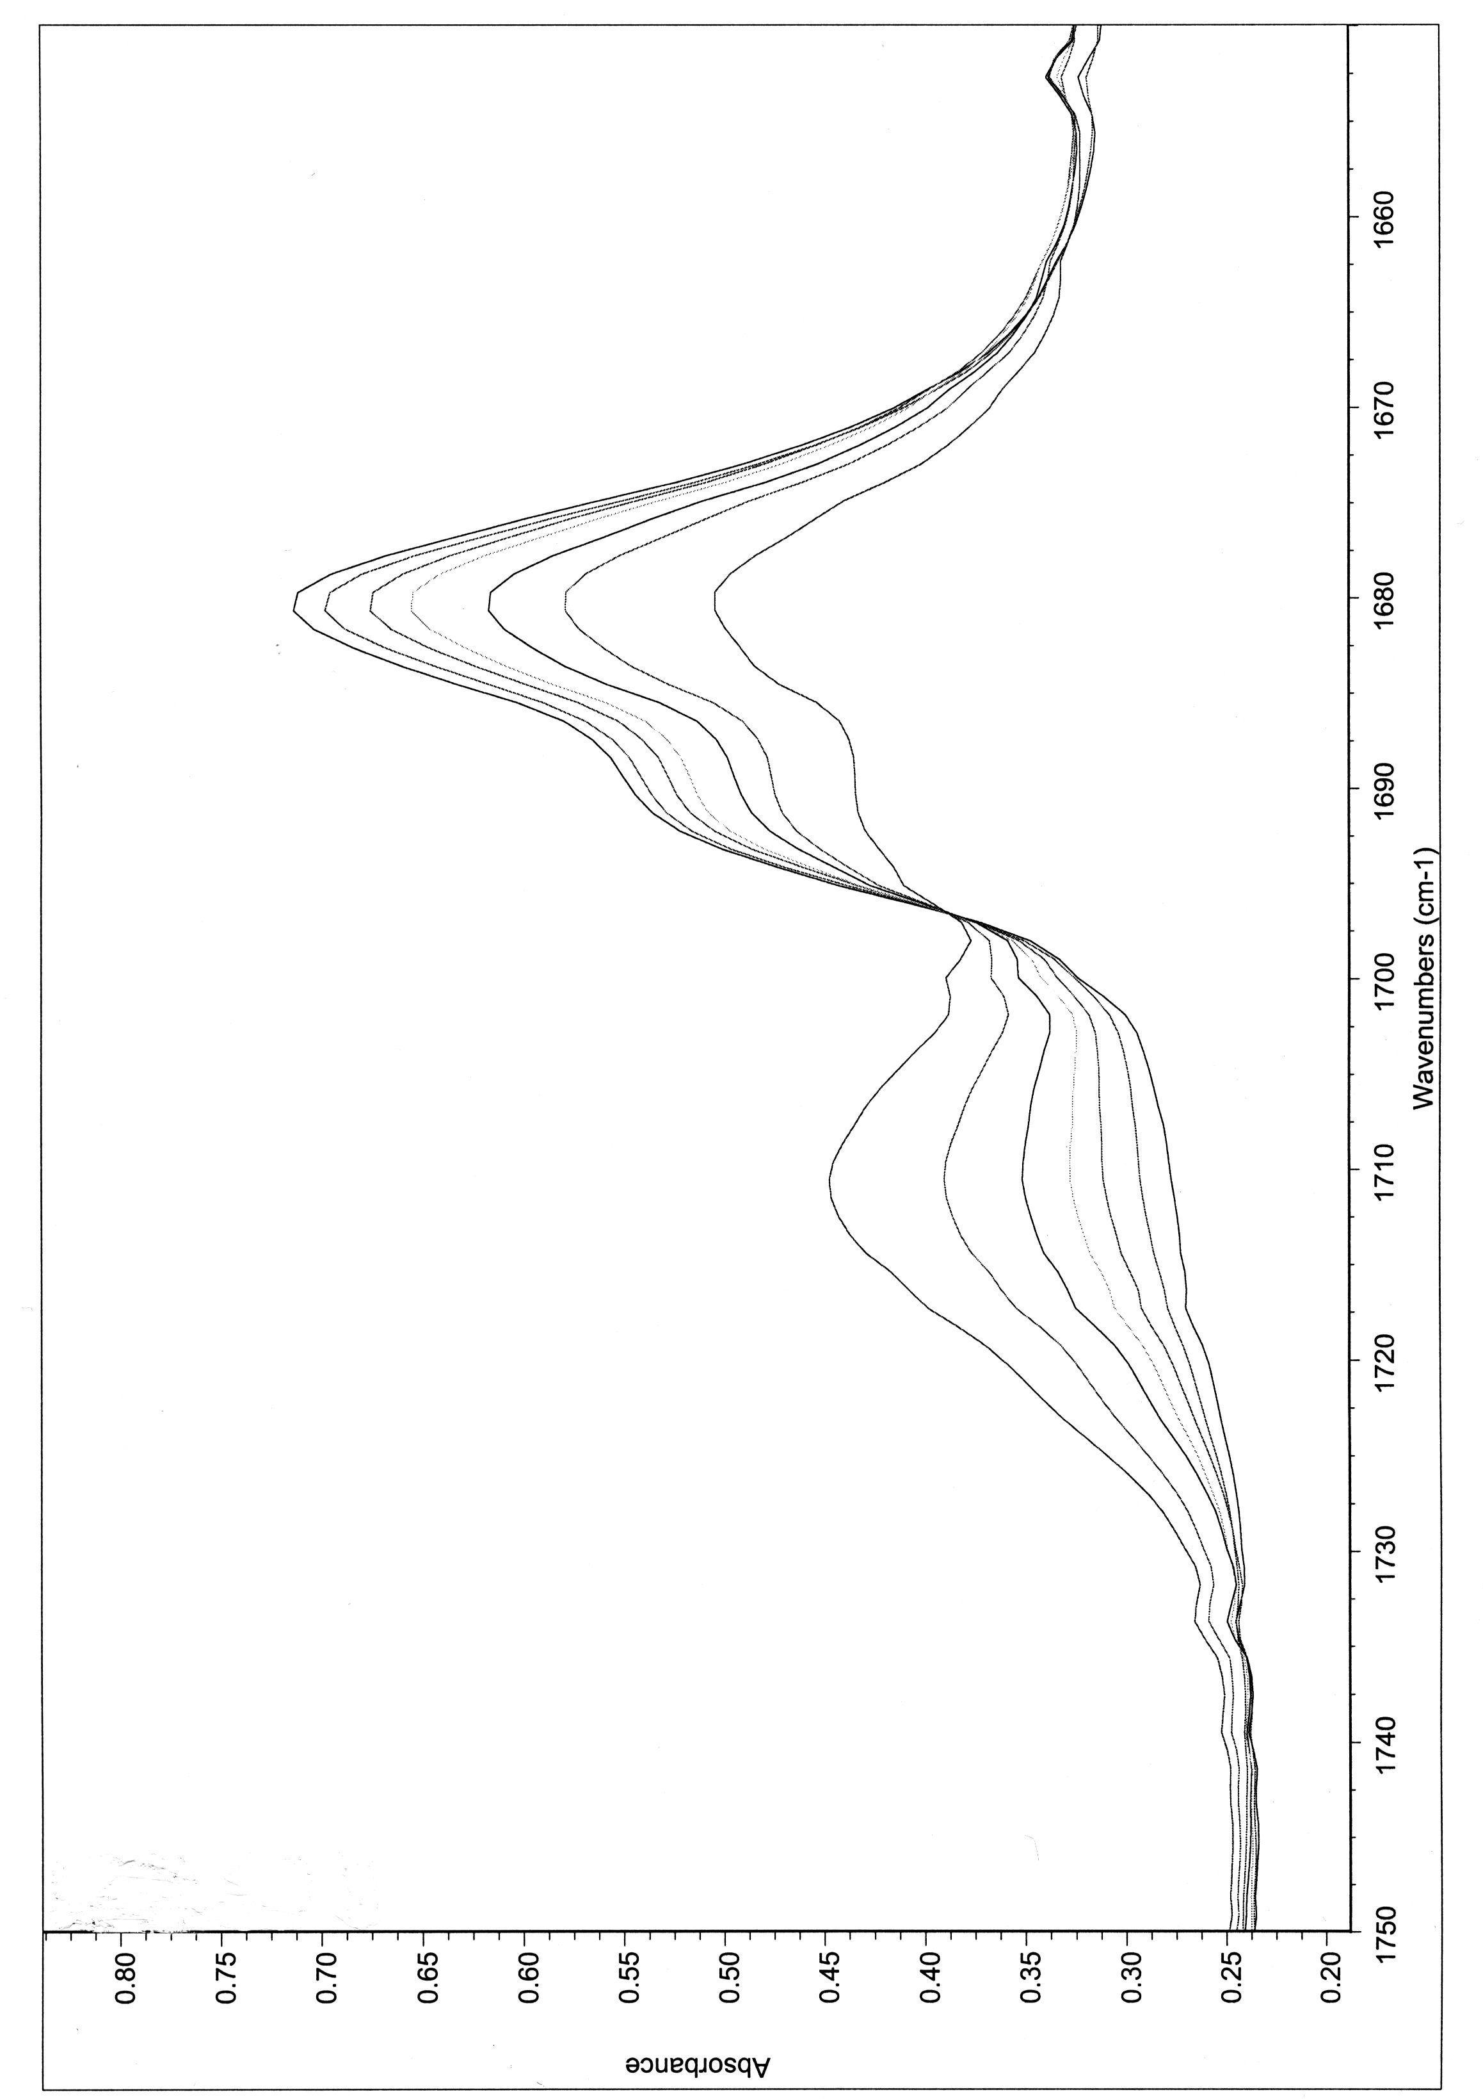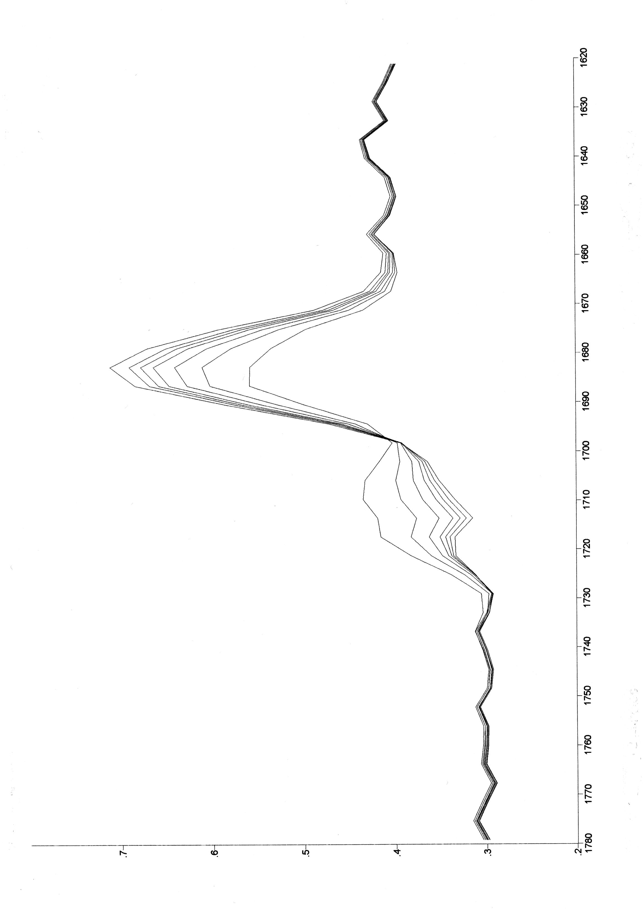

Figure C: Dehydrogenation of (R)-2- hexanol (left) and (S)- 2- hexanol (right) using ligand 1 and acetophenon.

