Supporting Information

EIMS spectra and NMR assignments of products 11-16 inferred from H-H COSY 45, HOHAHA, NOESY, DEPT, HMQC and HMBC are included. The EIMS and NMR spectra were measured with a JEOL SX102 (operated at 70 eV) and with a Bruker DMX 600 spectroscopy, respectively.

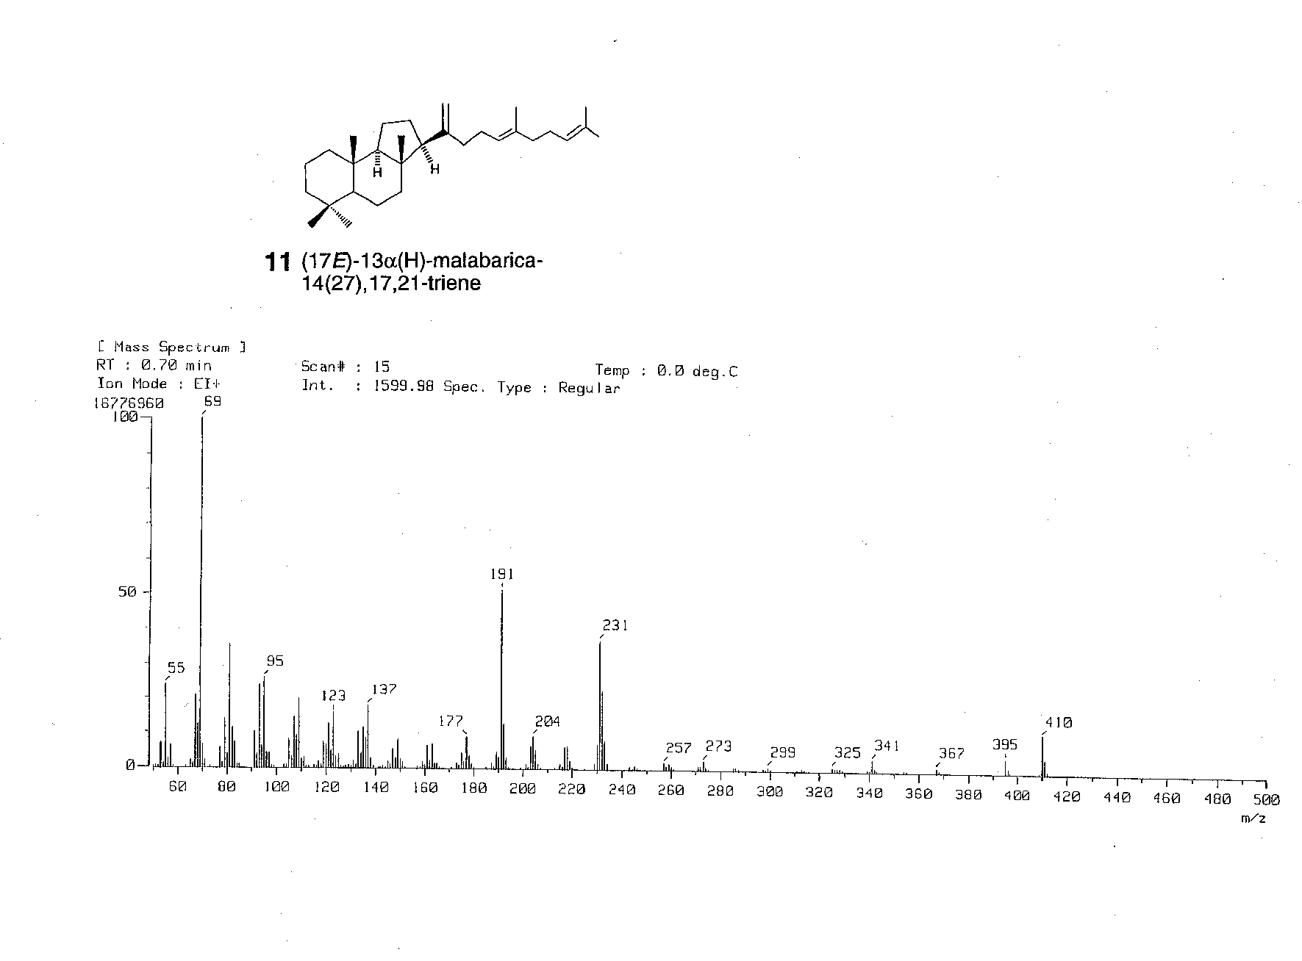
Compound 11

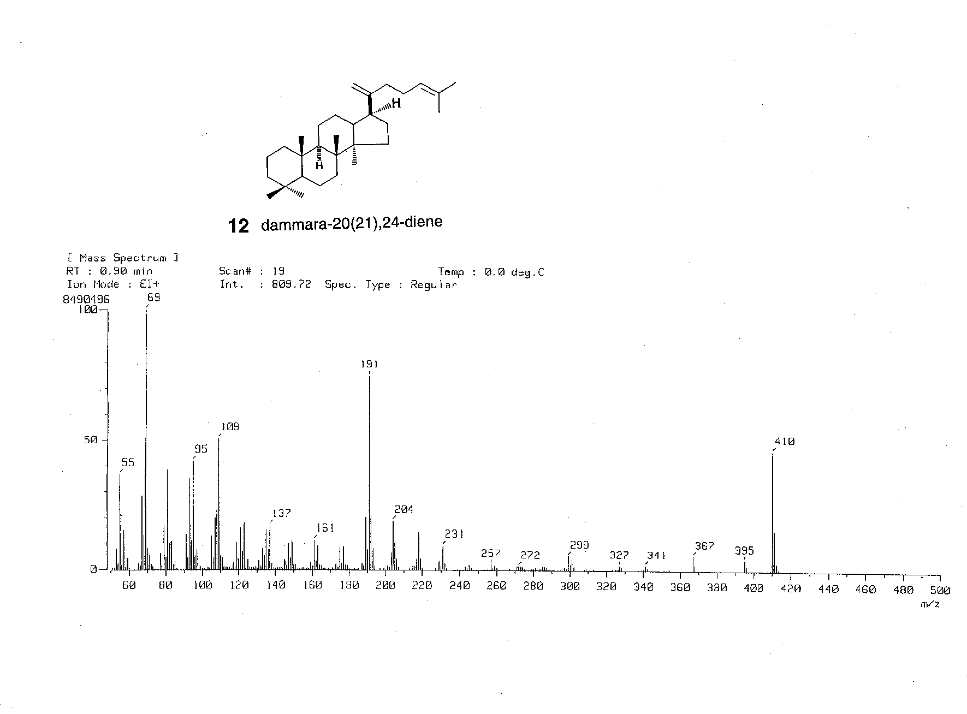
Compound 12

Compound 13

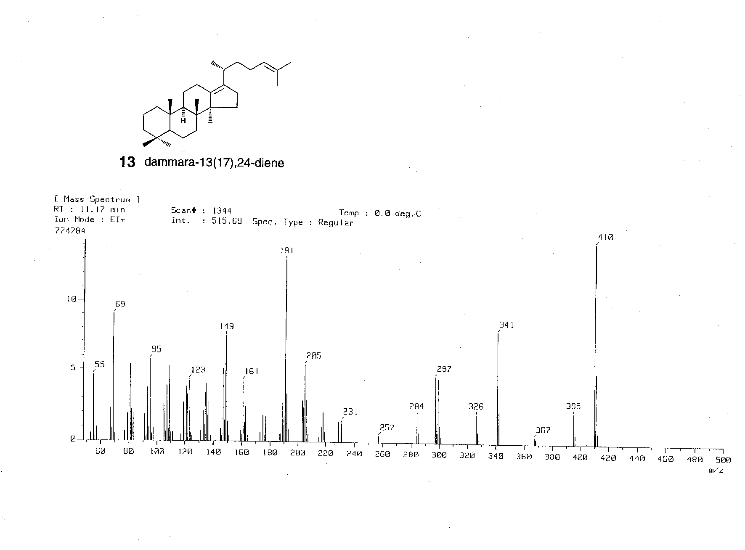

Compound 14

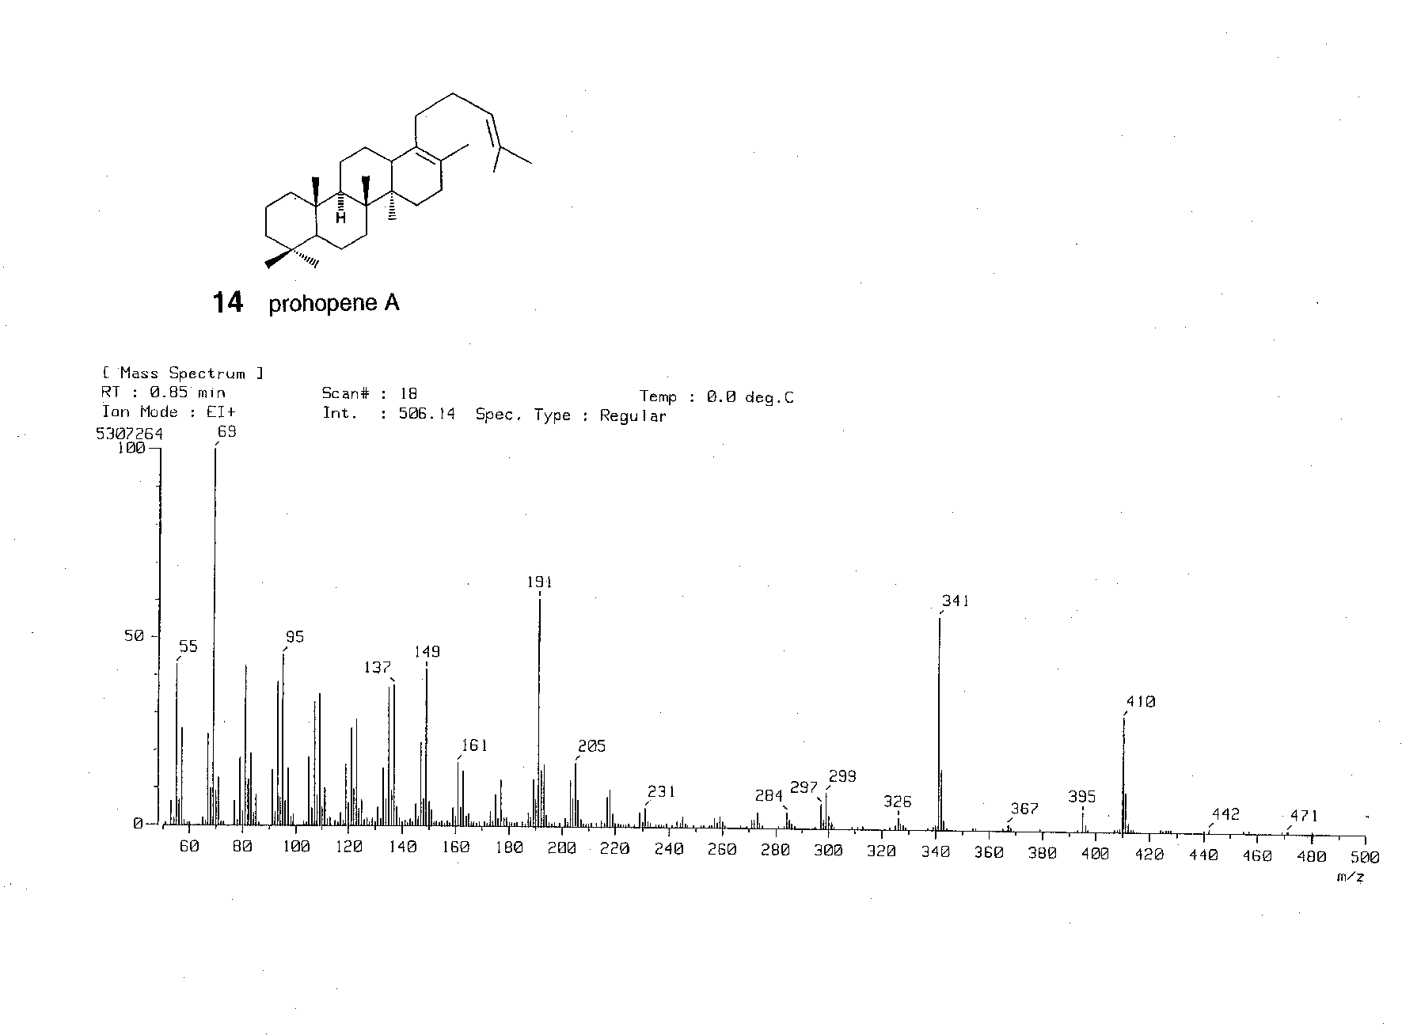

Compound 15

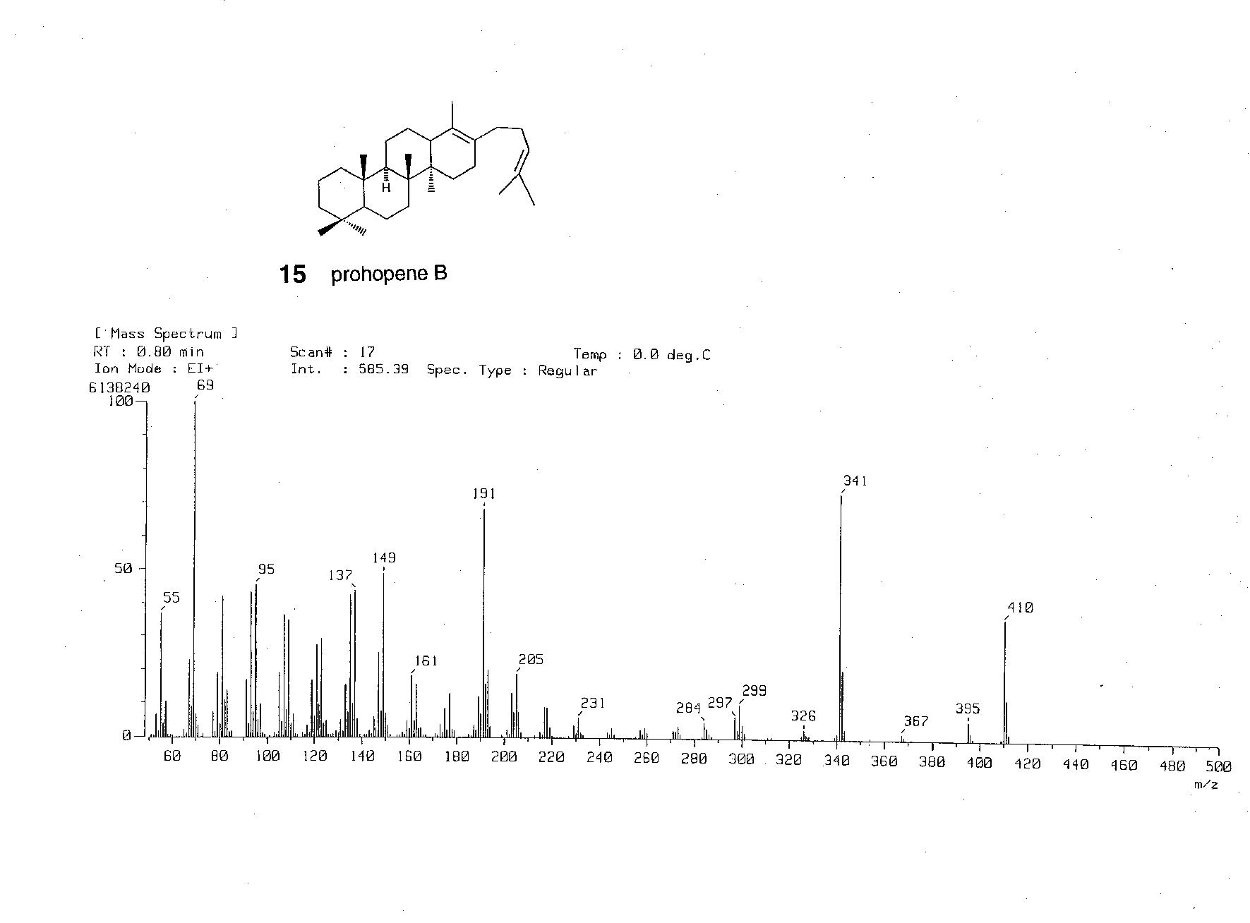

Compound 16

