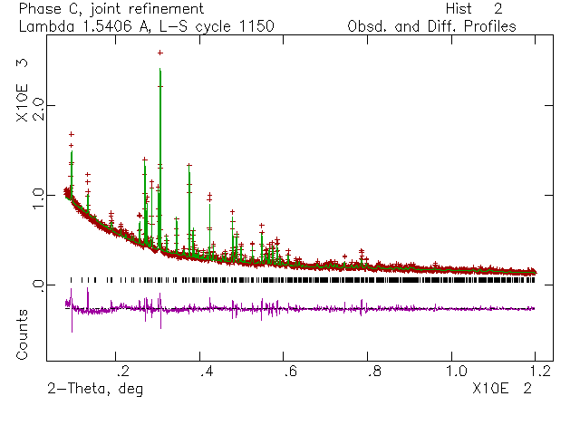
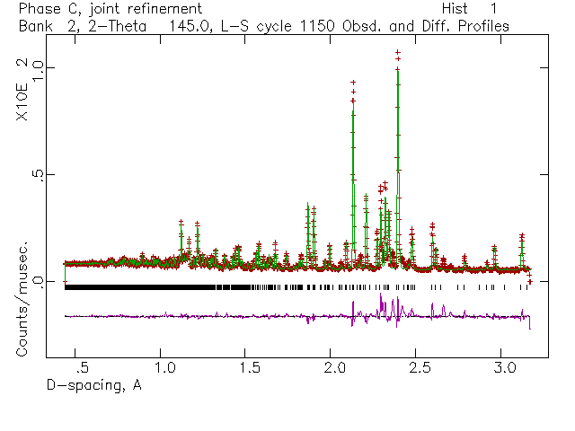
Figure One: Observed, Calculated and Difference Profiles from Refinement of XRD and ND Data of La₂₄Ti₆Li₁₈O_{56.}

