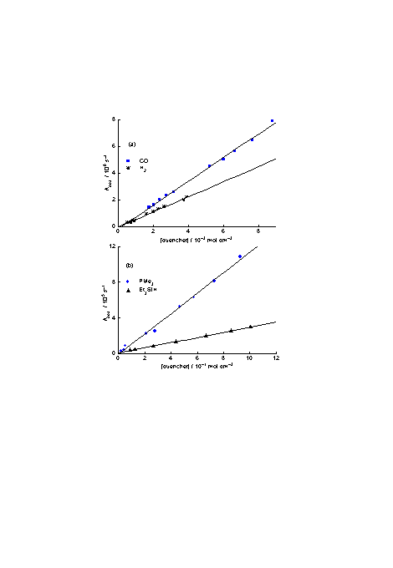
Fig. S1 Plots of the pseudo-first order rate constants vs concentration of quencher measured from decay of transient in laser flash photolysis experiments. (a) Quencher = CO, H₂. (b) Quencher = PMe₃, Et₃SiH.

