Supplementary Information
Meso–meso-linked porphyrin dimer as a novel scaffold for the selective binding of oligosaccharides

Masato Ikeda, Seiji Shinkai* and Atsuhiro Osuka

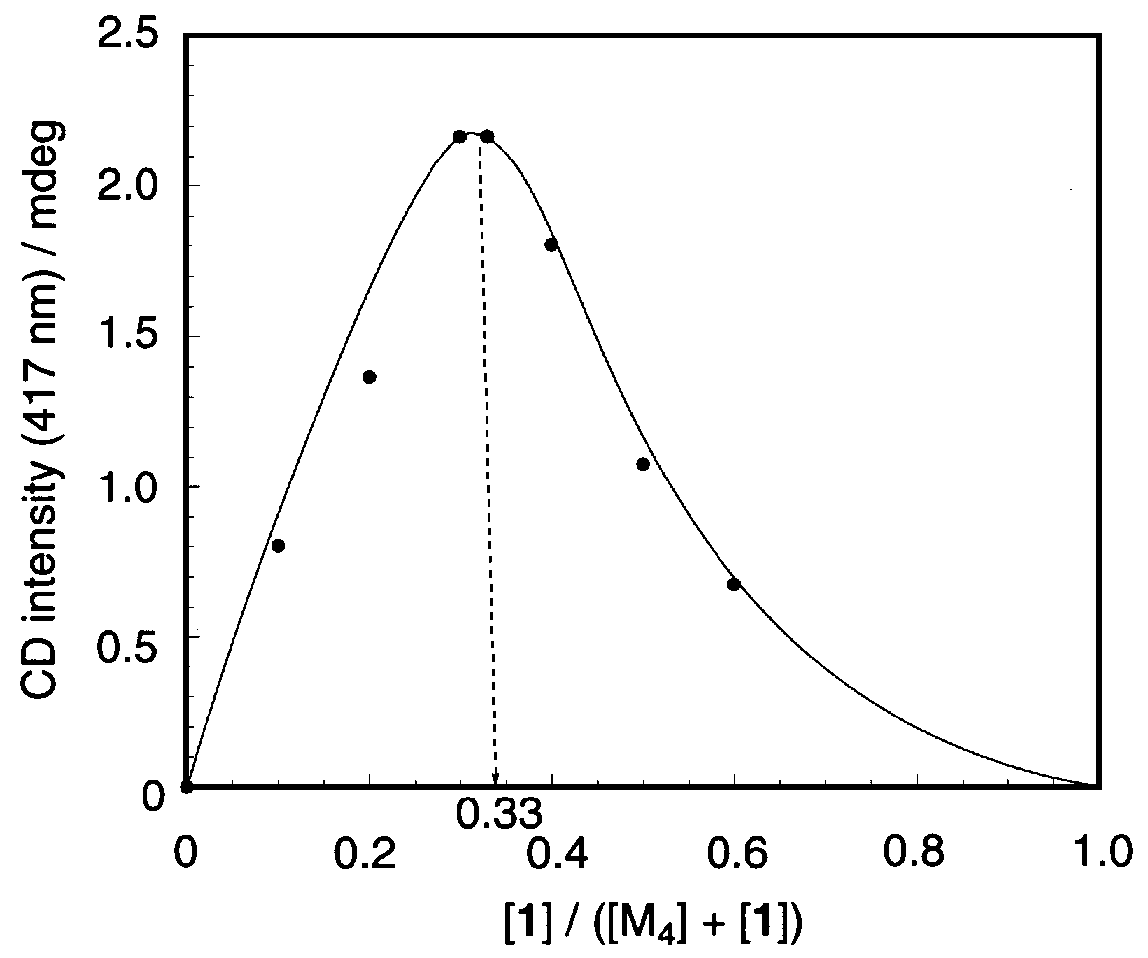

Fig. A Job plot for a 1 + M₄ system with a 0.1 mm cell: the sum of [1] and [M₄] was maintained constant (1.00 x 10^{–3} mol dm^{–3}).
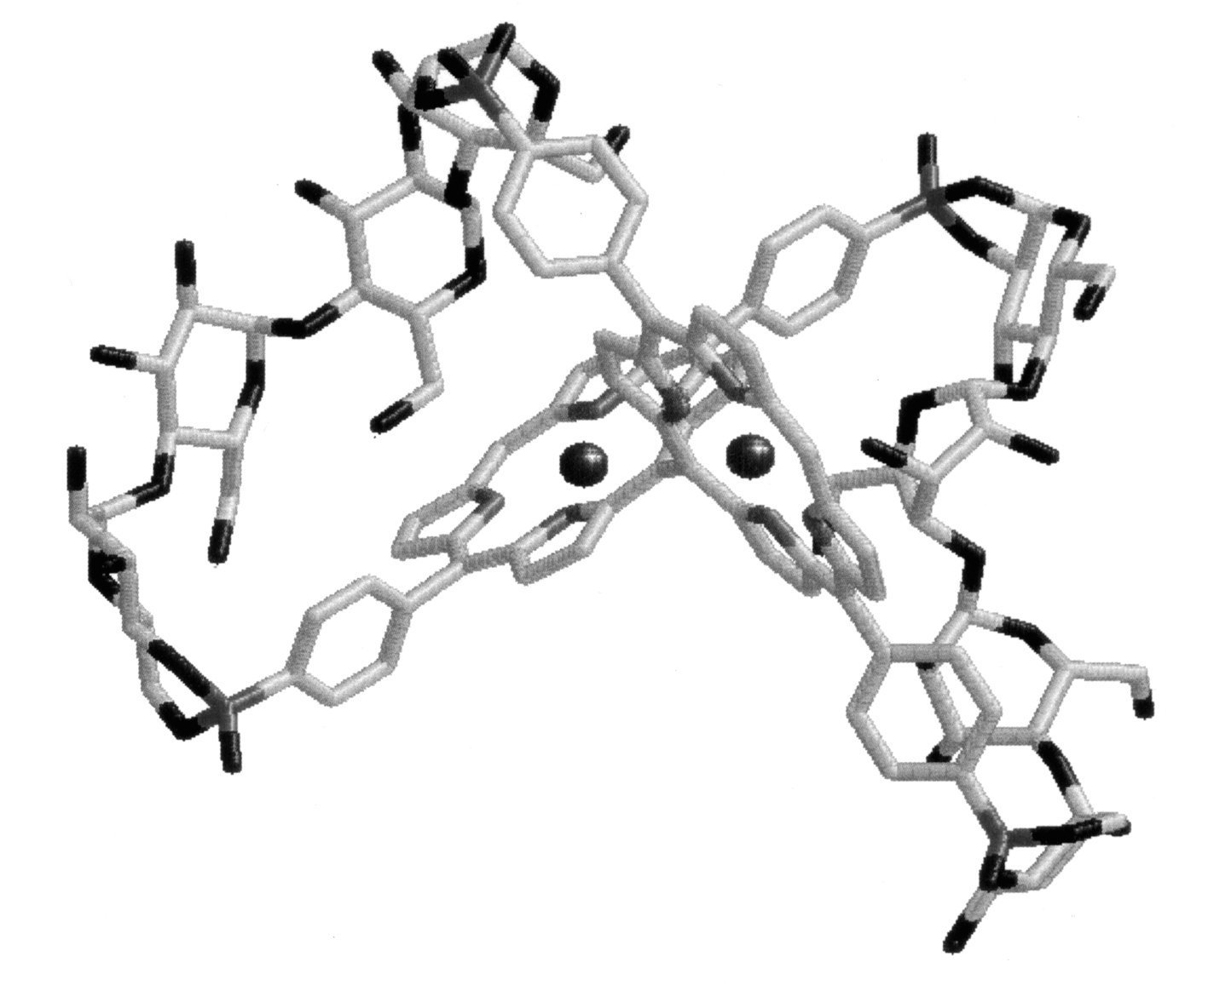

Fig. B Possible binding mode proposed on the basis of the Job plot and computational studies.

