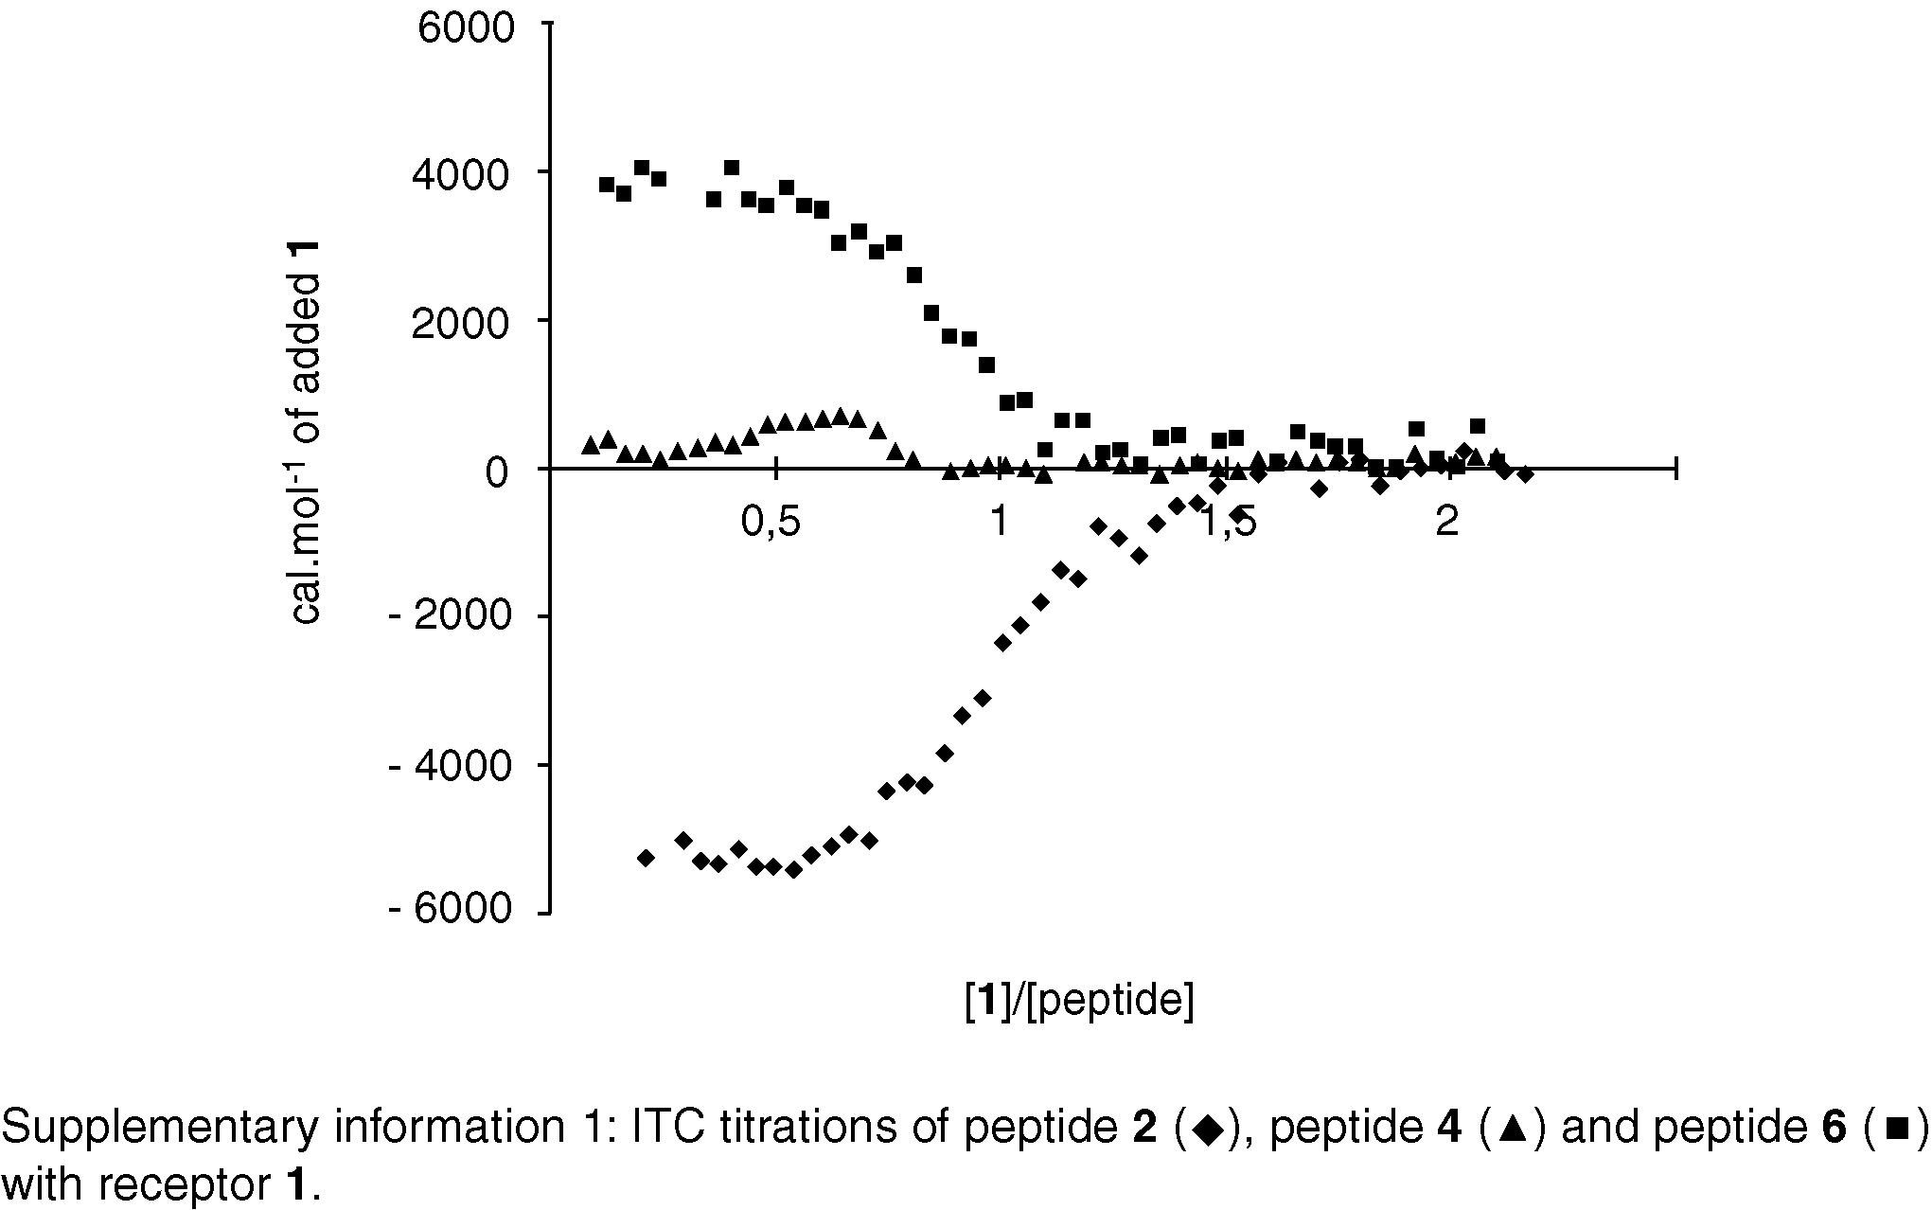

Supplementary Information 2. Chemical shift changes in 1 due to complexation/ppm
Nucleus | 1 | 1:6 complex | 1:2 complex
CH₂O | 3.76 | 3.73 | 3.65
α_{O} | 3.56 | 3.56 | 3.50
α_{S} | 3.67 | 3.63 | 3.63
β_{S} | 1.95 proS  2.24 proR | 1.90 proS  2.22 proR | 1.94/1.99 proS  2.20 proR
γ_{S} | 3.48 | 3.47 | 3.38
CH₂S | 2.73 proS  2.98 proR | 2.73 proS  2.82 proR | 2.62/2.64 proS  2.94/2.99 proR

