The addition of n-BuLi (1.05 equiv.) to a mixture of p-bromophenyl-ortho-carborane 2a (1 equiv.) and MeI (1.1 equiv.) in THF at –78 ºC afforded the methylated ortho- carborane 3a in 87 % yield. A THF solution of 3a (1 equiv.), trimethylsilylacetylene (1.05 equiv.) and triethylamine (1.5 equiv.) was refluxed in the presence of a catalytic amount of Pd(PPh₃)₄(2 mol %) and CuI (4 mol %), giving the TMS ethynylated ortho-carborane 4a. Subsequent deprotection of a TMS group with KF lead to the ethynylphenyl-ortho-carborane 5a in 80% yield. Treatment of 5a with n-BuLi (1 equiv.) in THF gave the corresponding lithium acetylide of 5a, which was added to a toluene solution of C₆₀ at 35 ºC, affording the ortho-carborane fullerene dyad 1a in 67% yield (Scheme 1). The meta- and para-carborane analogues, 1b and 1c, were prepared in a similar manner. The structures of 1a-c were confirmed by ¹H and ¹³C NMR, IR, ESI, and elemental analysis.

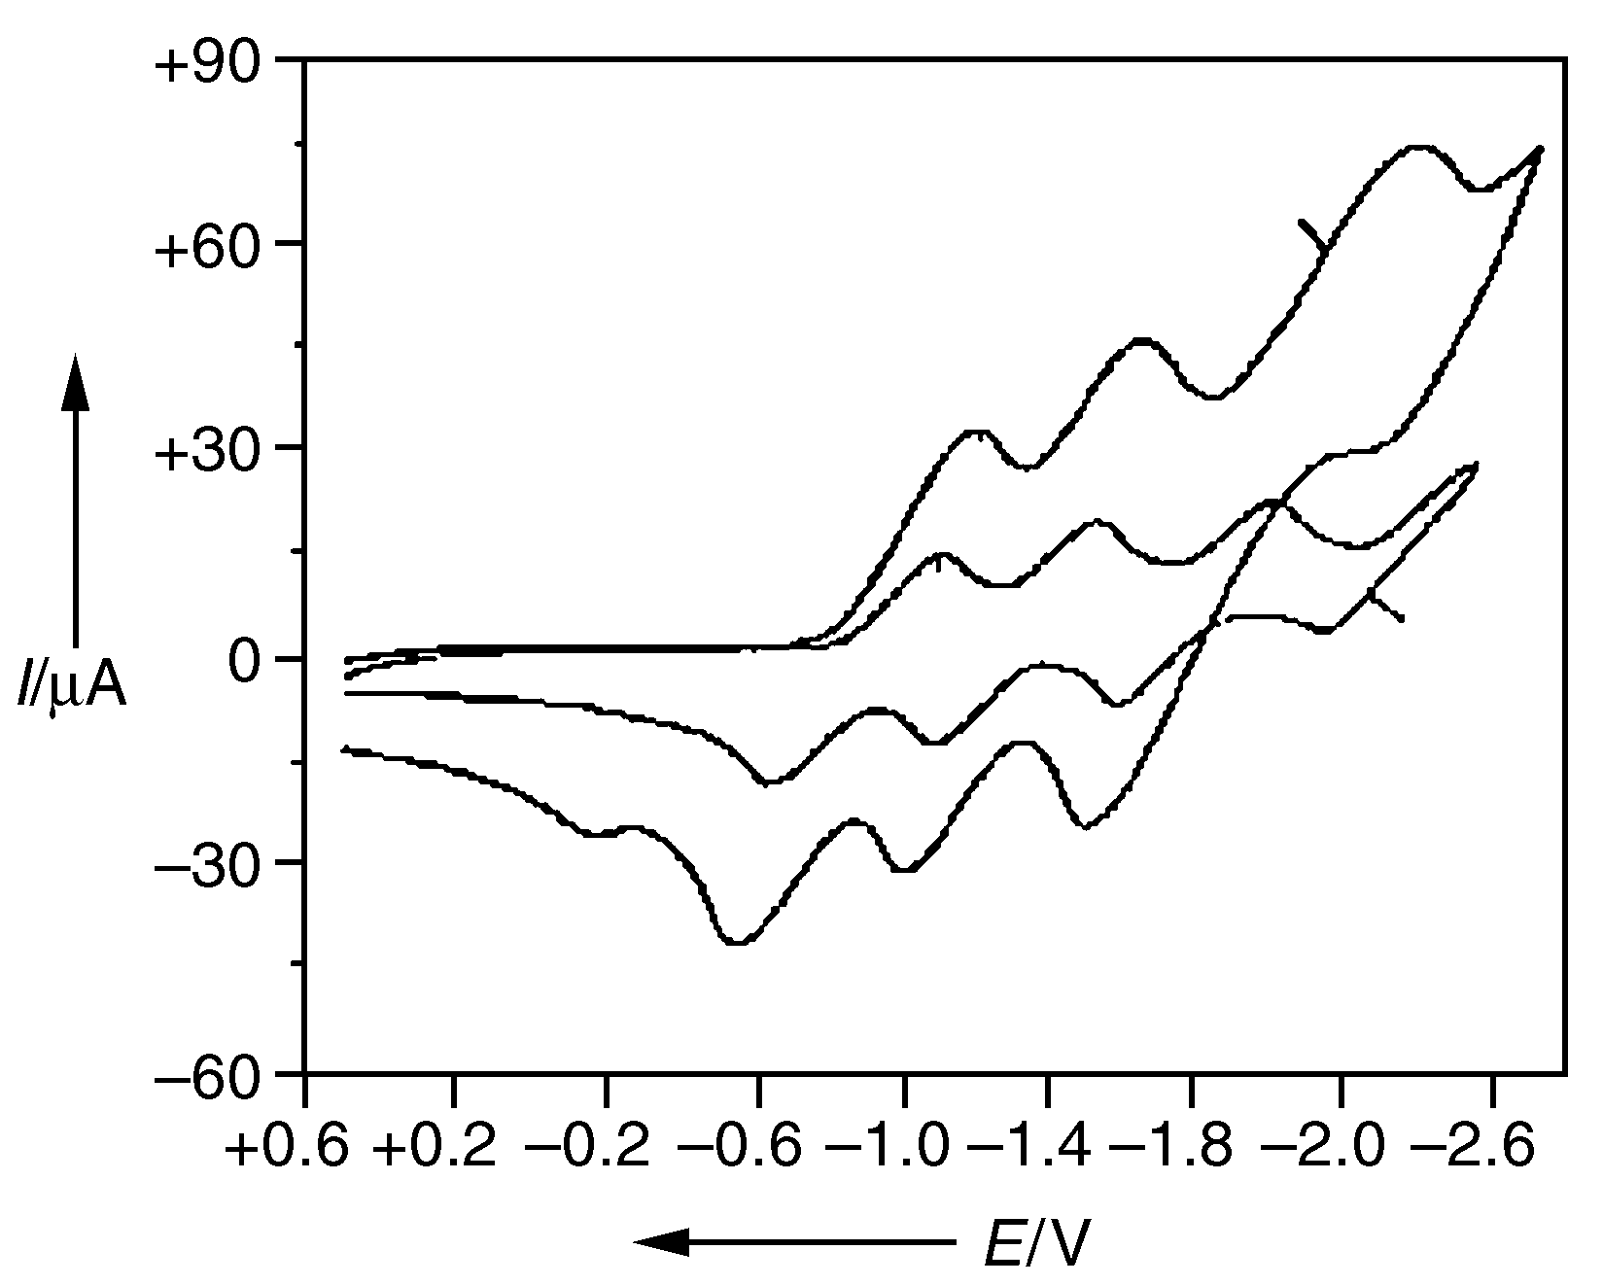
Fig. 1 CV of 1a (5 x 10⁻³ M) and C60 (2.5 x 10⁻³ M) in o-dichlorobenzene. Supporting electrolyte: 0.1 M nBu₄ClO₄; working electrode: glassy carbon; counter electrode: Pt wire; reference electrode: Ag/0.01 M AgNO₃ in acetonitrile with 0.1 M nBu₄ClO₄ (E¹/₂ (ferrocene/ferrocenium) = 180 V); scan rate: 100 mV s⁻¹.

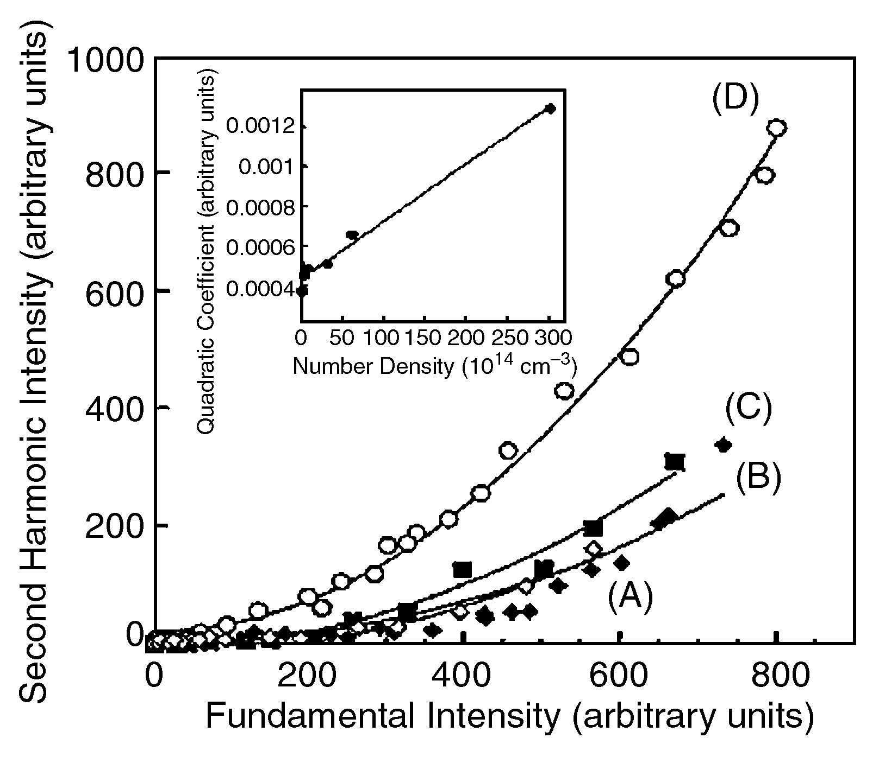
Fig. 2 Hyper-Rayleigh scattering signal for 1a in chloroform at different nember densities in units of 1014 cm⁻¹: (A)3.0, (B)6.0, (C)30 and (D)301. (Inset) Quadratic coefficient I(2w/I²(w) vs. nuber density of 1a.

