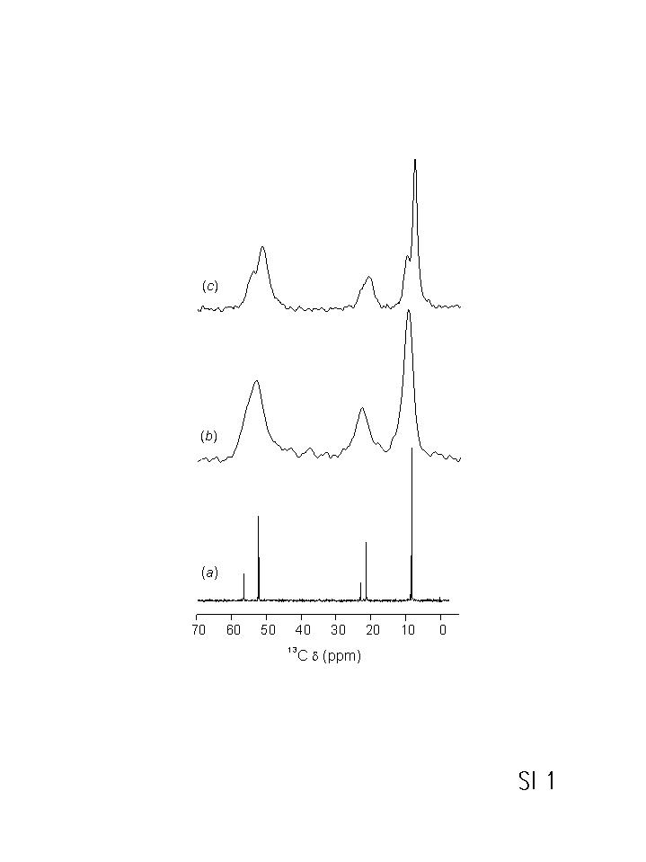
SI 1. ¹³C NMR spectra of organic SDA, Et₆-diquat-5: (a) ¹³C NMR of a CDCl₃ solution of the bromide form of Et₆-diquat-5, and ¹H-¹³C CP/MAS NMR of as-synthesized (b) P1 and (c) SUZ-4 with Et₆-diquat-5 occluded in their pores.
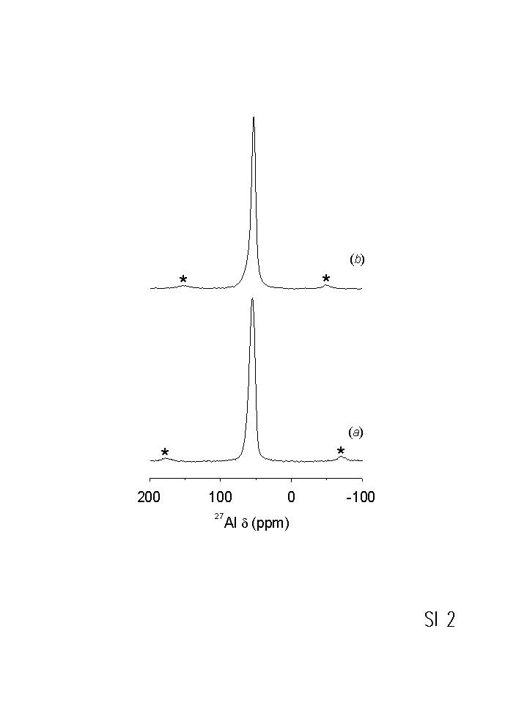
SI 2. ²⁷Al NMR spectra of as-synthesized P1 (a) and SUZ-4 (b).

