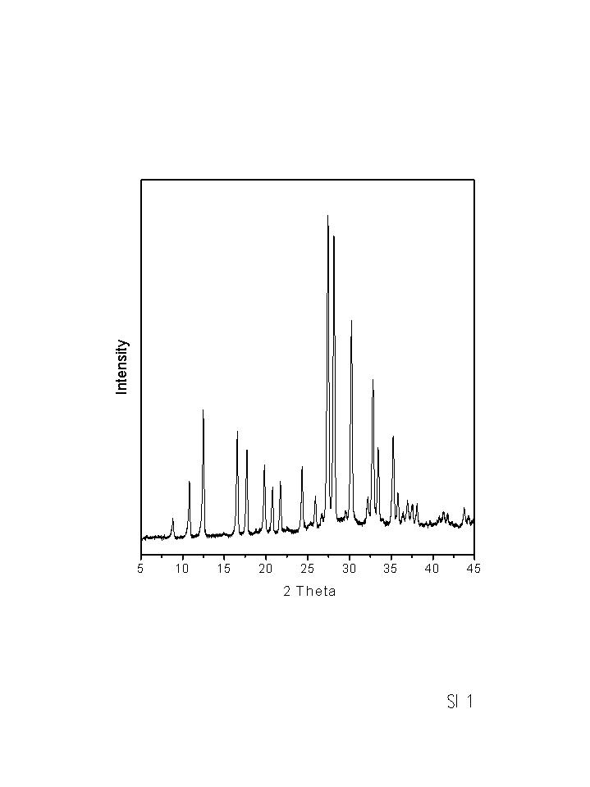 SI 1. X-ray powder diffraction pattern of MER zeolite prepared here.
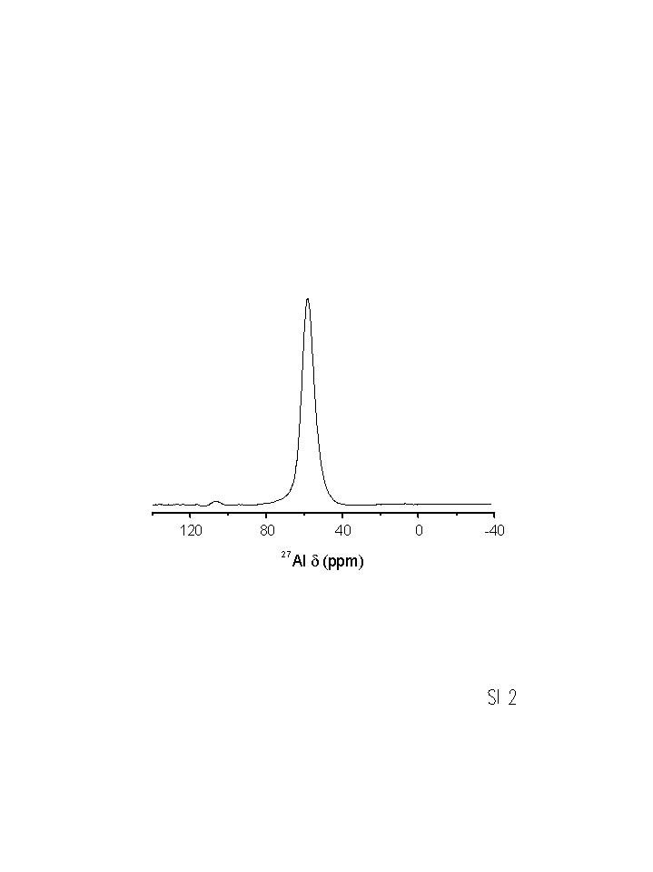 SI 2. ²⁷Al MAS NMR spectrum of MER zeolite recorded on a Varian VXR 300 at 4 kHz spinning rate, 0.1 s recycle delay, 78.164 MHz, 4 μs pulse length (π/12 rad), 1000 scans.

