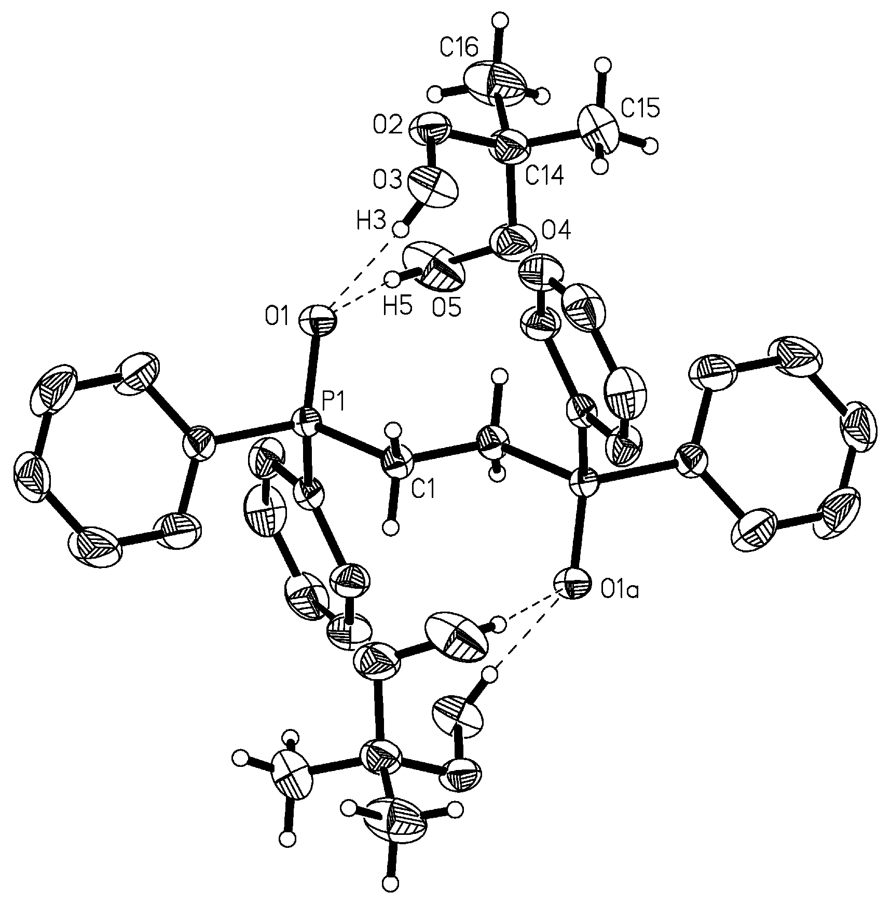

Fig. SI 1 Structure of 3 with labeling scheme. Selected bond distances (Ǻ) and angles (°): P1–N2 1.730(1), P1–N3 1.701(1), P1–C4 1.844(1), N2–C5 1.390(2), N2–C6 1.463(2), N3–C11 1.480(2), N3–C18 1.469(2), C7–C14 1.502(2); N2–P1–N3 92.7(1), N2–P1–C4 101.5(1), N3–P1–C4 98.8(1), P1–N2–C5 124.0(1), P1–N2–C6 113.3(1), C5–N2–C6 121.7(1), P1–N3–C11 108.7(1), P1–N3–C18 118.4(1), C11–N3–C18 107.7(1), P1–C4–C7 119.2(1), P1–C4–C9 121.4(1), N2–C5–C8 121.3(1), N2–C5–C17 121.1(1), N2–C6–C11 106.4(1), C4–C7–C14 122.3(1), N3–C11–C6 107.9(1), N3–C11–C20 104.3(1), N3–C18–C21 106.1(2).

Physical and spectroscopic data for 3:

Ligand 3 was purified by distillation and was obtained as a white, air and moisture stable solid in 89% yield on cooling; bp 130 °C (10 Pa), mp 138 °C. ¹H NMR (200 MHz): δ 1.85–2.12 (m, 4H), 2.62 (s, 3H), 3.08–3.28 (m, 2H), 3.28–3.49 (m, 1H), 3.60–3.68 (m, 1H), 3.88–3.98 (m, 1H), 6.76–6.87 (m, 4H), 7.07–7.38 (m, 5H). ¹³C NMR (50 MHz): δ 20.3 (d, J_{PC} 18.4 Hz), 25.7 (d, J_{PC} 6.1 Hz), 30.6 (s), 52.2 (d, J_{PC} 27.6 Hz), 53.7 (d, J_{PC} 4.5 Hz), 63.9 (d, J_{PC} 8.7 Hz), 115.0 (d, 2C, J_{PC} 13.1 Hz), 117.4 (s), 125.3 (s), 128.6 (d, J_{PC} 5.5 Hz), 128.9–129.4 (m, 5C), 130.7 (d, J_{PC} 4.2 Hz), 139.0 (s), 146.7 (s). ³¹P NMR (40,54 MHz): δ 96.9.

General information for norbornene hydroarylation:

General procedure for the hydroarylation of norbornene [eqn. (3)]: the appropriate catalyst concentration was obtained by successive dilution in DMSO of an initial catalyst solution prepared by mixing 11 x 10^{–6} mol of Pd(OAc)₂ and 23 x 10^{–6} mol of ligand 3 in 5 mL of DMSO under argon at 60 °C for 10 min (the mixture turned black after complete formation of the catalyst). In a 25 mL two-necked flask the appropriate catalyst solution (5 x 10^{–7} mol%) in 10 mL of DMSO was introduced under argon. To the stirred solution were added 459 mg of iodobenzene (2.3 x 10^{–3} mol), 700 mg of norbornene (7.4 x 10^{–3} mol), 760 mg of NEt₃ (7.5 x 10^{–3}) and 280 mg of formic acid (6 x 10^{–3} mol). The mixture was heated at 120 °C for 16 h. After cooling, 15 mL of water were added and the mixture was extracted with pentane (3 x 30 mL). The organic phases were dried over MgSO₄, filtered and the solvents removed under reduced pressure. The product was purified by distillation to afford 387 mg of the expected phenyl norbornane (98% yield) as a viscous oil; bp 124 °C (0.2 mbar). ¹H NMR (CDCl₃, 200 MHz): δ 1.25–1.92 (m, 8H), 2.44 (s, 2H), 2.83 (q, J 8.0 Hz, 1H), 7.20–7.41 (m, 5H). ¹³C NMR (CDCl₃, 50 MHz): δ 29.0 (s), 30.7 (s), 36.1 (s), 36.9 (s), 39.2 (s), 43.0 (s), 47.4 (s), 125.4 (s), 127.1 (s, 2C), 128.3 (s, 2C), 142.7 (s).

