Electronic Supplementary Information for:
Fabrication of a Novel Polypyrrole/Poly(methyl methacrylate) Coaxial Nanocable using Mesoporous Silica as a Nanoreactor

Jyongsik Jang,* Byungkwon Lim, Jinwoo Lee and Taeghwan Hyeon
School of Chemical Engineering, Seoul National University, Seoul 151-742, Korea.

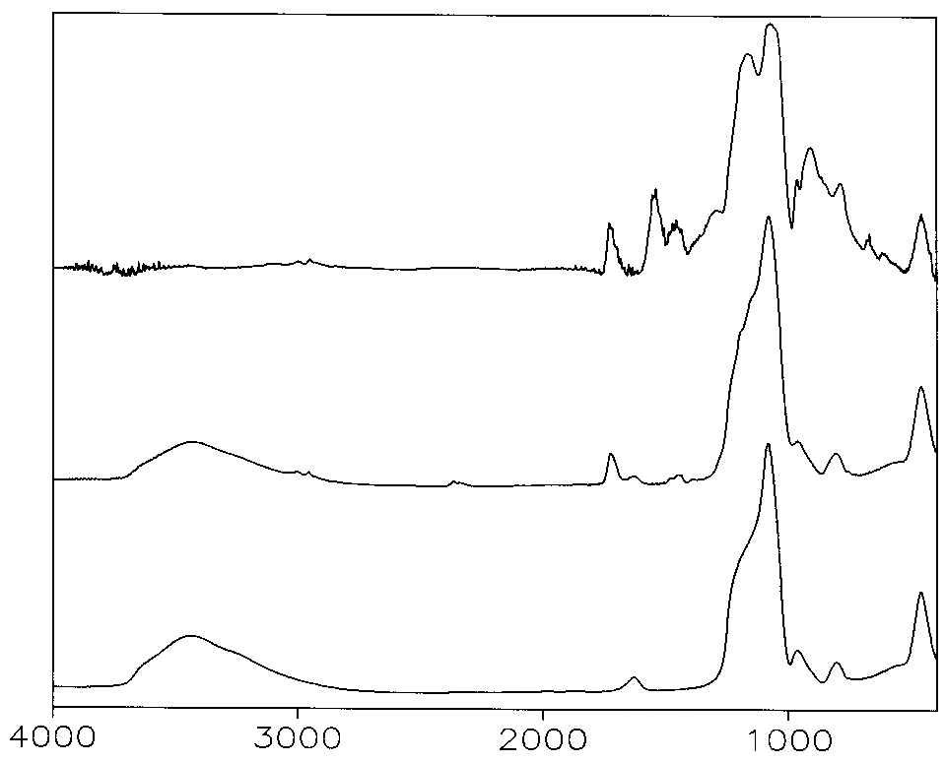
1. The FT-IR spectra of SBA-15, PMMA/SBA-15, and PPy/PMMA/SBA-15 nanocomposites. The spectra were obtained with a Bomem MB-100 instrument.
Absorbance
Wavenumber (cm⁻¹)
(A)
(B)
(C)
The characteristic peaks of PMMA
The characteristic peaks of PPy
2. Small-angle X-ray diffraction (XRD) patterns of SBA-15 silica (trace A), PMMA/SBA-15 nanocomposite (trace B), and PPy/PMMA/SBA-15 nanocomposite (trace C). The patterns were acquired on a Bruker GADDS small-angle X-ray scattering with general area detector diffracting system.

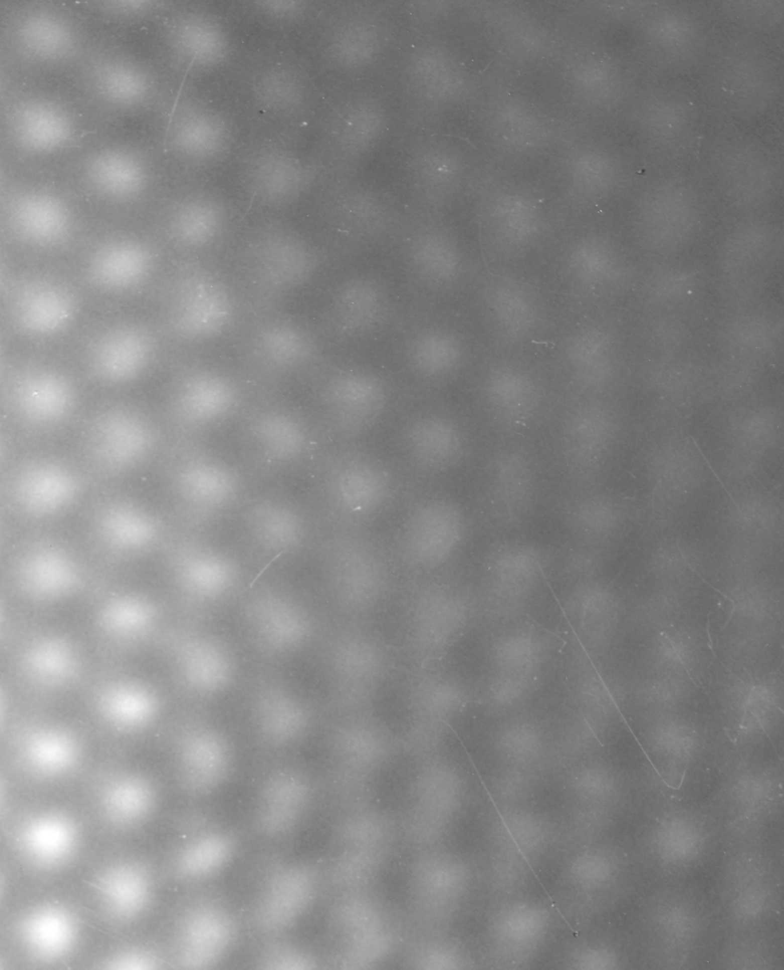
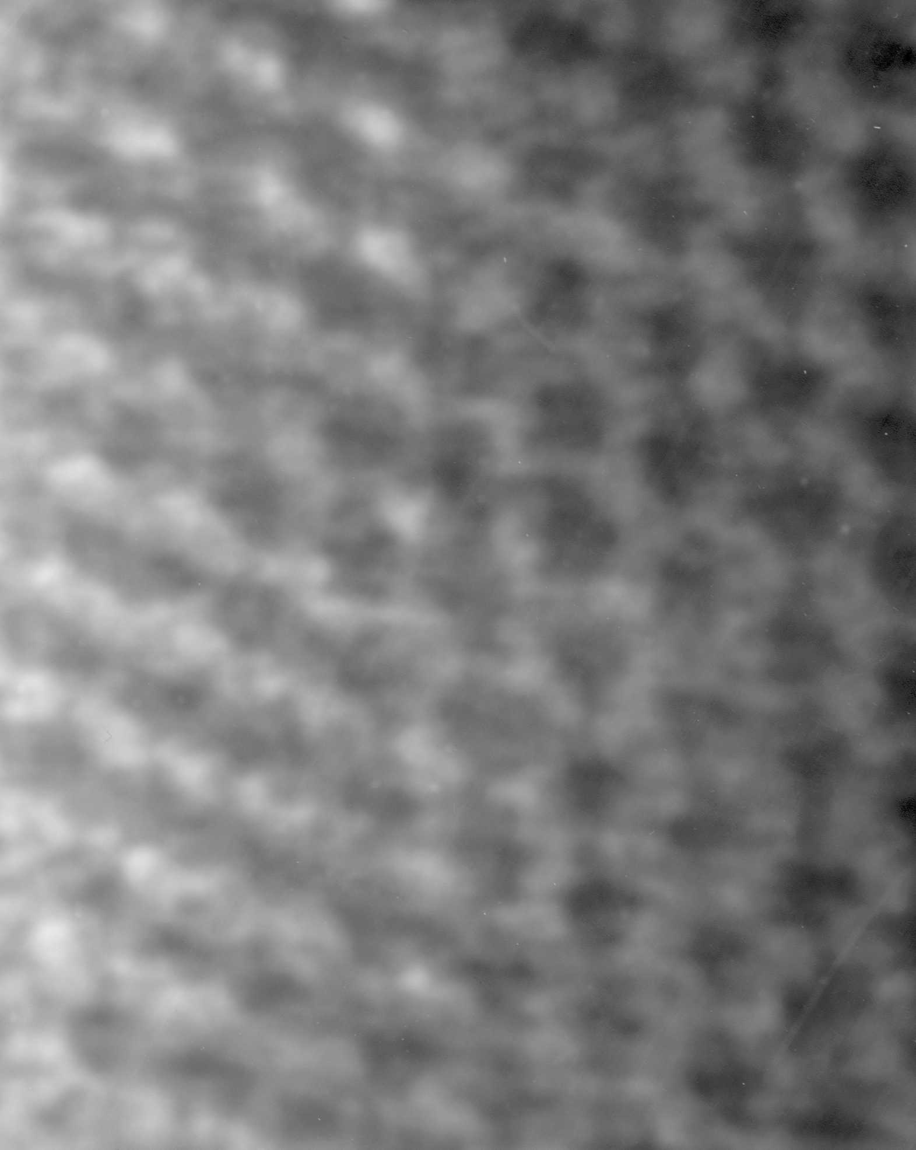
3. TEM images of SBA-15 (A) and PMMA/SBA-15 (B).
20 nm
20 nm
(A)
(B)

