Electronic Supplementary Information (ESI) service

First definitive spectroscopic evidence for a stable intermediate in a sulfinyl-transfer reaction : Reaction of dibenzo[1,2]oxathiin-6-oxide with sodium ethoxide in anhydrous ethanol

Ik-Hwan Um,* Myung-Jin Kim, and Hye-Won Lee
Department of Chemistry, Ewha Womans University, Seoul 120-750, Korea
Tel: 822) 3277-2349, Fax: 822) 3277-2844, E-mail: ihum@mm.ewha.ac.kr

Figure S1. A plot of 1/k_{obs} versus 1/[EtONa] for the reaction of 1 with EtONa (1 2 →3) in anhydrous ethanol at 25.0±0.1ºC.

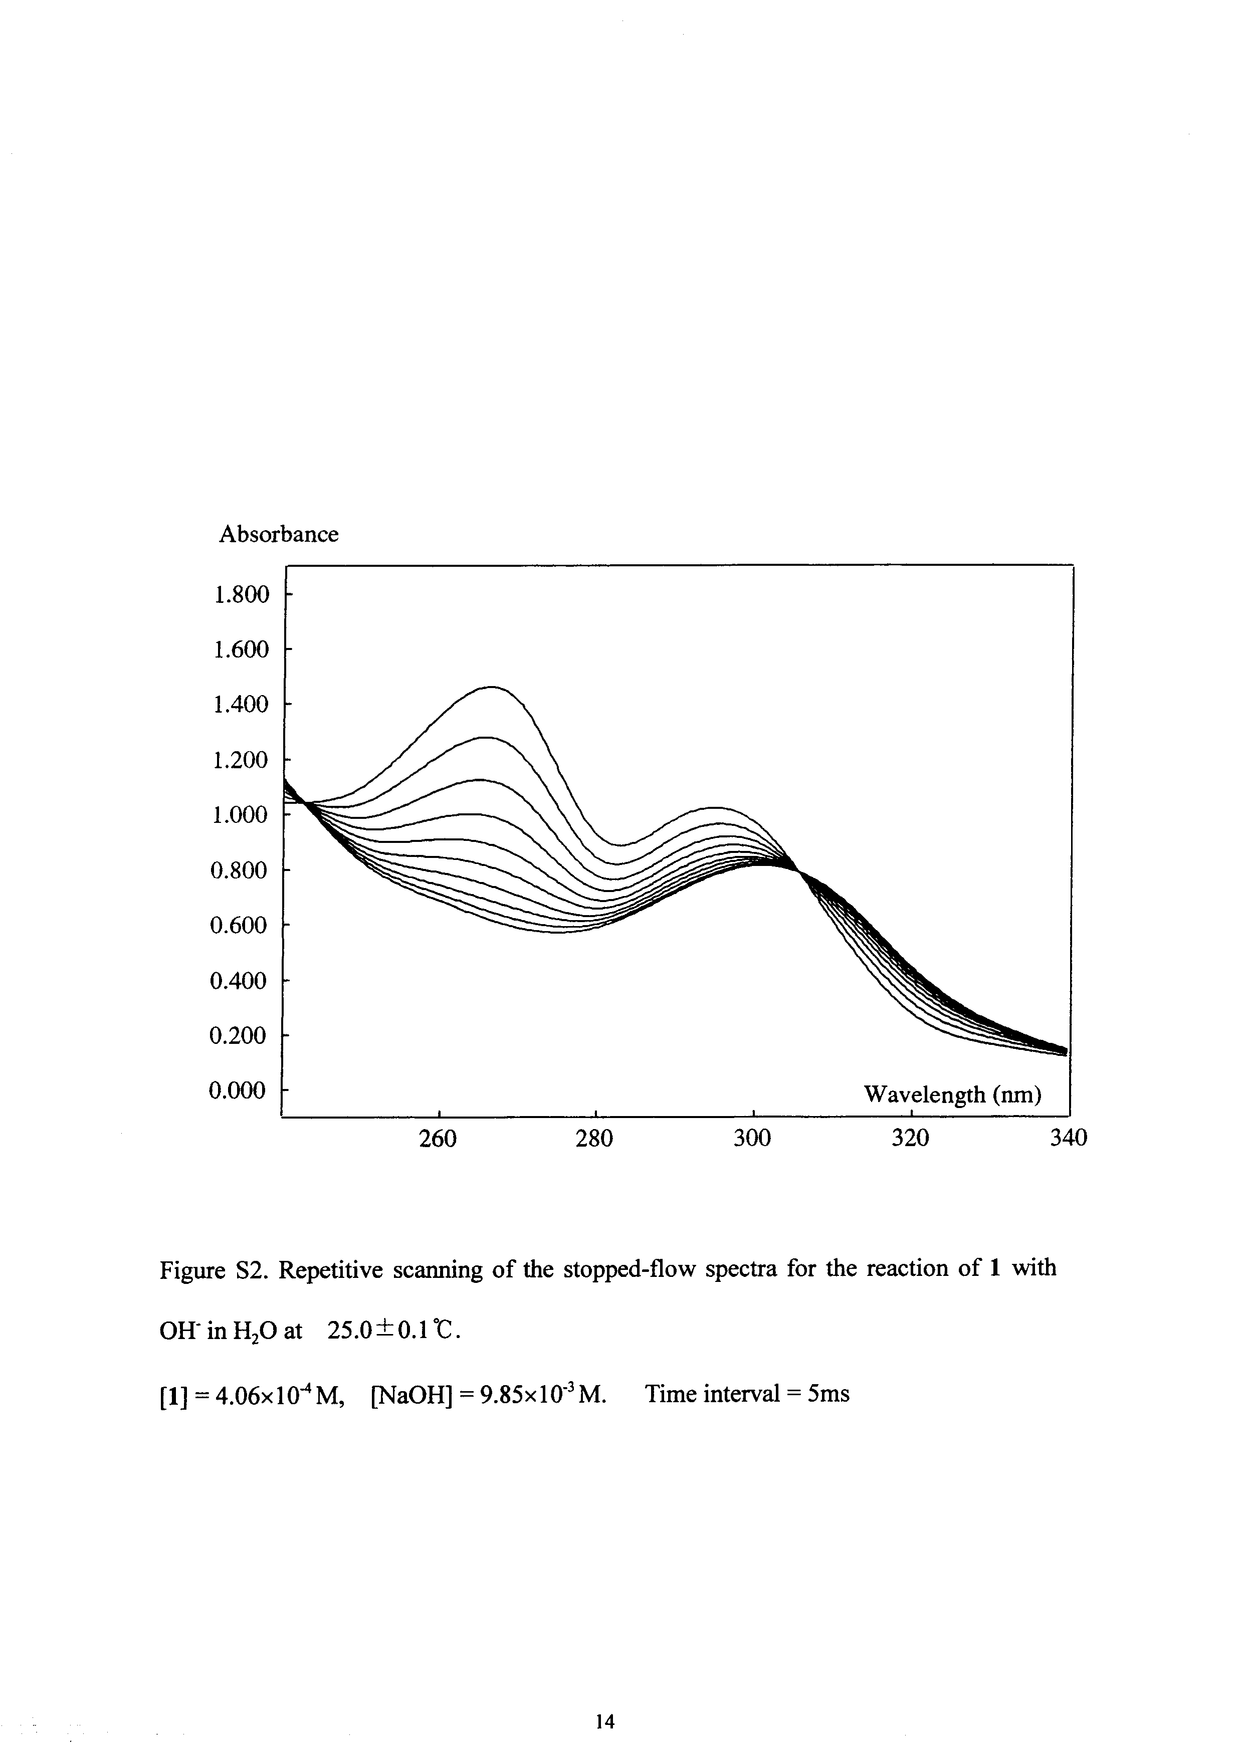

Table S1. Summary of kinetic results for the fast process of the reaction of 1 with EtONa (1 ↔ 2) in anhydrous ethanol at 25.0±0.1˚C.[a]
[EtONa] ,10⁻³ M | K_{obs} , s⁻¹
1.63 | 52.5
3.26 | 80.1
4.89 | 100
6.52 | 128
8.15 | 147
[a] The linear regression line for k_{obs} vs [EtONa] has r = 0.998, intercept(k₋₁) = 30.5 s⁻¹, slope(k₁) = 14,500 M⁻¹s⁻¹ (See text).

Table S2. Summary of kinetic results for the slow process of the reaction of 1 with EtONa (1 ↔ 2 → 3) in anhydrous ethanol at 25.0±0.1˚C.^{[a]}
[EtONa] ,10⁻³ M | k_{obs} ,10⁻³ s⁻¹
1.61 | 0.401
3.19 | 0.599
6.51 | 0.813
15.9 | 1.05
26.0 | 1.2
39.0 | 1.30
52.1 | 1.32
65.1 | 1.37
[a ] The plot of k_{obs} vs [EtONa] shows a saturation kinetic curve (See text).

