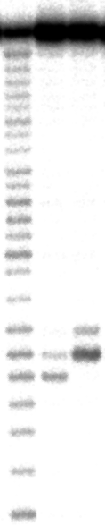
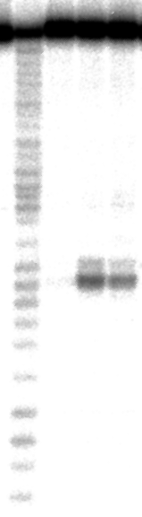
Supplemental Figure 1. Selective RNA scission by various systems composed of DNA bearing an acridine, another unmodified DNA, and Lu(III) ion.

(a) The effect of position of unpaired ribonucleotide.

Lane 1:

Lane 2:

Note that the scission site is satisfactorily modulated by changing the position of the unpaired ribonucleotide. In a proposed mechanism, the unpaired base partially flips out because of steric repulsion against the bulky intercalator, and the C2’-C3’-O-P dihedral angles and/or the puckering of the ribose residues are accordingly changed.

(b) Effect of the number of non-pairing ribonucleotides.
The numbers of unpaired ribonucleotides are zero (lane 1), one (lane 2), and two (lane 3). In lanes 1 and 3, DNA₂ (in lane 3 of Figure 2 in the text) is replaced by appropriate DNA oligomers. One or two unpaired ribonucleotides are appropriate for the present site-selective scission. With three of them, the scission becomes less site-selective (data not presented).

