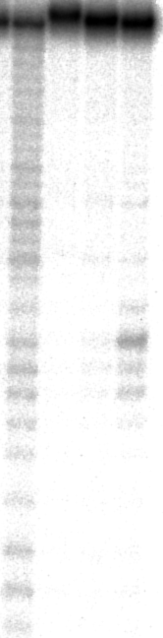
Supplemental Figure 2. Effect of bulge formation on the Lu(III)-induced RNA scission.

Lane 1:

Lane 2:

Lane 3:

Note that the scissions took place at several sites. Under the same reaction conditions, the DNA₁-Acr/DNA₂/Lu(III) ternary system provided much more selective scission (compare this Figure with Supplemental Figure 1 (b)).

