Supplementary Information

1,3-Diphenyl-2,2,2,4,4,4-hexazido-1,3-diaza-2,4-diphosphetidine: synthesis and structural characterisation of the first nitrogen-penta-coordinated phosphorus with three azide-groups.

Christoph Aubauer, Thomas M. Klapötke,* Heinrich Nöth,≠ Axel Schulz, Max SuterError: Reference source not found and Jan Weigand
Department of Chemistry, Ludwig-Maximilians-University, Butenandtstr. 5-13 (D), D-81377 Munich, Germany. E-mail: tmk@cup.uni-muenchen.de
Experimental details
General: CAUTION – covalent azides are potentially explosive and safety precautions must be taken during work with azides. All manipulations were performed under an inert atmosphere of dry nitrogen using standard Schlenk techniques. Solvents were dried and degassed by standard methods. (C₆H₅)₂N₂P₂Cl₆ was prepared as described. Raman spectra were recorded on a Perkin-Elmer 2000 NIR FT-Raman spectrometer, IR spectra as neat solids between KBr plates on a Perkin-Elmer Spectrum One FT-IR spectrometer. The NMR spectra were recorded in CD₂Cl₂ solution on a JEOL EX 400 DELTA instrument. Chemical Shifts are reported with respect to (CH₃)₄Si (¹H, ¹³C), H₃PO₄ (³¹P) and CH₃NO₂ (¹⁴N). An exact melting point could not be determined since the compound exploded above 90 °C. The elemental analysis was not determined because of the explosive nature of the compound.

(C₆H₅)₂N₂P₂(N₃)₆ 1: A colourless solution of (C₆H₅)₂N₂P₂Cl₆ (1.0 mmol) in CH₂Cl₂ (20 mL) was treated with trimethylsilyl azide (7.5 mmol) at –78 °C. The solution was allowed to warm slowly and stirred for 48 h at room temperature. The solvent and all volatile products were removed by vacuum evaporation leaving a white solid. The solid was purified by crystallisation from CH₂Cl₂ at –28 °C. The crystals of 1 which formed were found to be suitable for X-ray diffraction studies and were isolated. Yield 0.39 g, 78 %, mp – (explosion). IR (powder between KBr plates): 2963s, 2906m, 2154s [ν_{as} (N₃)], 2142s [ν_{as} (N₃)], 2113m [ν_{as} (N₃)], 1594m, 1485m, 1449m, 1412m, 1260vs (br), 1092vs, 1018vs, 929m, 872s, 798vs, 697m, 624m, 590m, 564w, 542m, 518w, 481m and 451m. Raman (100 mW): 3067 [10, ν (CH)], 2158 [7, ν_{as}(N_{3, eq})], 2136 [4, ν_{as}(N_{3, eq})], 2111 [1, ν_{as}(N_{3, ax})], 1597 [10, ν (CC_{arom.})], 1492 [1, ν (CN)], 1327 [10, ν (CN)], 1275 [3, ν_{s}(N₃, _{eq})], 1260 [2, ν_{s}(N₃, _{eq})], 1236 [1, ν_{s} (N_{3, ax})], 1165 [1, δ (CH_{arom.})], 1155 [1, δ (CH_{arom.})], 1037 [1, δ (CH_{arom.})], 1000 [10, δ (CH_{arom.})], 875 [1, ν (PN)], 717 [2, δ (N₃) + δ (PN-ring)], 670 [2, δ (CH_{arom.})], 638 (1, δ), 623 (1, δ), 522 (1, δ), 473 (3, δ), 451 (4, δ), 300 (2, δ), 271 (3, δ), 252 (4, δ) and 171 (5, δ), Fig. SI 1. ³¹P NMR [109 MHz, CD₂Cl₂]: δ –87.6 (s). ¹⁴N NMR [29 MHz, CD₂Cl₂]: δ –152 [br, sh, N(2), N(5)], –154 [N(8)], –166 [br, N(3), N(6)], –169 [N(9)], –296.0 [N(1), N(4), N(7)]. ¹H NMR [400 MHz, CD₂Cl₂]: δ 7.48 – 7.37 (m, 10 H). ¹³C NMR [101 MHz, CD₂Cl₂]: δ 137.1, 131.4, 128.9, 127.8.
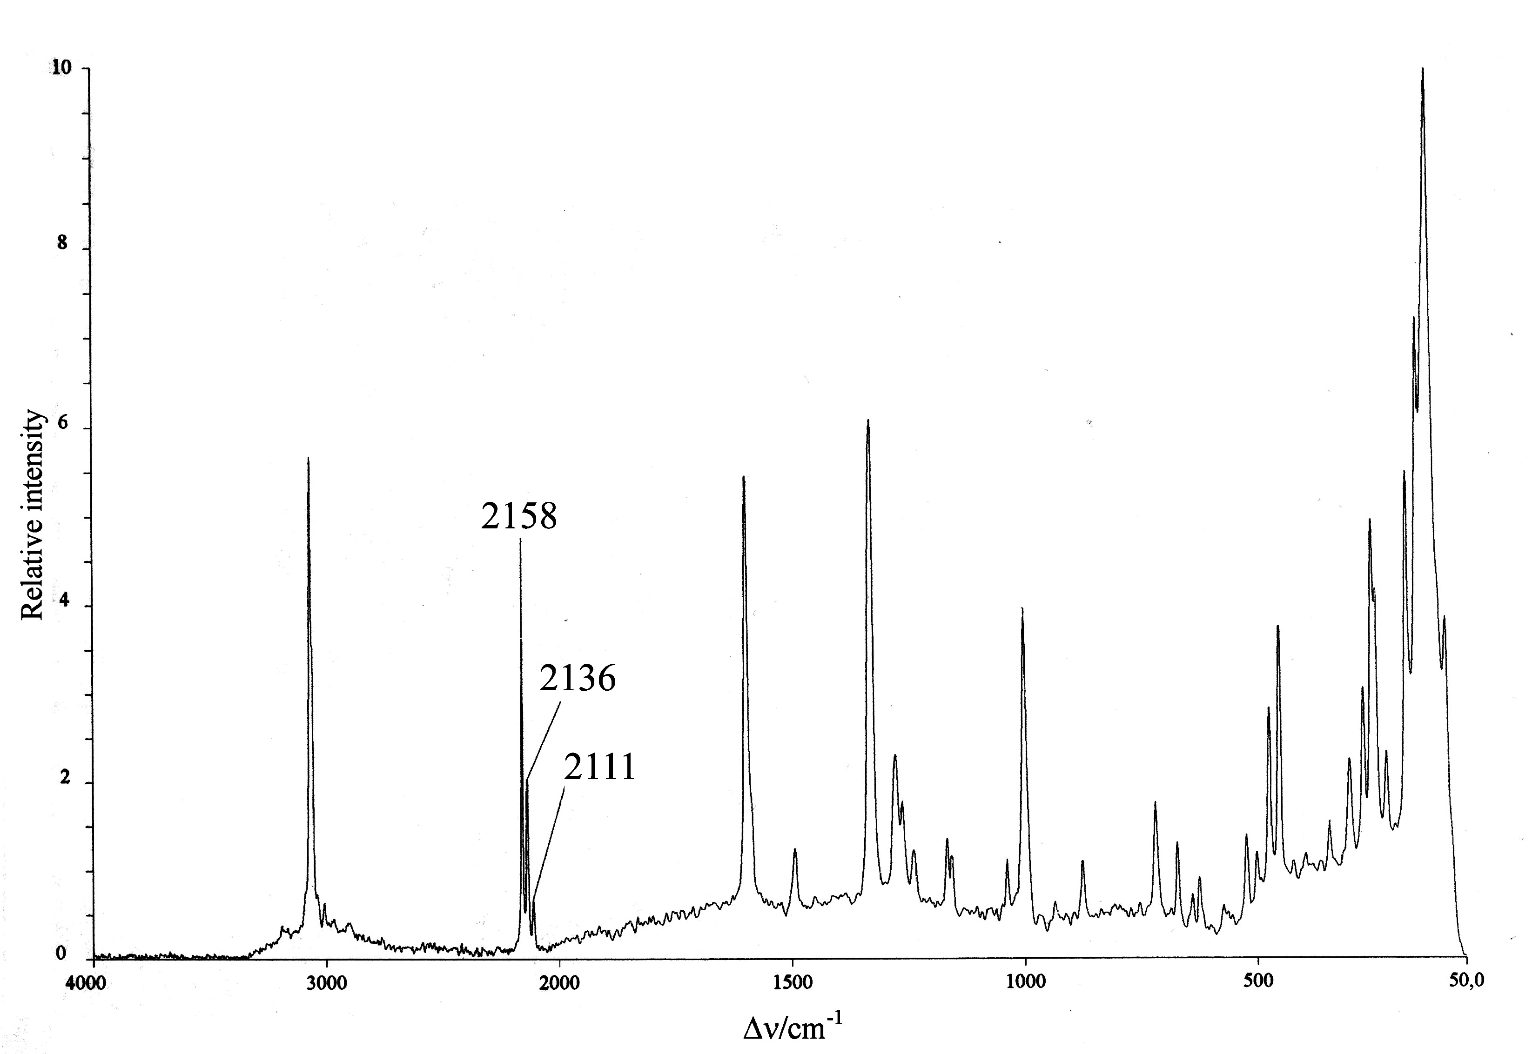
Fig. SI 1 Raman spectrum of 1.

Computational details
Computations have been carried out at B3LYP/6-31G(d,p) and HF/6-31G(d,p) level on a model compound where the phenyl rings of 1 are replaced by hydrogen atoms. The structure was fully optimised and characterised by a frequency analysis using the G98 program suite. Additionally, NBO population analysis was carried out on the X-ray structural data of 1 to investigate the bonding and hybridisation in this species [single point at B3LYP/6-31G(d,p) level].
The partly occupied orbitals (ϕ_{AB}*) lead to differences from the ideal Lewis structure. The corrections to the Lewis-type picture are usually so small as to be well approximated by simple, second-order perturbation energy expressions. By this perturbation approach, the donor–acceptor interaction involving a filled orbital ϕ (donor, in our case the lone pair on the N atom) and an unfilled antibonding orbital ϕ* [acceptor, in our case: σ*(P–N)] can be quantitatively described. The energy lowering is given by: Δ_{ϕϕ*}$E^{(2)}=−2($ with h^{F} being the Fock operator.

References

 For queries relating to crystal structure analysis.
H. A. Klein and H. P. Latscha, Z. Anorg. Allg. Chem., 1974, 406, 214.
M. J. Frisch, G. W. Trucks, H. B. Schlegel, G. E. Scuseria, M. A. Robb, J. R. Cheeseman, V. G. Zakrzewski, J. A. Montgomery, Jr., R. E. Stratmann, J. C. Burant, S. Dapprich, J. M. Millam, A. D. Daniels, K. N. Kudin, M. C. Strain, O. Farkas, J. Tomasi, V. Barone, M. Cossi, R. Cammi, B. Mennucci, C. Pomelli, C. Adamo, S. Clifford, J. Ochterski, G. A. Petersson, P. Y. Ayala, Q. Cui, K. Morokuma, D. K. Malick, A. D. Rabuck, K. Raghavachari, J. B. Foresman, J. Cioslowski, J. V. Ortiz, B. B. Stefanov, G. Liu, A. Liashenko, P. Piskorz, I. Komaromi, R. Gomperts, R. L. Martin, D. J. Fox, T. Keith, M. A. Al-Laham, C. Y. Peng, A. Nanayakkara, C. Gonzalez, M. Challacombe, P. M. W. Gill, B. Johnson, W. Chen, M. W. Wong, J. L. Andres, C. Gonzalez, M. Head-Gordon, E. S. Replogle and J. A. Pople, Gaussian 98, Revision A.6, Gaussian, Inc., Pittsburgh PA, 1998.
(a) A. E. Reed, L. A. Curtiss and F. Weinhold, Chem. Rev., 1988, 88, 899; (b) A. E. Reed, R. B. Weinstock and F. Weinhold, J. Chem. Phys., 1985, 83, 735.

