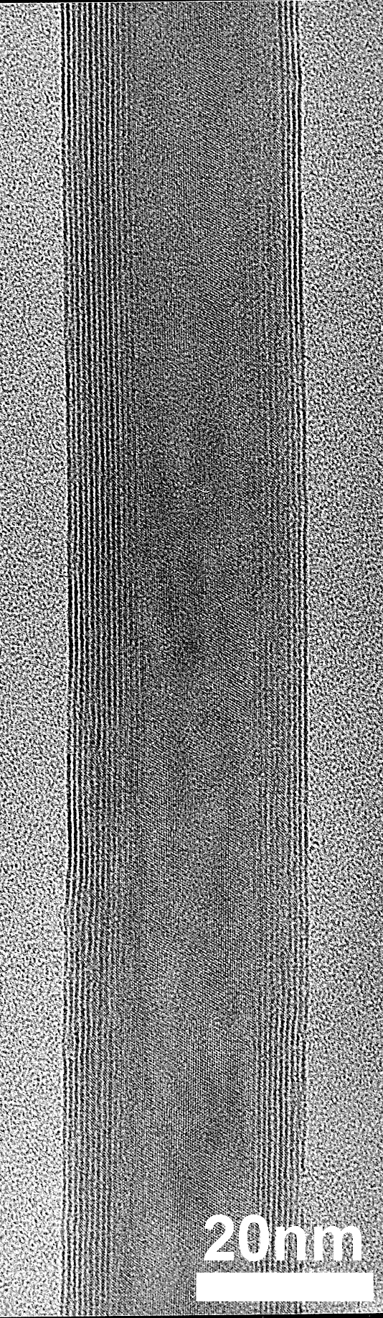

HRTEM image of a typical 10-layered W_{0.9}Nb_{0.1}S₂ nanotube; layer separation = 0.62 nm.

