Figure 1s. Crystal packing for rac-1. Animated image with stepwise rotation along the approximate c-axis is shown. The enantiomers are color coded.

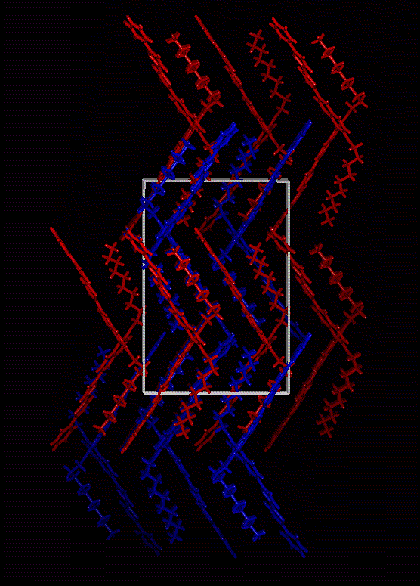

Figure 2s. Crystal packing for rac-1. Projection on the approximate bc-plane. The enantiomers are color coded: the red/cyan correspond to one enantiomer and orange/blue correspond to the other enantiomer.

