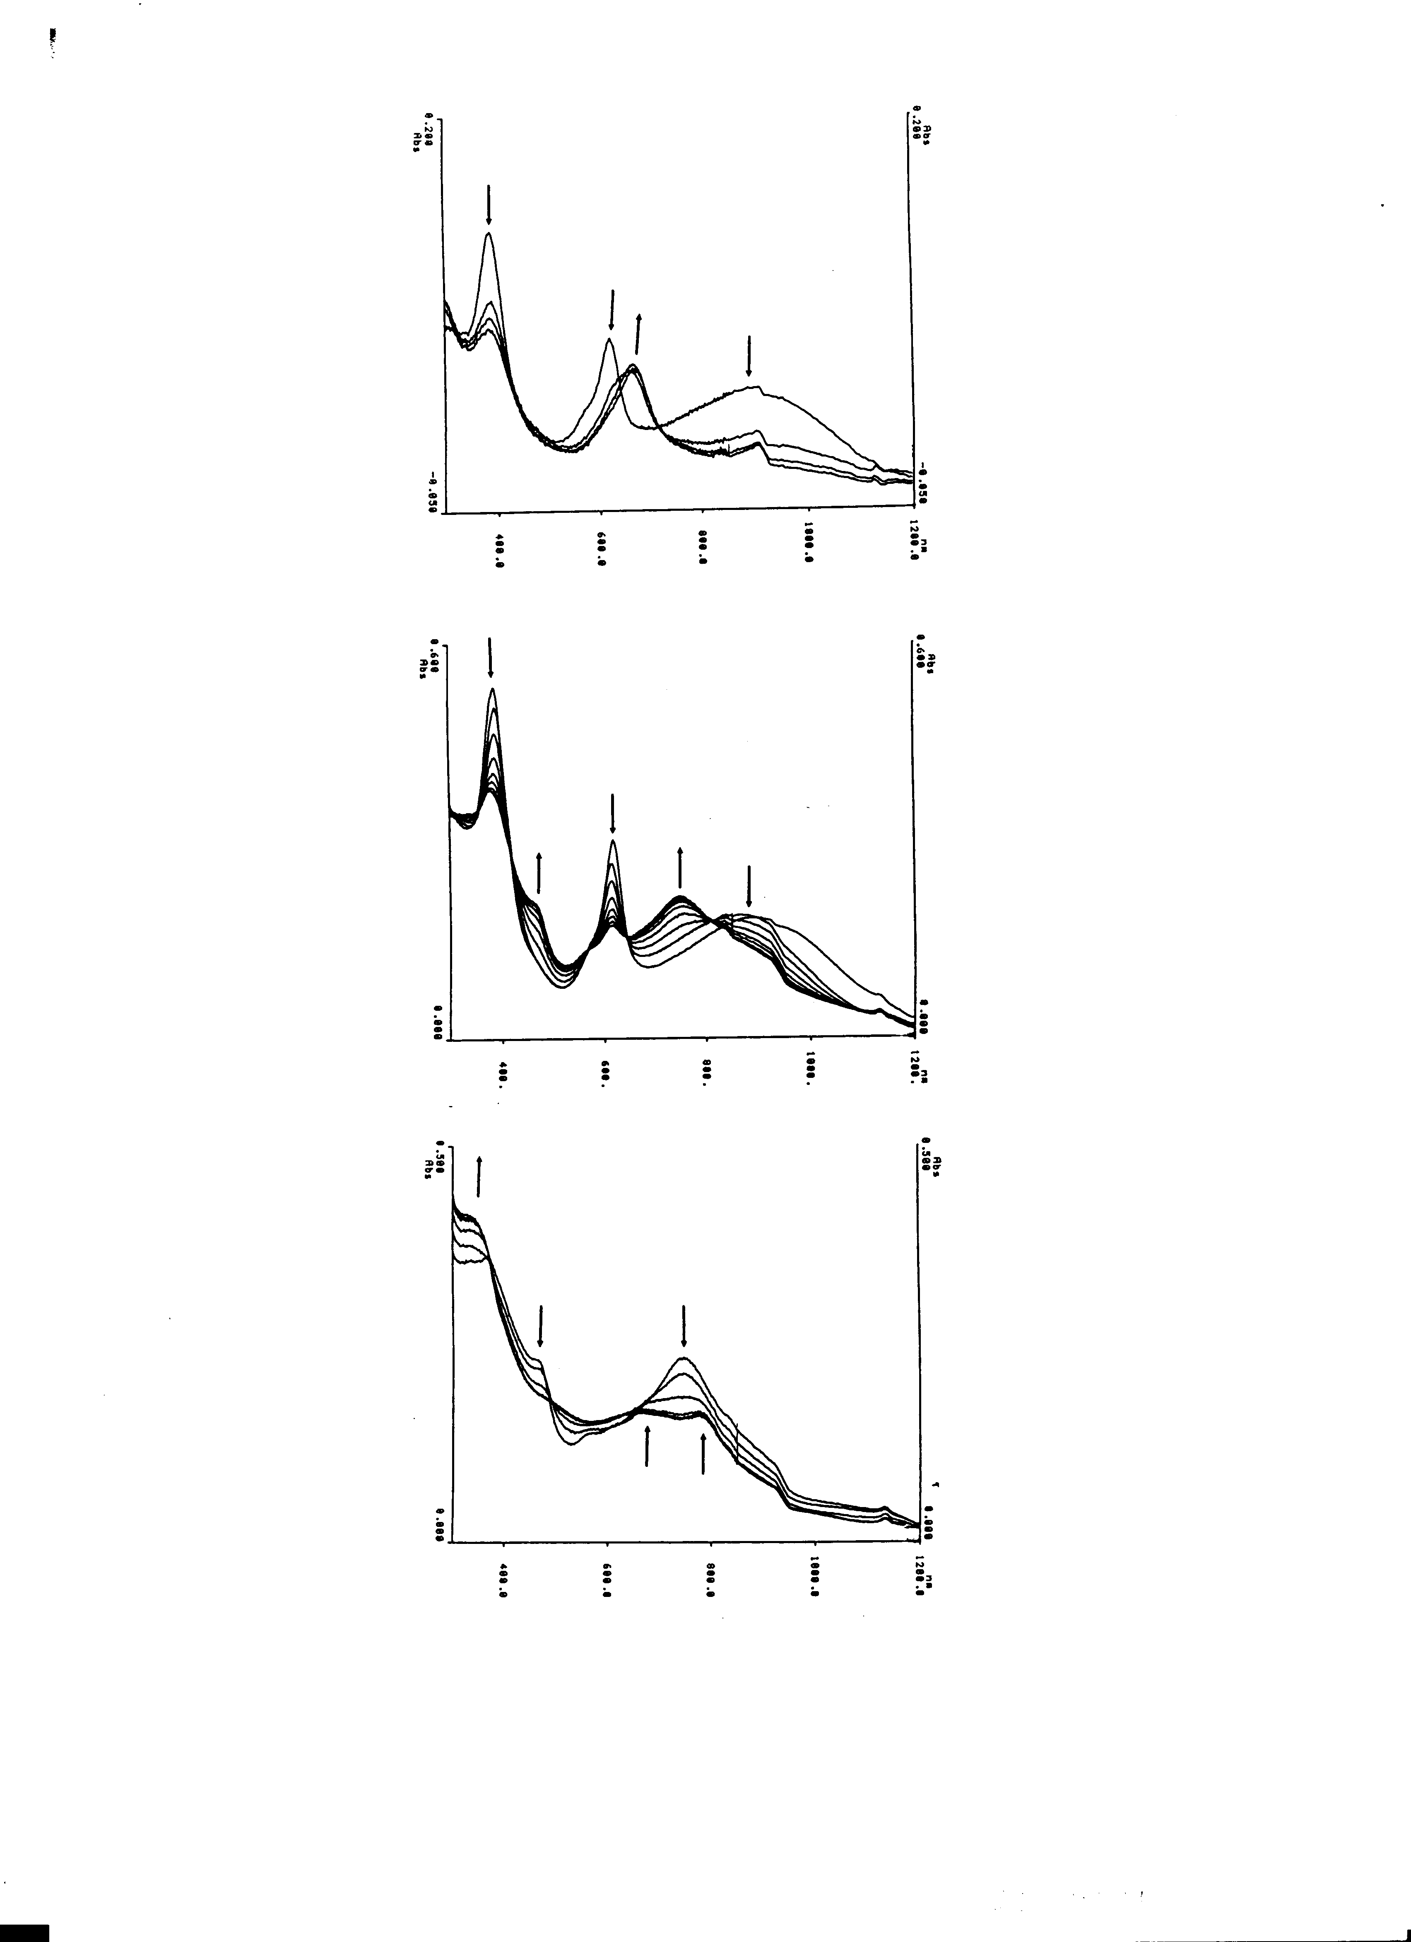
UV-VIS spectra recorded during the electrolysis of 1 at controlled potentials. Top spectrum – first oxidation (potential +0.7V). Middle spectrum – first reduction (potential –0.45V). Bottom spectrum – second reduction (potential –1.0V).

