Carbon-Carbon Bond Forming Reactions of N-Bound Transition Metal α-Cyanocarbanions: A Mechanistic Probe for Catalytic Michael Reactions of Nitriles

Takeshi Naota*, Akio Tannna, and Shun-Ichi Murahashi*
Department of Chemistry, Graduate School of Engineering Science, Osaka University

Experimental Section
General. All experiments were carried out under argon atmosphere using standard Schlenk tube techniques and M.Braun inert gas system LabMaster130. Melting points were measured in a glass capillary on a BÜCHI melting point apparatus B-545. FAB-MS spectra were obtained on a JEOL JMS-DX303HF mass spectrometer. IR spectra were recorded on a Shimadzu FTIR-4100 spectrometer in the region of 4000 - 400 cm⁻¹. ¹H, ¹³C {¹H}, and ³¹P {¹H} NMR spectra were obtained on Varian Unity-Inova 500 spectrometers.

Materials. Benzene, hexane, and THF were purified by distillation over sodium benzophenone ketyl, and stored under argon atmosphere. Ethanol was purified by distillation over magnesium and stored under argon atmosphere. All solvents were degassed by freeze-pump-thaw technique with liquid nitrogen prior to use. (Phenylsulfonyl)acetonitrile was commercially available and purified by recrystallization from ethanol. Acrylonitrile was commercially available and purified by distillation. 3-Pentene-2-one, dimethyl ethylidenemalonate, benzylidene-malononitrile, mesitylene, and bibenzyl were commercially available and used without further purification. Dimethyl benzylidenemalonate,¹ RuCpCl(PPh₃)₂,² Ru⁺Cp(NCCH–SO₂Ph)(PPh₃)₂,³ and Ru⁺Cp(NCCH–CO₂Et)(PPh₃)₂⁴ were prepared according to the reported methods. Na[CH(CN)CO-t-Bu] was prepared by the reaction of pivaloylacetonitrile with sodium hydride and stored under argon atmosphere.

Synthesis of Ru⁺Cp[NCC–(SO₂Ph)CH(CH₃)CH(CO₂CH₃)₂](PPh₃)₂ (2a). A solution of Ru⁺Cp(NCCH–SO₂Ph)(PPh₃)₂ (1a) (0.100 mmol, 0.0871 g) and dimethyl ethylidenemalonate (0.100 mmol, 0.0158 g) in benzene (4.0 mL) was stirred at room temperature for 3 h under argon atmosphere. After removal of the solvent under reduced pressure, the residue was washed with hexane and dried under reduced pressure to give 2a (0.103 g, 99 %) as an orange solid. mp 110 °C (decomp.). IR (KBr) 2153 (CN), 1732 (C=O), 1480, 1433, 1281 (C-O, S=O), 1134 (S=O), 1090, 745, 696, 610 cm⁻¹; FABMS m/z 1030 ([M]⁺); ¹H NMR (500 MHz, C₆D₆) δ 1.26 (d, J = 7.0 Hz, 3 H, CHCH₃), 3.27 (s, 3 H, OCH₃), 3.37 (s, OCH₃), 3.63 (dq, J = 9.6, 7.0 Hz, 1 H, CHCH₃), 4.11 (d, J = 9.6 Hz, 1 H, CH(CO₂CH₃)₂), 4.44 (s, 5 H, C₅H₅), 6.92-7.02 (m, 21 H, ArH), 7.36-7.44 (m, 12 H, PC₆H₅ (ortho)), 8.07 (dd, J = 8.0, 2.5 Hz, 2 H, SO₂C₆H₅ (ortho)); ¹³C {¹H} NMR (126 MHz, C₆D₆) δ 169.5 (C=O), 169.4 (C=O), 150.9 (SO₂C₆H₅ (ipso)), 143.7 (CN), 137.9 (PC₆H₅ (ipso)), 134.0 (SO₂C₆H₅ (ortho)), 133.8 (PC₆H₅ (ortho)), 129.3 (SO₂C₆H₅ (para)), 129.2 (PC₆H₅ (para)), 128.5 (PC₆H₅ (meta)), 126.4 (SO₂C₆H₅ (meta)), 83.6 (C₅H₅), 59.9 (CH(CO₂CH₃)₂), 58.7 (CCN), 52.0 (OCH₃), 51.6 (OCH₃), 34.2 (CHCH₃), 20.4 (CH₃); ³¹P {¹H} NMR (202 MHz, C₆D₆) δ 43.2 (s). Anal. Calcd for C₅₆H₅₁NO₆P₂RuS: C, 65.4; H, 5.00; N, 1.36. Found: C, 65.5; H, 4.82; N, 1.36.

Synthesis of Ru⁺Cp[NCC–(CO₂Et)CH(CH₃)CH(CO₂CH₃)₂](PPh₃)₂ (2b). A solution of Ru⁺Cp(NCCH–CO₂Et)(PPh₃)₂ (1b) (0.100 mmol, 0.0803 g) and dimethyl ethylidenemalonate (0.100 mmol, 0.0158 g) in benzene (4.0 mL) was stirred at room temperature for 3 h under argon atmosphere. Removal of the solvent under reduced pressure gave 2b (0.0942 g, 98 %) as an orange solid. mp 81 °C (decomp.). IR (KBr) 2164 (CN), 1752 (C=O), 1732 (C=O), 1618, 1480, 1433, 1092, 747, 696, 534, 521 cm⁻¹; FABMS m/z 962 ([M]⁺), 693 (RuCp(PPh₃)₂), 431 (RuCp(PPh₃)); ¹H NMR (500 MHz, C₆D₆) δ 1.21 (t, J = 7.5 Hz, 3 H, OCH₂CH₃), 1.66 (d, J = 7.0 Hz, 3 H, CHCH₃), 3.40 (s, 3 H, OCH₃), 3.45 (s, 3 H, OCH₃), 3.85 (dq, J = 9.5, 7.0 Hz, 1 H, CHCH₃), 4.38 (s, 5 H, C₅H₅), 4.42-4.48 (m, 2 H, OCH₂CH₃), 4.81 (d, J = 9.5 Hz, 1 H, CH(CO₂CH₃)₂), 6.98-7.12 (m, 18 H, PC₆H₅ (meta, para)), 7.41-7.49 (m, 12 H, PC₆H₅ (ortho)); ³¹P {¹H} NMR (202 MHz, C₆D₆) δ 43.3 (s).

Preparation of Ru⁺Cp(NCCH–CO-t-Bu)(PPh₃)₂ (1c). A mixture of RuCpCl(PPh₃)₂ (1.00 mmol, 0.726 g) and Na[CH(CN)CO-t-Bu] (2.00 mmol, 0.294 g) in ethanol (40 mL) was stirred at room temperature for 24 h under argon atmosphere. After removal of the solvent under reduced pressure, the yellow residue was dissolved in benzene (30 mL) and filtered. Removal of the solvent under reduced pressure gave 1c (0.726 g, 89 %) as a yellow solid. mp 94 °C (decomp.). IR (KBr) 2174 (CN), 1510, 1480 (CO), 1433, 1356, 1090, 743, 696, 534, 520, 498 cm⁻¹; FABMS m/z 815 ([M]⁺); ¹H NMR (500 MHz, C₆D₆) δ 1.62 (s, 9 H, C₄H₉), 4.28 (s, 5 H, C₅H₅), 4.36 (s, 1 H, NCCH–), 6.98-7.03 (br, 18 H, PC₆H₅ (meta, para)), 7.42-7.48 (m, 12 H, PC₆H₅ (ortho)); ¹³C {¹H} NMR (126 MHz, CDCl₃) δ 201.0 (s, CO), 143.2 (s, CN), 137.2 (t, J = 22.6 Hz, PC₆H₅ (ipso)), 136.9 (t, J = 22.2 Hz, PC₆H₅ (ipso)), 133.5 (s, PC₆H₅ (ortho)), 129.1 (s, PC₆H₅ (para)), 127.8 (s, PC₆H₅ (meta)), 82.8 (dd, J = 90.9, 76.4 Hz, C₅H₅), 50.4 (dd, J = 82.8, 62.5 Hz, NCCH–), 40.3 (s, C(CH₃)₃), 28.9 (dd, J = 74.5, 35.5 Hz, C(CH₃)₃); ³¹P {¹H} NMR (202 MHz, C₆D₆) δ 43.6 (s).

Synthesis of Ru⁺Cp[NCC–(CO-t-Bu)CH(CH₃)CH(CO₂CH₃)₂](PPh₃)₂ (2c). A solution of 1c (0.100 mmol, 0.0814 g) and dimethyl ethylidenemalonate (0.100 mmol, 0.0158 g) in benzene (4.0 mL) was stirred at room temperature for 3 h under argon atmosphere. After removal of the solvent under reduced pressure, the residue was washed with hexane and dried under reduced pressure to give 2c (0.0954 g, 98 %) as an orange solid. mp 59 °C (decomp.). IR (KBr) 2151 (CN), 1751 (C=O), 1736 (C=O), 1522, 1480, 1435, 1356, 1090, 745, 696, 521 cm⁻¹; FABMS m/z 973 ([M]⁺); ¹H NMR (500 MHz, C₆D₆) δ 1.38 (d, J = 7.0 Hz, 3 H, CHCH₃), 1.60 (s, 9 H, C₄H₉), 3.27 (s, 3 H, OCH₃), 3.29 (s, 3 H, OCH₃), 3.48 (dq, J = 7.0, 7.0 Hz, 1 H, CHCH₃), 4.06 (d, J = 7.0 Hz, 1 H, CH(CO₂CH₃)₂), 4.29 (s, 5 H, C₅H₅), 6.96-7.10 (m, 18 H, PC₆H₅ (meta, para)), 7.41-7.47 (m, 12 H, PC₆H₅ (ortho)); ³¹P {¹H} NMR (202 MHz, C₆D₆) δ 43.6 (s).

Synthesis of Ru⁺Cp[NCC–(SO₂Ph)CH(Ph)CH(CO₂CH₃)₂](PPh₃)₂ (2d). A solution of 1a (0.100 mmol, 0.0871 g) and dimethyl benzylidenemalonate (3) (0.100 mmol, 0.022 g) in benzene (4.0 mL) was stirred at room temperature for 24 h under argon atmosphere. After removal of the solvent under reduced pressure, the residue was washed with hexane and dried under reduced pressure to give 2d (0.107 g, 98 %) as an orange solid. mp 70 °C (decomp.). IR (KBr) 2152 (CN), 1732 (C=O), 1480, 1433, 1277, 1213, 1186, 1130, 745, 696, 521 cm⁻¹; FABMS m/z 1091 ([M]⁺); ¹H NMR (500 MHz, C₆D₆) δ 3.18 (s, 3 H, CO₂CH₃), 3.76 (s, 3 H, CO₂CH₃), 4.54 (s, 5 H, C₅H₅), 4.67 (d, J = 12.0 Hz, CHPh), 4.84 (d, J = 12.0 Hz, CH(CO₂CH₃)₂), 6.82-7.11 (m, 24 H, ArH), 7.30-7.40 (m, 8 H, ArH), 7.49-7.56 (m, 6 H, ArH), 7.88 (dd, J = 8.5, 7.0 Hz, SO₂C₆H₅ (ortho)); ³¹P {¹H} NMR (202 MHz, C₆D₆) δ 41.0 (d, J = 39.0 Hz), 45.1 (d, J = 39.0 Hz).

Synthesis of Ru⁺Cp[NCC–(SO₂Ph)CH(Ph)CH(CN)₂](PPh₃)₂ (2e). A solution of 1a (0.100 mmol, 0.0871 g) and benzylidenemalononitrile (0.100 mmol, 0.0154 g) in benzene (4.0 mL) was stirred at room temperature for 3 h under argon atmosphere. After removal of the solvent under reduced pressure, the residue was washed with hexane and dried under reduced pressure to give 2e (0.101 g, 99 %) as an orange solid. mp 70 °C (decomp.). IR (KBr) 3056, 2164 (CN), 1480, 1433, 1279, 1130, 1090, 747, 696, 521 cm⁻¹; FABMS m/z 1025 ([M]⁺); ¹H NMR (500 MHz, C₆D₆) δ 4.20 (d, J = 7.0 Hz, 1 H, CHPh), 4.29 (s, 5 H, C₅H₅), 4.62 (d, J = 7.0 Hz, 1 H, CH(CN)₂), 6.81-7.05 (m, 18 H, ArH), 7.08 (dt, J = 7.0, 2.0 Hz, 6 H, ArH), 7.12-7.18 (m, 6 H, ArH), 7.30 (d, J = 7.0 Hz, 2 H, ArH), 7.41 (d, J = 7.0 Hz, 2 H, ArH), 7.43 (dd, J = 8.5, 1.5 Hz, 4 H, ArH), 7.76 (dd, J = 8.5, 1.0 Hz, 2 H, SO₂C₆H₅ (ortho)); ³¹P {¹H} NMR (202 MHz, C₆D₆) δ 41.0 (d, J = 38.9 Hz), 43.5 (d, J = 38.9 Hz).

Synthesis of Ru⁺Cp[NCC–(SO₂Ph)CH(CH₃)CH₂COCH₃](PPh₃)₂ (2f). A solution of 1a (0.0175 mmol, 0.0153 g), 3-pentene-2-one (0.070 mmol, 0.0103 g), and mesitylene (internal standard, 0.0058 mmol, 0.80 μL) in C₆D₆ (0.70 mL) was sealed in a Wilmad 5 mm φ screw-capped NMR tube under argon atmosphere, and stand at room temperature for 24 h. ¹H NMR (500 MHz) analysis of the solution showed that complex 2f was formed in 31 % yield (conversion of 1a, 50 %). 2f: ¹H NMR (500 MHz, C₆D₆) δ 1.13 (d, J = 7.0 Hz, 3 H, CHCH₃), 1.87 (s, 3 H, COCH₃), 2.36 (dd, J = 14.0, 7.0 Hz, 1 H, CH₂COCH₃), 2.66 (d, J = 14.0, 8.0 Hz, 1 H, CH₂COCH₃), 3.18 (ddq, J = 8.0, 7.0, 7.0 Hz, 1 H, CHCH₃), 4.42 (s, 5 H, C₅H₅), 6.94-7.10 (m, 21 H, ArH), 7.31-7.37 (m, 6 H, ArH), 7.41-7.47 (m, 6 H, ArH), 8.18 (dd, J = 8.0, 1.5 Hz, 2 H, SO₂C₆H₅ (ortho)); ³¹P {¹H} NMR (202 MHz, C₆D₆) δ 43.5 (d, J = 38.8 Hz), 43.8 (d, J = 38.8 Hz).

Synthesis of Ru⁺Cp[NCC–(SO₂Ph)CH₂CH₂CN](PPh₃)₂ (2g). A solution of 1a (0.0175 mmol, 0.0153 g), acrylonitrile (0.0193 mmol, 0.0010 g), and mesitylene (internal standard, 0.0058 mmol, 0.80 μL) in C₆D₆ (0.70 mL) was sealed in a Wilmad 5 mm φ screw-capped NMR tube under argon atmosphere, and stand at room temperature for 24 h. ¹H NMR (500 MHz) analysis of the solution showed that complex 2g was formed in 36 % yield (conversion of 1a, 67 %). 2g: ¹H NMR (500 MHz, C₆D₆) δ 2.78-2.88 (m, 2 H, CH₂CH₂CN), 3.35-3.46 (m, 2 H, CH₂CH₂CN), 4.30 (s, 5 H, C₅H₅), 6.85-7.20 (m, 21 H, ArH), 7.26-7.45 (m, 12 H, ArH), 8.01 (dd, J = 7.0, 2.2 Hz, 2 H, SO₂C₆H₅ (ortho)); ³¹P {¹H} NMR (202 MHz, C₆D₆) δ 43.1 (d, J = 20.4 Hz), 43.5 (d, J = 20.4 Hz).

Complex 1a-Catalyzed Michael Addition of (Phenylsulfonyl)acetonitrile (4) to 3. A solution of 4 (1.00 mmol, 0.181 g), 3 (1.10 mmol, 0.242 g), and catalyst 1a (0.0300 mmol, 0.0261 g) in THF (0.25 mL) was stirred at room temperature for 24 h under argon atmosphere. After removal of the solvent under reduced pressure, the residue was purified by column chromatography (SiO₂) to give methyl 4-cyano-1-methoxycarbonyl-3-phenyl-4-(phenylsulfonyl)butanoate (5) (0.345 g, 86 %) as a colorless solid. ¹H NMR (500 MHz, C₆D₆) analysis showed that the diastereomeric ratio of 5 is 90 : 10. IR (neat) 3038, 2961, 2245 (CN), 1740 (C=O), 1447, 1350, 1306, 1240, 1211, 1163, 1086, 1014, 939, 802, 704, 685, 623, 586, 567, 534 cm⁻¹; MS (EI) m/z 401 ([M]⁺); ¹H NMR (500 MHz, C₆D₆) δ 3.05 (s, 3 H, OCH₃ (major)), 3.11 (s, 3 H, OCH₃ (minor)), 3.18 (s, 3 H, OCH₃ (major)), 3.37 (s, 3 H, OCH₃ (minor)), 4.28 (d, J = 10.5 Hz, 1 H, CH(CO₂Me)₂ (major)), 4.49 (d, J = 9.5 Hz, 1 H, CH(CO₂Me)₂ (minor)), 4.57 (dd, J = 8.5, 6.5 Hz, 1 H, CHPh (minor)), 4.64 (d, J = 8.5 Hz, 1 H, CHCN (minor)), 4.81 (dd, J = 10.5, 4.5 Hz, 1 H, CHPh (major)), 5.35 (d, J = 4.5 Hz, 1 H, CH(CO₂Me)₂ (major)), 6.76-7.06 (m, 6 H, ArH), 7.57 (d, J = 7.5 Hz, 2 H, CHC₆H₅ (ortho, major)), 7.73 (d, J = 8.5 Hz, 2 H, CHC₆H₅ (ortho, minor)), 7.79 (d, J = 8.5 Hz, 2 H, SO₂C₆H₅ (ortho, major)), 7.98 (d, J = 7.0 Hz, 2 H, SO₂C₆H₅ (ortho, minor)); ¹³C {¹H} NMR (126 MHz, C₆D₆) δ 168.0 (s, CO₂CH₃), 166.8 (s, CO₂CH₃), 137.6 (s, SO₂C₆H₅ (ipso)), 134.4 (CHC₆H₅ (ipso)), 134.3 (s, SO₂C₆H₅ (ortho)), 130.0 (s, CHC₆H₅ (ortho)), 129.5 (s, ArC), 129.3 (s, ArC), 129.2 (s, ArC), 128.3 (s, ArC), 113.8 (s, CN), 60.0 (s, OCH₃), 55.1 (s, CH(CO₂CH₃)₂), 55.0 (s, CHCN), 42.7 (s, CHC₆H₅).

Complex 2d-Catalyzed Michael Addition of 4 to 3. A solution of 4 (1.00 mmol, 0.181 g), 3 (1.10 mmol, 0.242 g), and catalyst 2d (0.0300 mmol, 0.0327 g) in THF (0.25 mL) was stirred at room temperature for 24 h under argon atmosphere. After removal of the solvent under reduced pressure, the residue was purified by column chromatography (SiO₂) to give 5 (0.353 g, 88 %) as a colorless solid.

Kinetic Measurement of the Reaction of 1a with 3. Complex 1a (0.014 mmol) and bibenzyl (internal standard, 0.0140 mmol) were placed in a Wilmad screw-capped 5 mm φ NMR tube and dissolved in THF-d₈ (0.700 mL). After olefin 3 (0.140 – 0.280 mmol) was added to the solution under argon atmosphere, the mixture was subjected to ¹H NMR (500 MHz) analysis keeping deviation of temperature within ± 0.3 K. Concentration of 1a was determined periodically by relative intensities of Cp group of 1a (4.19 ppm) based on the methylene protons of internal standard (2.80 ppm). Pseudo-first order rate constants, k_{obs}, were obtained by linear least-square analysis of the dependence of –ln([1a]/[1a]₀) versus time (Table S1). Second order rate constants, k₁, were determined by linear least-square analysis of the dependence of k_{obs} versus [3]₀ (Fig. 1 and Table S2). Activation parameters were obtained by linear least-square analysis of the dependence of ln(k₁) versus 1/T (Fig. S2 and Table S3). Blank experiments on solution of 1a in the absence of 3 showed no significant decay.

Kinetic Measurement of the Reaction of 2d with 4. Complex 2d (0.014 mmol) and bibenzyl (internal standard, 0.0140 mmol) were placed in a Wilmad screw-capped 5 mm φ NMR tube and dissolved in THF-d₈. After nitrile 4 (0.140 – 0.280 mmol) was added to the solution under argon atmosphere, the mixture was subjected to ¹H NMR (500 MHz) analysis keeping deviation of temperature within ± 0.3 K. Concentration of 2d was determined periodically by relative intensities of Cp group of 2d (4.54 ppm) based on the methylene protons of the internal standard (2.80 ppm). Pseudo-first order rate constants, k_{obs}, were obtained by linear least-square analysis of the dependence of –ln([2d]/[2d]₀) versus time (Table S4). First order rate constant, k₂, was determined as arithmetic mean of k_{obs} in different [4]₀. Blank experiments on solution of 2d in THF-d₈ in the absence of 4 showed no significant decay.

Kinetic Measurement of Catalytic Michael Addition of Nitrile 4 with 3. Nitrile 4 (0.140 – 0.210 mmol), bibenzyl (internal standard, 0.0140 mmol), and catalyst 1a or 2d (0.0140 – 0.0280 mmol) were placed in a Wilmad screw-capped 5 mm φ NMR tube, and dissolved in THF-d₈ (0.700 mL). After 3 (0.140 – 0.210 mmol) was added to the solution under argon atmosphere, the mixture was subjected to ¹H NMR (500 MHz) analysis keeping deviation of temperature within ± 0.3 K. Concentration of 5 was determined periodically by relative intensities of two methyl groups of 5 (3.52 ppm) based on the methylene protons of the internal standard (2.80 ppm). Observed rate constants, k_{obs}, were obtained by linear least-square analysis of the dependence of [5] versus time (Fig. S3 and Table S5).

References
1. C. F. H. Allen and F. W. Spangler, Org. Synth., Coll. vol. 3, 1955, 377.
2. M. L. Bruce, G. S. Ashby, I. B. Tomkins and R. C. Wallis, Aust. J. Chem., 1979, 32, 1003.
3. T. Naota, A. Tannna and S.-I. Murahashi, J. Am. Chem. Soc., 2000, 122, 2960.
4. S.-I. Murahashi, K. Take, T. Naota and H. Takaya, Synlett, 2000, 1016.
Supporting Information
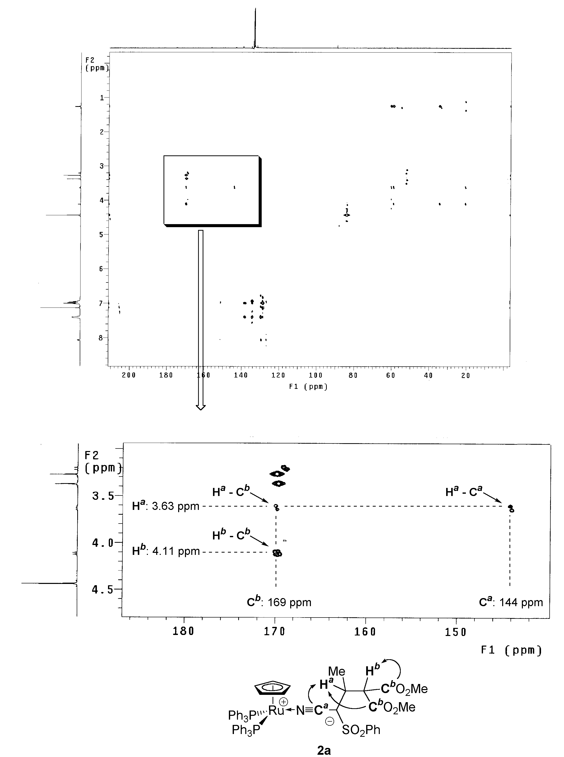

Fig. S1 500 MHz HMBC Spectrum of 2a.
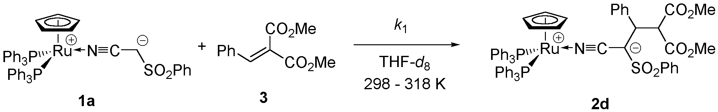

Fig. S2 Arrhenius Plot for the Reaction of 1a with 3 in THF-d₈.

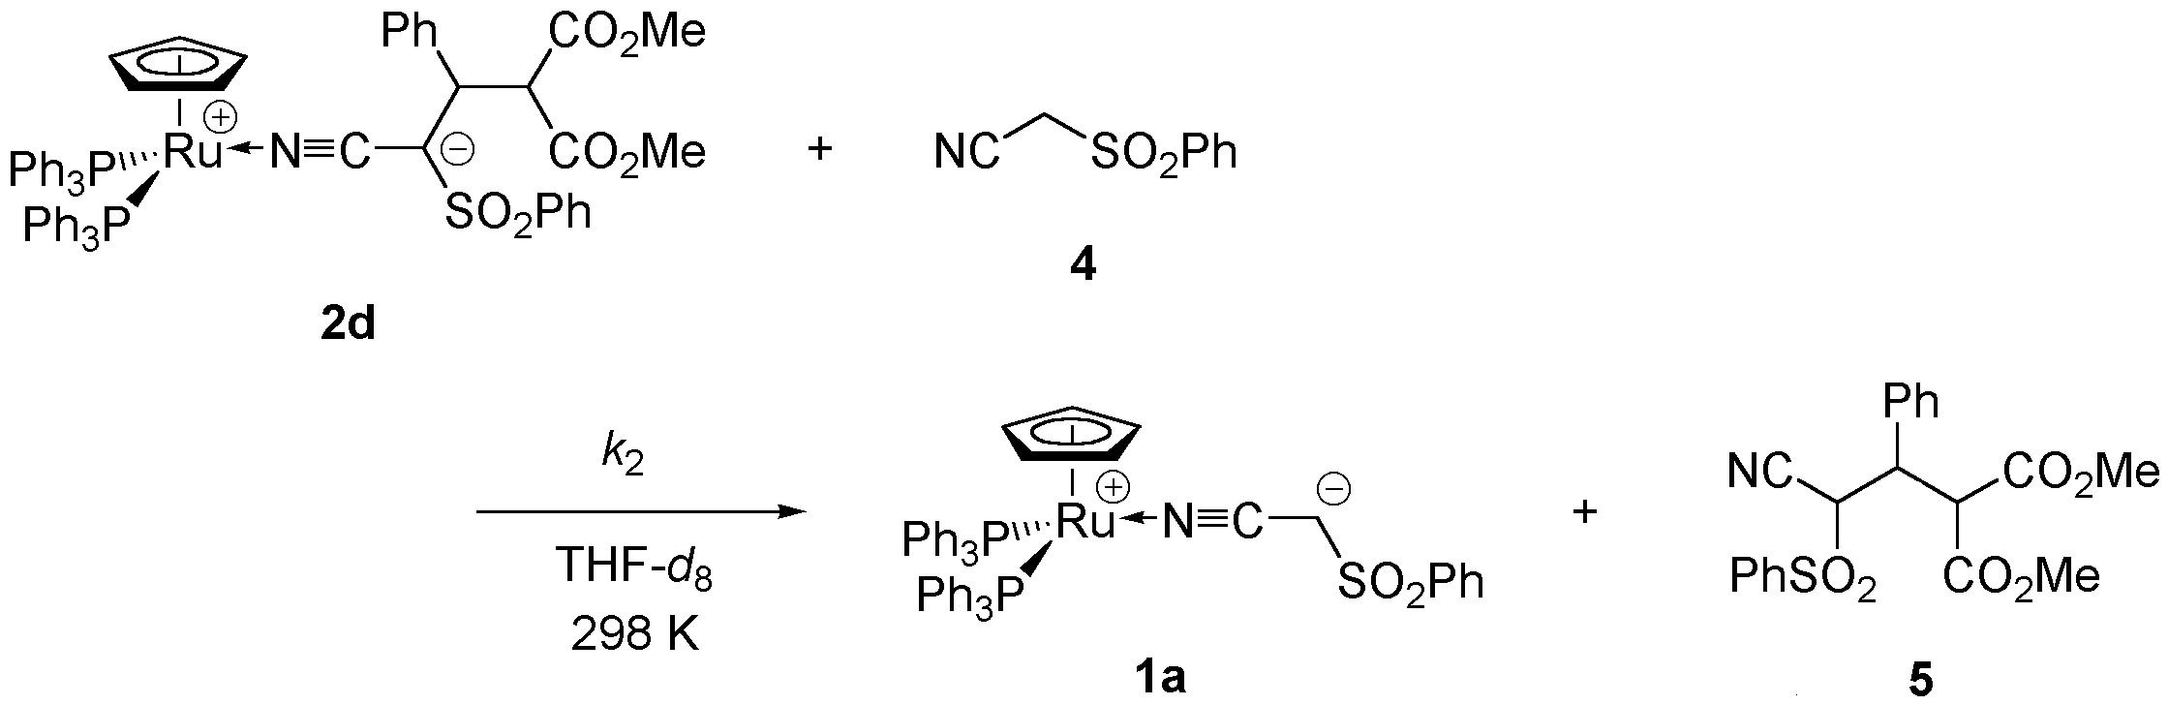

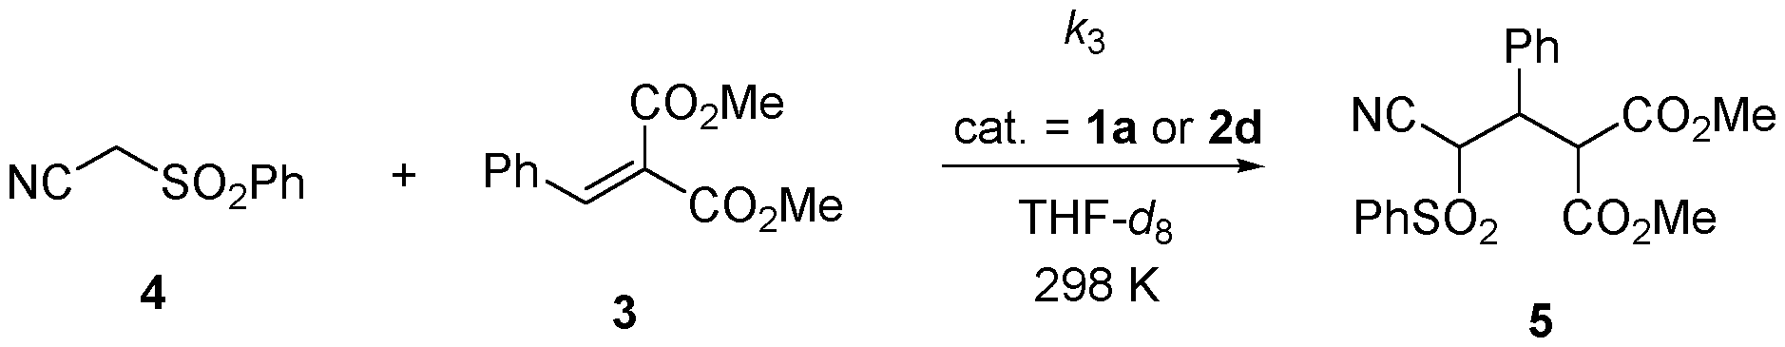

Fig. S3 Time-Dependence of [5] for 1a-Catalyzed Michael Reaction of 4 with 3 in THF-d₈ ([1a]₀ = 0.0200 M (), 0.0450 M (), T = 298 K).

