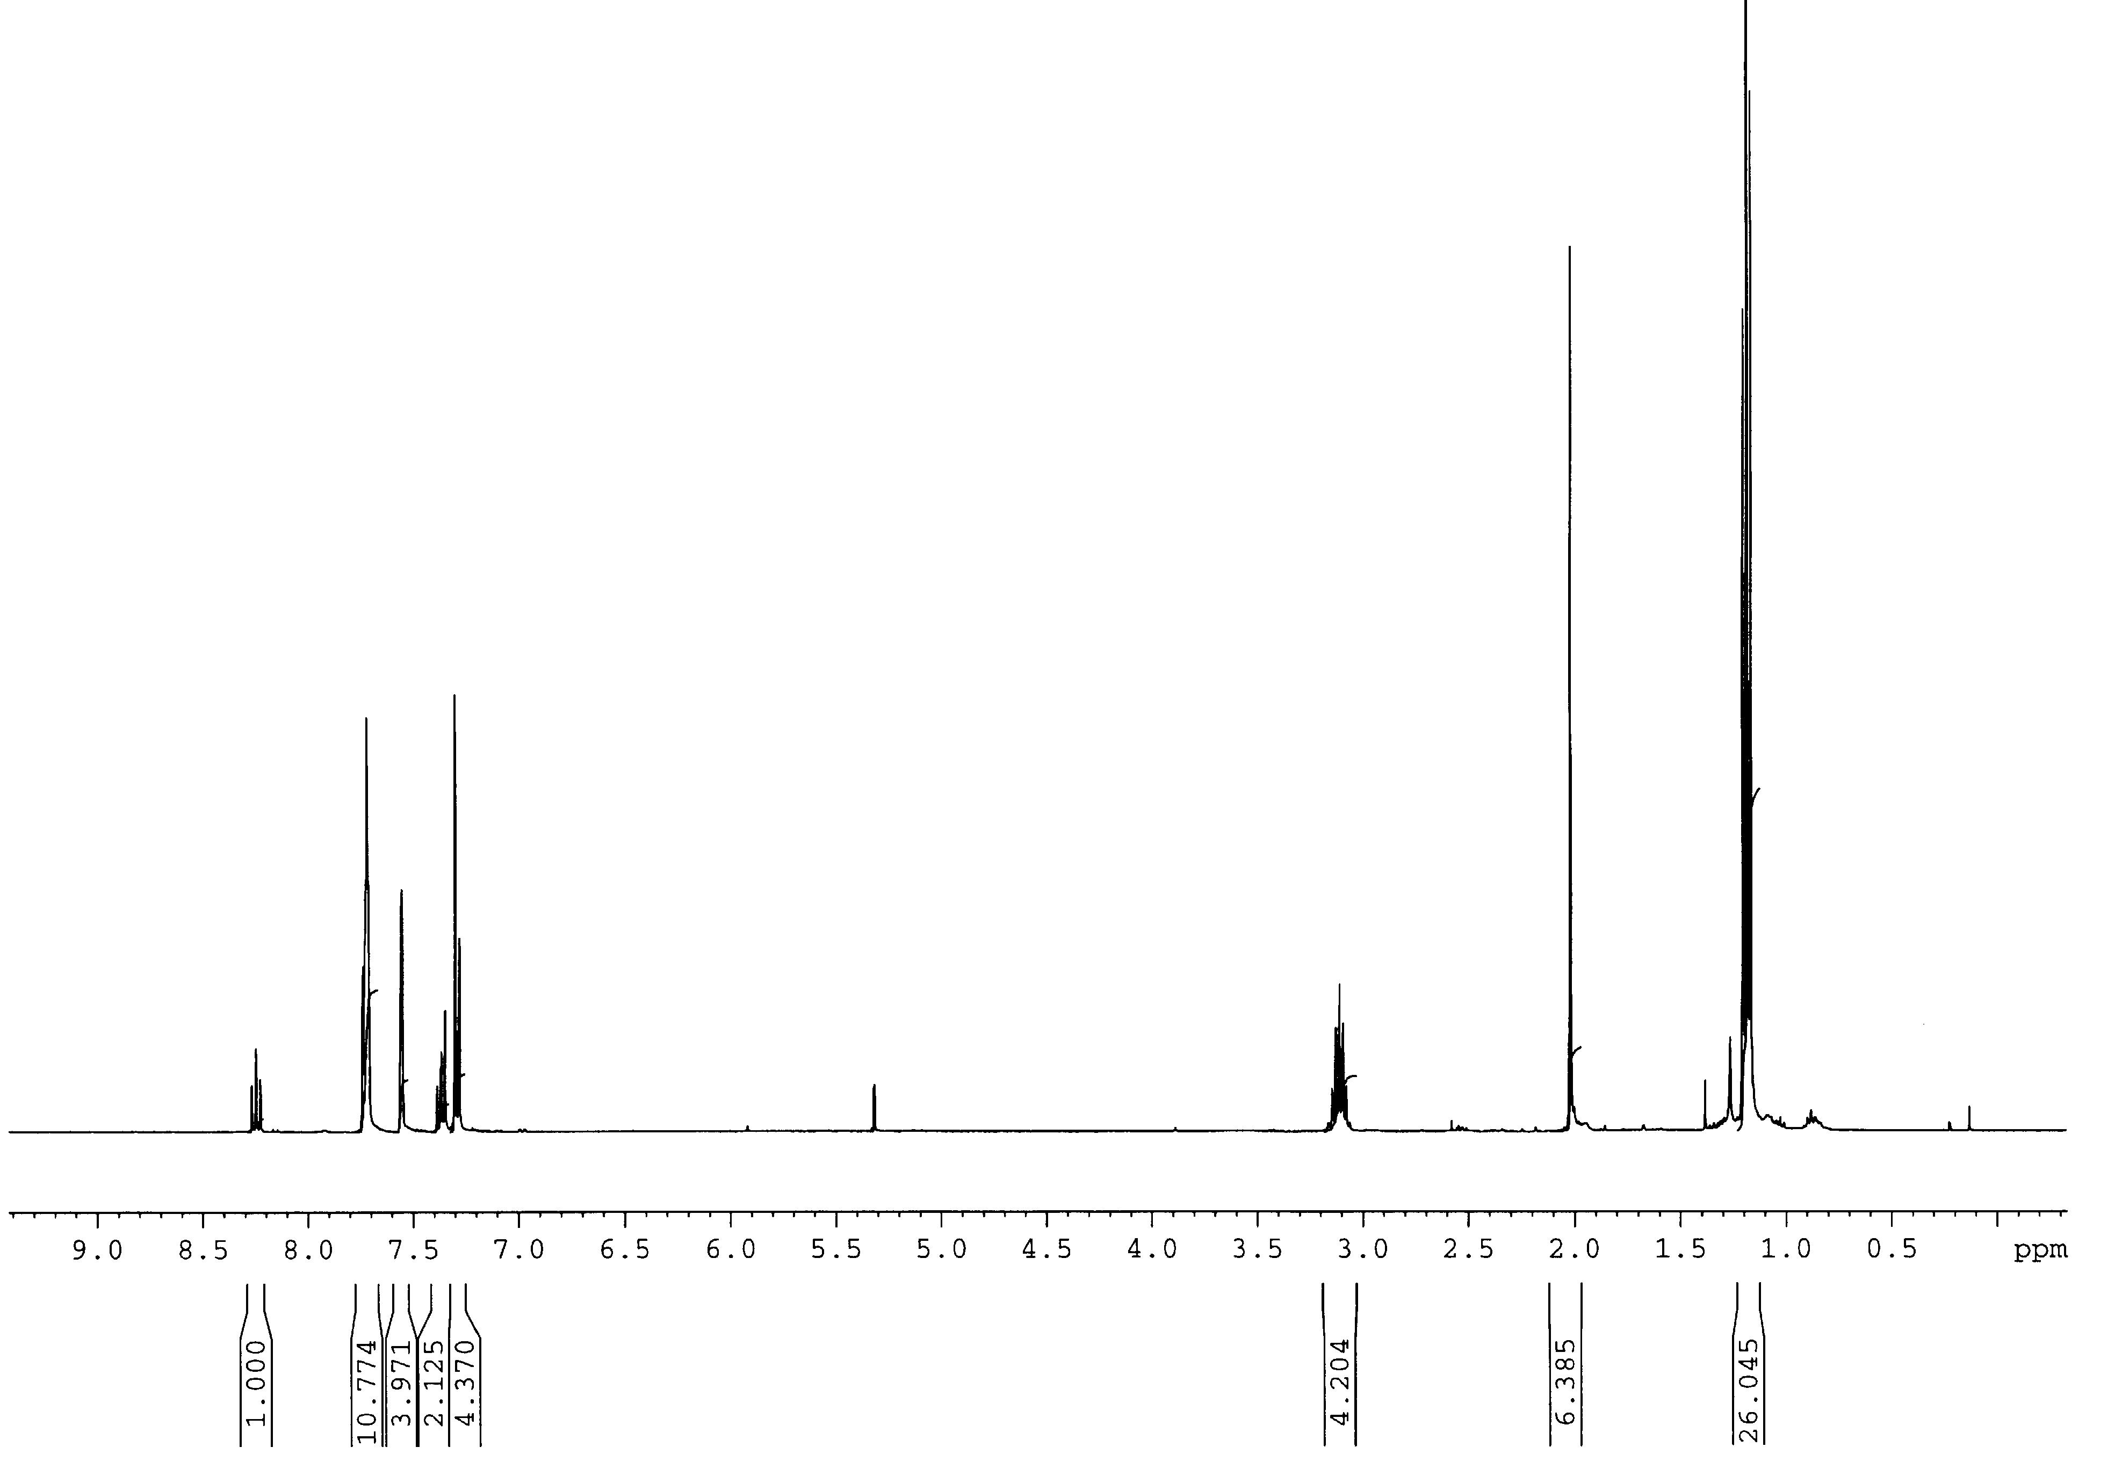

Figure S2. ¹H NMR spectrum of 1 in CD₂Cl₂ at 25°C.

