Supplementary Material:

Supplementary Figure 1. Chemical shift vs. concentration plots for the self-complimentary porphyrins. Fits of the data are summarized in supplementary materials table 1. =square tetramer, = linear tetramer,  = linear trimer, = linear dimer. At any concentration or temperature, only one amide proton is observed; thus supporting the quadruple and dynamic nature of the intermolecular interactions.

Species | n | K | r² | C_{1/2} M⁻¹ | ΔG (kJmol⁻¹)
1a dimer | 2 + 0.5 | 160 + 80 M⁻¹ | 0.9943 | 125  (~600) | -12.6 (-12.0)b
1a-2a-1a trimer | 3.2 + 1.2 | 110 + 60 M⁻² | 0.9952 | 200 | -11.6 (-13.1)
1a-2a-2a-1a tetramer | 4.1 + 1.8 | 70 + 40 M⁻³ | 0.9925 | 111 | -10.5 (-10.5)
3a square | 3.9 + 1.1 | 2400 + 220 M⁻³ | 0.9977 | 1250  (~3000) | -19.3 (-17.7)
Supplementary Table 1. Fits of the ¹H-NMR data at 298K in CDCl₃ for the self-complementary arrays. n = number of particles, K = equilibrium constant from the fit of the data, r²=correlation coefficient of the fit, C_{1/2}=[Por] at ½ rise to maximum, ( ) = in tolunene. ^{(a)}in toluene d₈. ΔG=-RTln(K) and ^{(b)}(using C_{1/2} values to estimate ΔG).

Note that the ¹H-NMR data and fits also indicate the relative amounts of the monomers and self-assembled species at each concentration. This information is then used to interpret the results of other spectroscopic techniques.

Van’t Hoff plots¹¹ of the chemical shift versus temperature for the free base dimer of 1a, in the same solvent using several concentrations, indicate that the formation enthalpy, ΔH_{f} , of the quadruple H-bond is –31 + 5 kJ mol⁻¹ and the entropy is about –80 + 80 Jmol⁻¹, yielding a ΔG of –7 kJ mol⁻¹, which is in qualitative agreement with the NMR equilibrium studies. Factoring in the four sets of H-bonding pairs, the formation enthalpy is –96 kJ mol⁻¹ for the square tetramer, or about -24 kJ mol⁻¹ per set. This lower value than the –31+5 kJ mol⁻¹ for the dimer may reflect some strain on a system that is unlikely to be exactly planar because of the small offset required for the quadruple H-bond links.

Assembly | −ΔH (kJmol⁻¹) (kcal) | ΔS (Jmol⁻¹K⁻¹) | ΔG (kJmol⁻¹)
1a dimer | 31 + 5 (7) | -80 + 30 | -7
3a square | 96 + 32 (23) | -240 + 150 | -24.5
Supplementary Table 2. Estimations of ΔH and ΔS (298K) from van’t Hoff plots of the ¹H-NMR data in CDCl₃ at temperatures between 270 and 328 K in CDCl₃. ΔG=ΔH-TΔS

Supplementary Figure 2. The Uv-visible spectra of 3a in ethanol (A) and chloroform (B). The smooth lines are at ~250 μM, and the jagged lines are at 2 μM multiplied by a factor of 110. Inset: the Soret band in chloroform (---) is ~ 3nm to the red of that in ethanol (___).

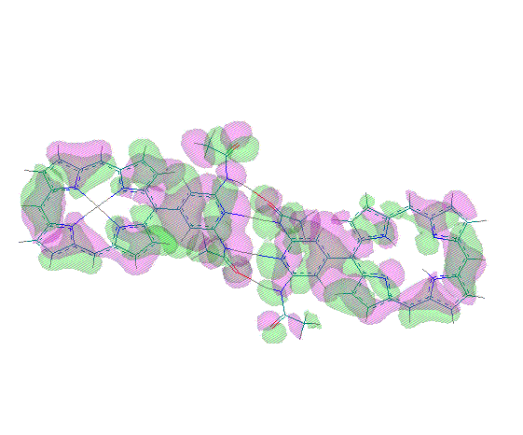
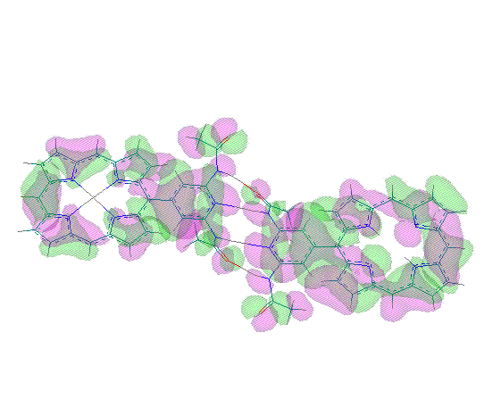

Supplementary material Figure 3. AM1 calculations of the molecular orbital densities for the free base dimers indicate two nearly degenerate orbitals with substantial electron density spanning from one porphyrin, across the diacetamidopyridy groups to the other porphyrin. These orbitals persist with somewhat different densities in the case of the 3a –3b dimer.

Vapor Phase Osmometry (VPO) of 3a on a Jupiter 833 instrument at 50 ⁰C in toluene using a 5KD polystyrene standard, shows two lines – one for low concentrations and one for concentration over ~ 0.1mM. The first yield a molar mass of 893 + 10% consistent with the monomer (957 D), and the second 3.6 KD which is consistent with the square (3.828 KD). Thus, no larger aggregates are indicated.

There is no indication of substantial pi-stacking or axial ligation of the zinc complexes, by UV-visible, fluorescence emission, resonance and dynamic light scattering, and NMR shifts and line widths. ¹¹ Electrospray ionization mass spectra (ESI-MS) has been shown to be a powerful tool in examining the relative concentrations of self-assembled species. To avoid using acids to protonate the free bases, the Mn(III) or Co(III) complexes of these porphyrins (acetate counter ions) are added at a ratio to impart one or more positive charges to the self-assembled arrays.

Supplementary Materials Figure 4. ESI-MS of the self-complimentary hydrogen bond assembled square using a 3:1 ratio of 3a to the Co(III) acetate porphyrin, 3Co(III)Ac. Positive ion mode, in chloroform, voltage was ramped from 50 to 300V.

Thus, at 0.1 mM ~10% of the dimer is observed in chloroform (1 equivalent of 1Mn(III)Ac). The greater equilibrium constant of the square, allows for lower concentrations to be used, and a more thorough ESI-MS study. As the concentration of 3a (with a 1:3 ratio of the Co(III) acetate complex to 3a) increases so does the formation of the square. At very low concentrations, only the monomers are observed. As the concentrations increase, the amount of the self-assembled species increases up to the concentration limit of the experiment. In the present case, the parent ions of the dimers, trimers, and square tetramers are readily observed with relative abundances consistent with those predicted the NMR data.

Several observations mitigate against simple aggregation by pi-stacking or large open chain polymers: (i) the ground state spectra of 1 μM and 280 μM solutions of these compounds are quantitatively similar in ethanol, chloroform and 2-methylTHF, (ii)the lower symmetry of the porphyrin, (iii)the bulky meta acetamido substituents, (iv)Stern-Volmer plots show a linear relation with a small slope for the ethanol data, and a substantially curved spectra for the 2-methyl-THF data, (v)NMR data shows neither axial coordination of the zinc nor the characteristic shifts due to ring the currents of the macrocycle even at the highest concentrations possible. At 0.480 mM concentrations of 3a, few if any (< 2%) large aggregates (mean radius 4.2 nm) are detected by Dynamic light scattering, and at lower concentrations, no aggregates are detected and a weak signal that may be the square (hydrodynamic radius of ~3) is observed. Resonance light scattering only detects aggregates of undetermined size at saturated concentrations.

Experimental Section
Instrumentation: Steady state and fluorescence life time measurements (phase modulated) were made on a Spex Tau-3 instrument. Varian 400 MHz and Joel 300 MHz NMR, Hewlett-Packard HP 1100 LC/MSD, and a Carey Bio-3 were used in characterization of the compounds and assemblies.

The complete synthesis and characterization of the porphyrin building blocks, as well as the starting aldehydes will be described elsewhere, but were made via modifications of the Adler^{[15a]} or in lower yields by the solventless^{[15b]} synthesis using a mixed aldehyde approach.^{[7]} All compounds had satisfactory ¹H and ¹³C NMR, electrospray ionization mass, and uv-visible spectra, as did all the squares and tapes. The electronic spectra were taken in toluene or chloroform and the NMR in chloroform-d and toluene-d₈ unless noted otherwise. Since these are self-complimentary species, self-assembly is accomplished by adding 1a or 1b for the dimer, and 3a or 3b for the square to an aprotic solvent – usually toluene, chloroform, or 2-methyltetrahydrofuran. The amount of the self-assembled species depends on the resultant thermodynamic equilibrium, thus on solvent, temperature and concentration.

