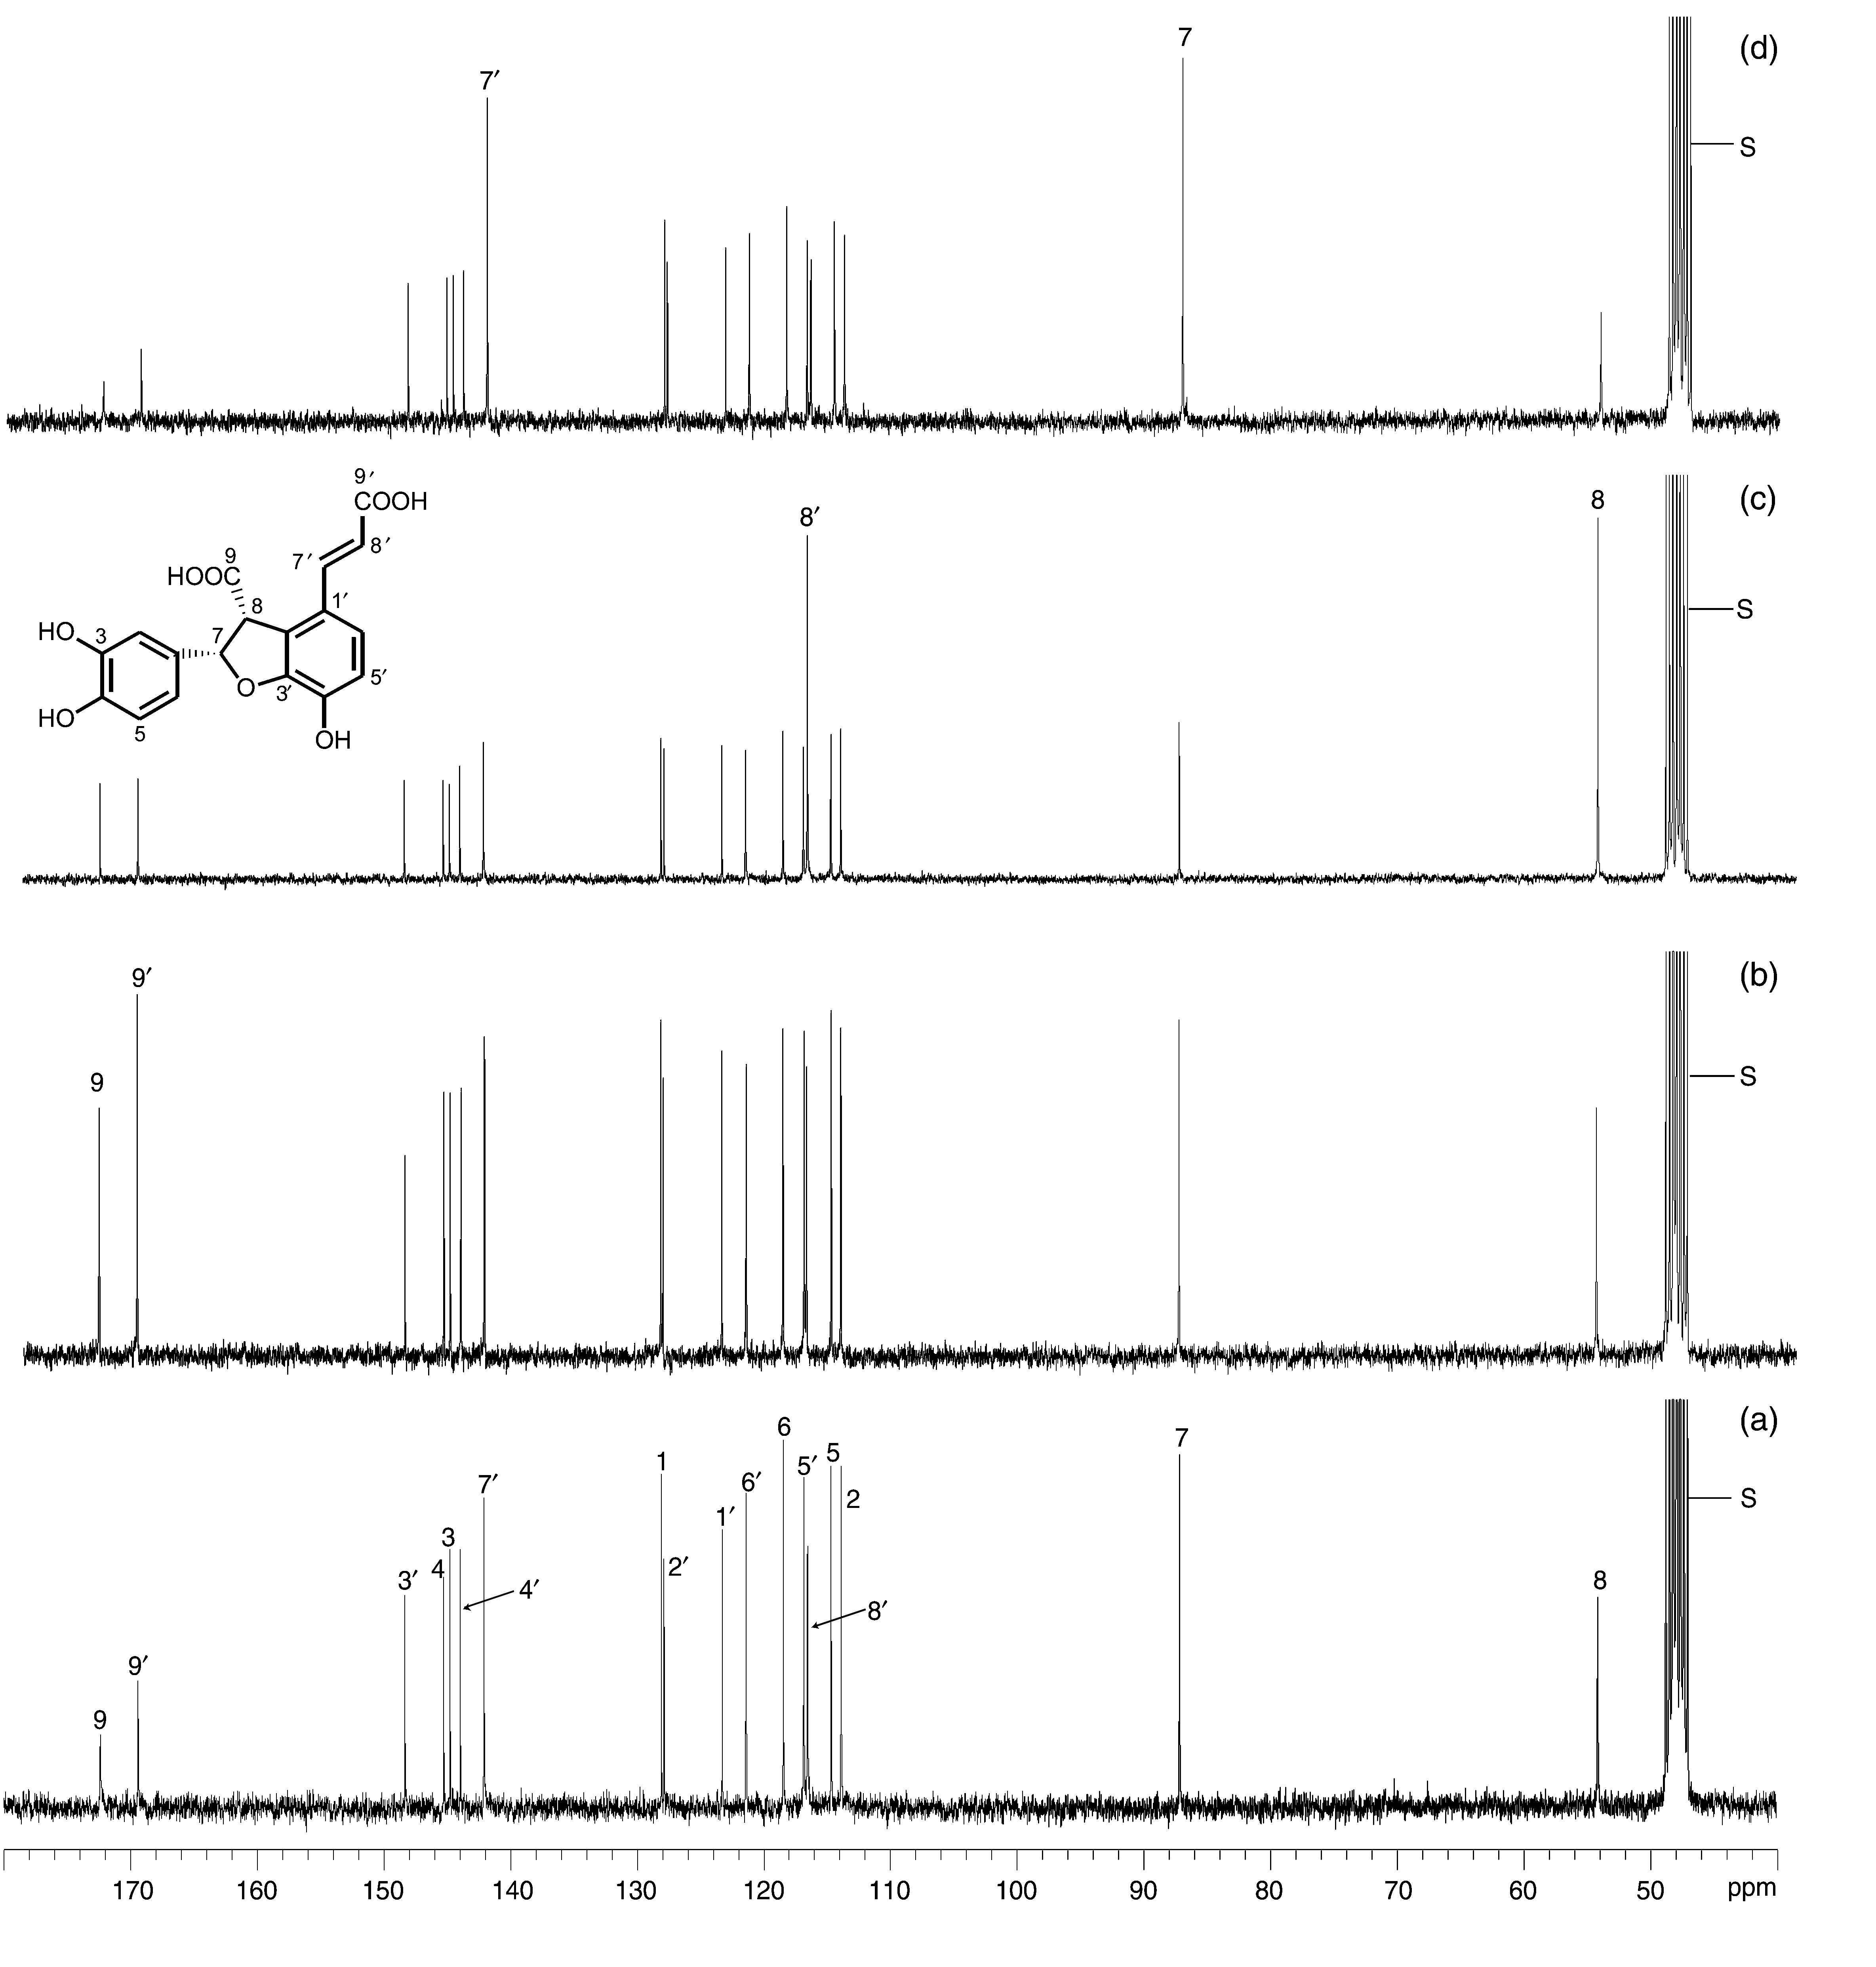

¹³C-NMR spectra of (a) natural abundance (–)-trans-blechnic 1 acid, as well as (–)-trans-blechnic acids 1 obtained following administration of (b) [1-¹³C], (c) [2-¹³C] and (d) [3-¹³C]-phenylalanine 6 (1 mM) to B. spicant fronds for 5 days; all spectra were recorded under identical conditions.

