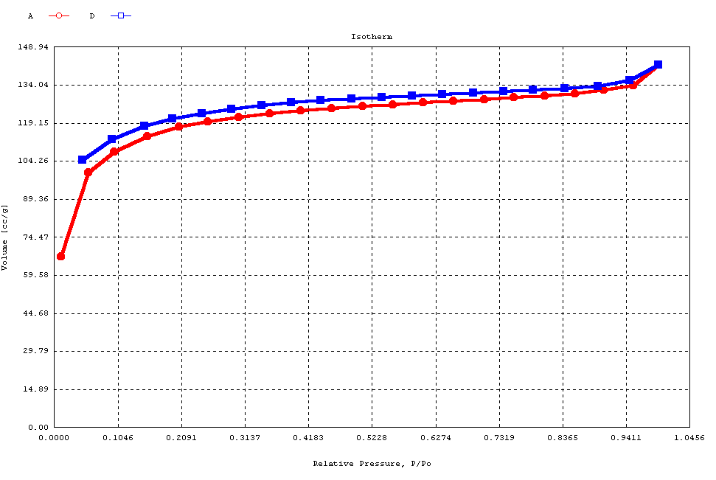

Figure 2. Nitrogen sorption isotherm of P2.

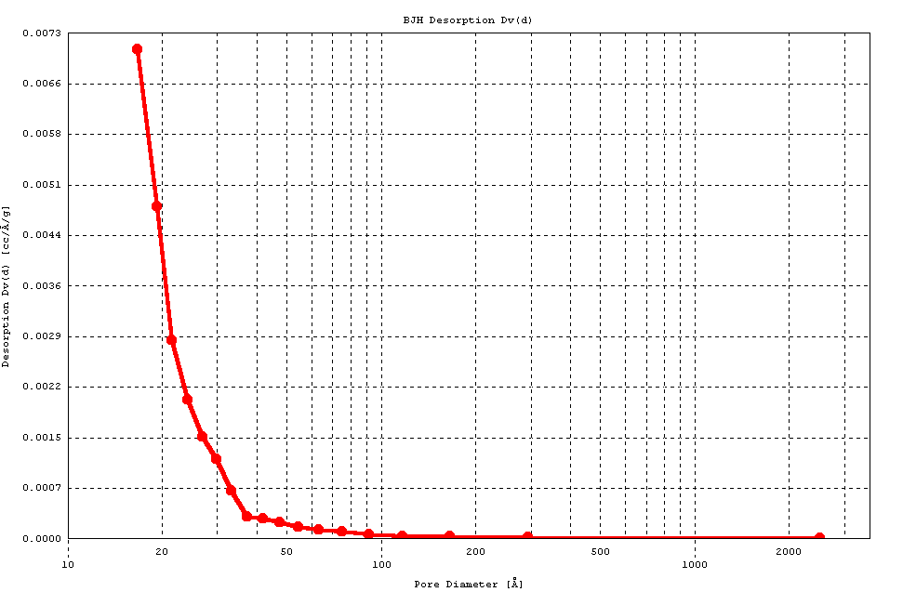

Figure 3 BJH pore size distribution of P2

