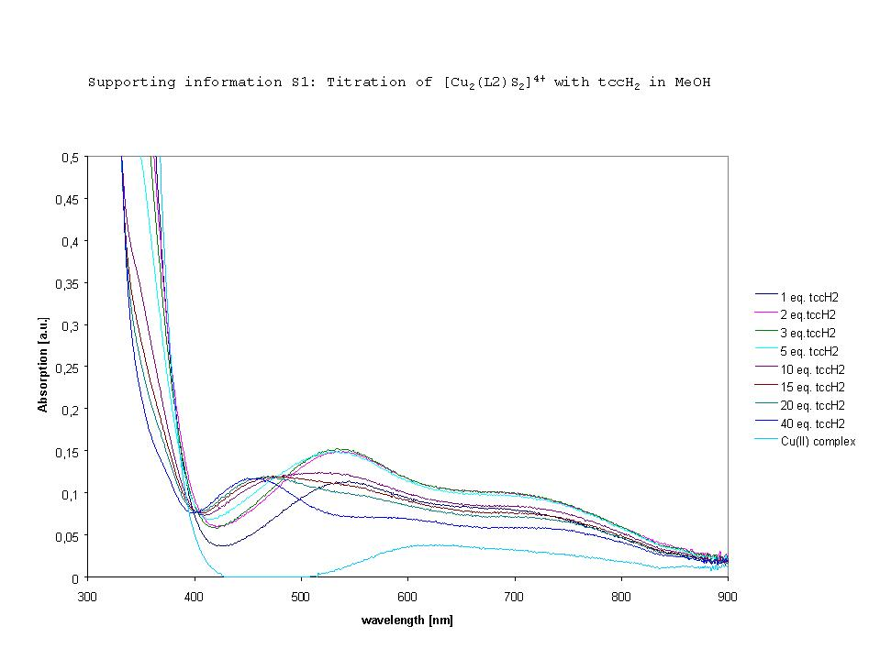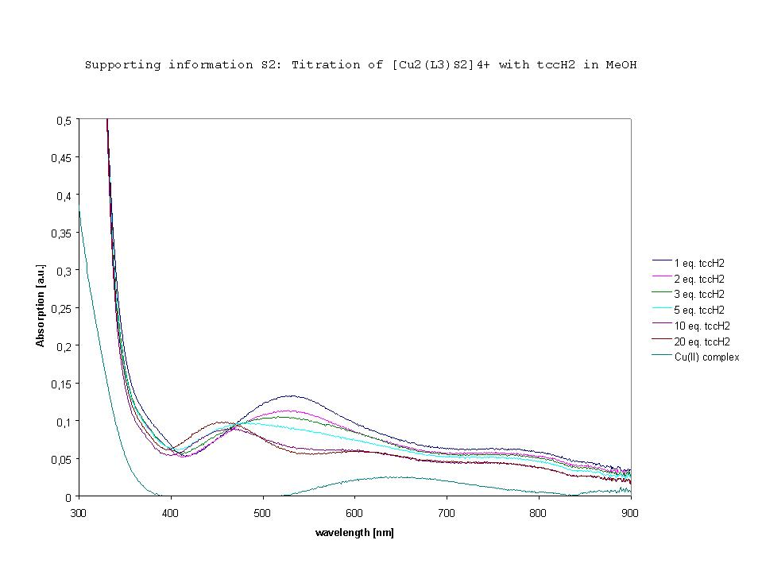
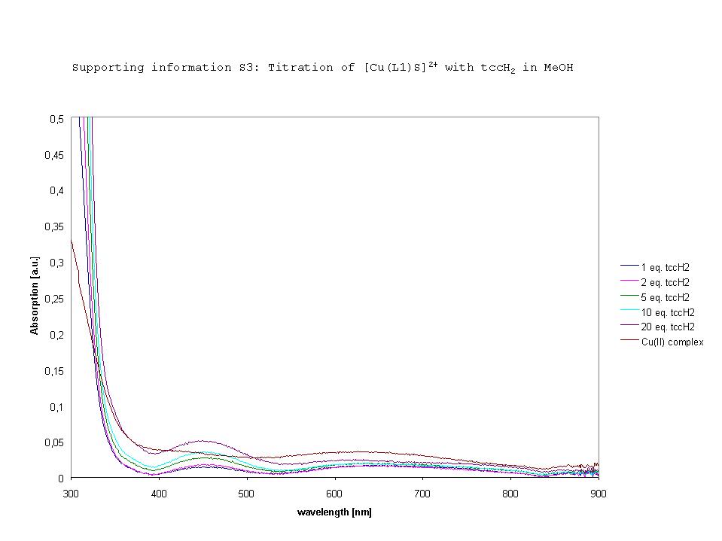
Supporting Information S4:
Experimental
The ligands were prepared as reported earlier1,2 (1): [Cu(CH₃CN)₄](BF₄)3(150mg, 0.46mmol) was added slowly to a suspension of L1 (200mg, 0.46mmol) in CH₃CN (4ml). The resulting yellow solution was oxygenated at –40°C for 20min. After purging with N₂ tccH₂xH₂O (122mg, 0.46mmol) was added to the solution. Green single crystals were obtained after 2 d (Et₂O diffusion bath, rt; 273mg,68%). FT-IR (KBr) [cm⁻¹] 2958(s), 1734 (C=O(ester)), 1608 (C=N(py)), 1460 (C-O), 1450 (C-O), 1390 (C-C(ar)). UV-Vis (CH₃CN), λ_{max} (ε) [nm](lmol⁻¹cm⁻¹) 315 (2826), 371 (386, sh), 451 (512), 614 (183), 733 (159). Calc. for CuC₂₉H₃₁N₄O₉Cl₄BF₄, 871.75 (found): C 39.96 (40.15), H 3.58 (3.53), N 6.43 (6.72). (2): Cu(ClO₄)₂x6H₂O (85mg, 0.23mmol) in CH₃CN (1ml) was added to a suspension of L1 (200mg, 0.46mmol) in CH₃CN (1ml), followed by tccH₂xH₂O (61 mg, 0.23mmol) in CH₃CN (0.5ml). After addition of triethylamin (0.066ml, 0.46mmol, 10min), a red precipitate was filtered off the solution(108mg, 60%). Burgundy-red crystals were obtained upon slow evaporation of the solvent when a substoichiometric amount of triethylamin was used. UV-Vis (CH₃CN), λ_{max} (ε) [nm](lmol⁻¹cm⁻¹) 334 (3168), 516 (131), 677 (93). FT-IR (KBr) [cm⁻¹] 1732 (C=O(ester)), 1606 (C=N(py)), 1437 (C-O), 1370 (C-C(ar)). Calc for CuC₂₉H₃₀N₄O₉Cl₄, 783.94 (found): C 44.43 (44.75), H 3.86 (4.24), N 7.15 (N 7.37), Cl 18.09 (18.48). [Cu₂(L2)(tcc)](BF₄)₂x2H₂O: [Cu(CH₃CN)₄] (BF₄)₂ (144mg, 0.44mmol) was added slowly to a suspension of L2 (200mg, 0.22mmol) in CH₃CN (4ml), followed by addition of tcbq (60mg, 0.22mmol). The product was isolated after addition of Et₂O (20ml) as a deep violet powder (167mg, 53%). UV-Vis (CH₃CN), λ_{max} (ε) [nm](lmol⁻¹cm⁻¹) 303 (9600), 364 (3290), 418 (1100), 528 (2430), 700 (1428). Calc. for Cu₂C₅₂H₅₄N₈O₁₄B₂Cl₄F₈, 1457.56 (found): C 42.85 (42.45), H 3.73 (4.23), N 7.69 (7.65). (3): As for [Cu₂(L2)(tcc)](BF₄)₂x2H₂O, with [Cu(CH₃CN)₄](BF₄)₂ (71mg, 0.22mmol), L3 (100mg, 0.11mmol) and tcbq (30mg, 0.11mmol) in CH₃CN (2ml). Violet crystals were isolated after 1d (110mg, 66%). Alternative: as for [Cu(L1)(tcc)]x2H₂O with Cu(ClO₄)₂x6H₂O (82 %). FT-IR (KBr) [cm⁻¹]: 2954 (w), 1734 (C=O(ester)), 1608 (C=N(py)), 1450 (C-O), 1374 (C-C(ar)), 1056 (ClO₄). UV-Vis (CH₃CN): λ_{max} (ε) [nm](lmol⁻¹cm⁻¹] : 335 (3831), 395 (1010, sh),538 (1900), 801 (838). Calc. for Cu₂C₅₃H₅₈N₈O₂₃Cl₆, 1514.89 (found): C 42.02 (42.07), H 3.86 (4.16), N 7.40 (7.88). (4): Preparation as for [Cu(L1)(tcc)] x 2 H₂O (2), with Cu(ClO₄)₂ x 6 H₂O (163 mg, 0.44 mmol) and L4 (200 mg, 0.23 mmol) in CH₃CN (4 ml). Blue-green crystals were isolated after 2 d (ether diffusion, r.t.) (73.9%). FT-IR (KBr) [cm⁻¹]: 2952 (w), 1740 (C=O(ester)), 1608 (C=N(py)), 1452 (C-O), 1374 (C-C(ar)), 1256 (s), 806(m), 788 (m). UV-Vis (CH₃CN): λ_{max} (ε) [nm] (lmol⁻¹cm⁻¹): 338 (3299), 488 (371), 612 (313). Calc. for Cu₂C₅₉H₅₂N₈O₁₄Cl₈, 1507.82 (found): C 46.99 (46.52), H 3.48 (3.72), N 7.43 (7.33).

[1] H. Börzel, P. Comba, C. Katsichtis, W. Kiefer, A. Lienke, V. Nagel, H. Pritzkow, Chem. Eur. J. 5 (1999) 1716.
[2] U. Holzgrabe, E. Erciyas, Arch. Pharm. 325 (1992) 657.
[3] G.J. Kubas, Inorg. Synth. 1979, 19, 90.

