Material to be published as Electronic Supplementary Information (ESI)

General procedures

Analytical (for data obtained in Table): Separate solutions of 1a (20.1mg, 0.095mmol, in 1.5 cm3) and the catalysts (5 mol%, in 0.5 cm3) in the appropriate solvent were equilibrated at the desired temperature for 15 minutes. The catalyst solution was then transferred to the solution of 1a via cannula and the reaction stirred for the time indicated. Samples (0.1 cm3) were withdrawn periodically via syringe, passed through a small plug of silica (1cm), the plug washed with CH2Cl2 (2 cm3) and the sample stored at -20 °C prior to analysis by GC. Solvents: Chloroform (BDH) was filtered through a column of neutral alumina and then distilled from P2O5. Anhydrous CH2Cl2 (Fluka) and dichloroethane (Acros) were used as received. GC Analysis was performed on a Shimadzu GC17A fitted with a Restek Corp. RTX® – 5 Column, Crossbond® 5% diphenyl – 95% dimethyl polysiloxane stationary phase (15m, 0.25mm, 0.25mm df). Conditions: injector, 220 °C; detector, 220 °C; oven, 100 °C; total flow, 0.4 cm3/min; pressure, 100 kPa. See accompanying typical GC analyses from a run (Table, entry 10) giving 29 / 1 selectivity for 3a.

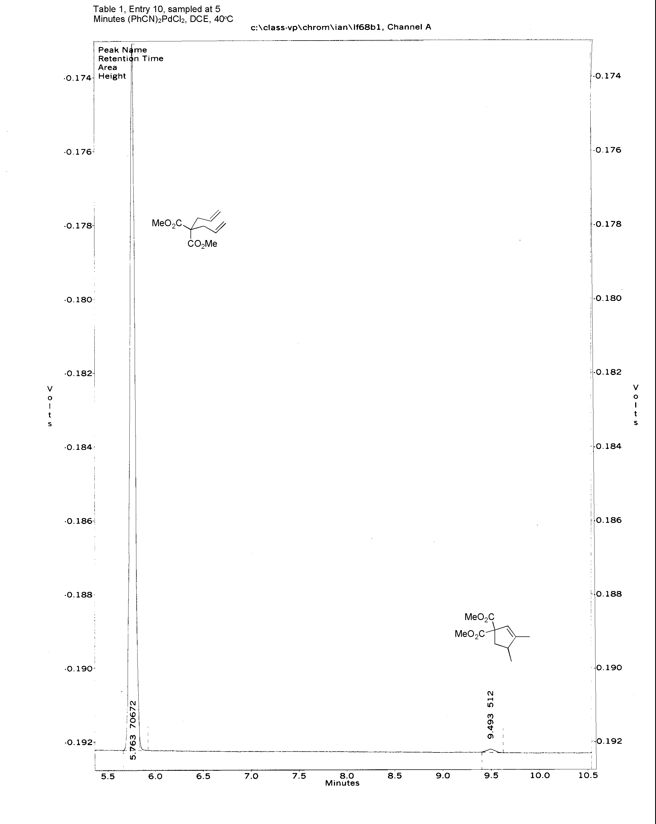
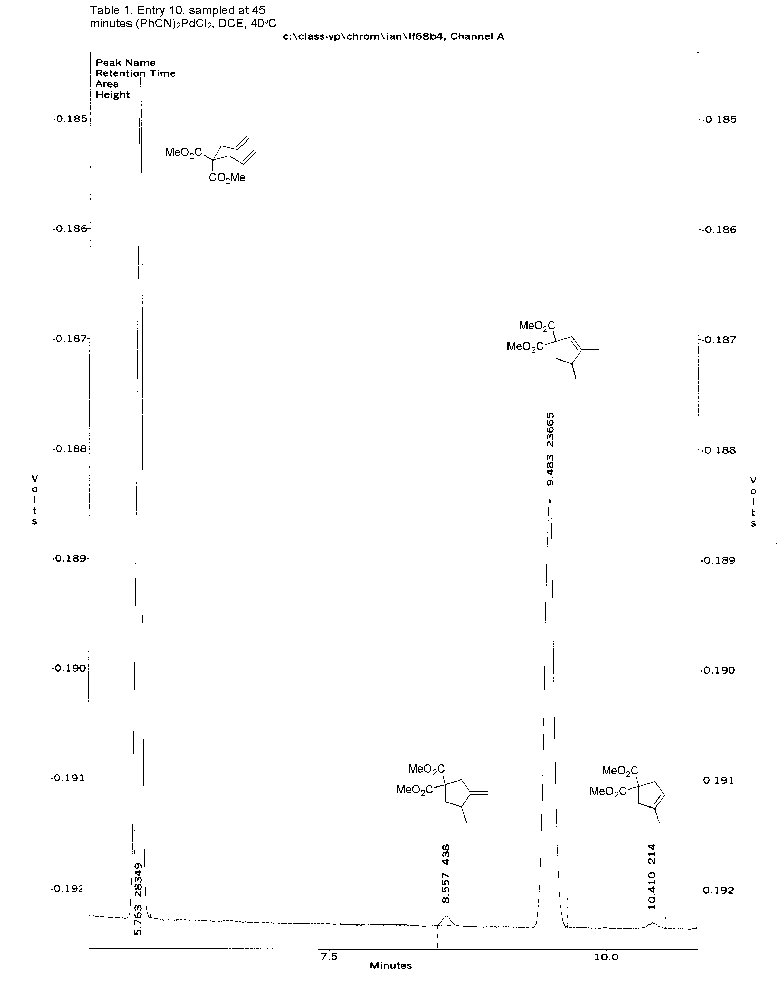
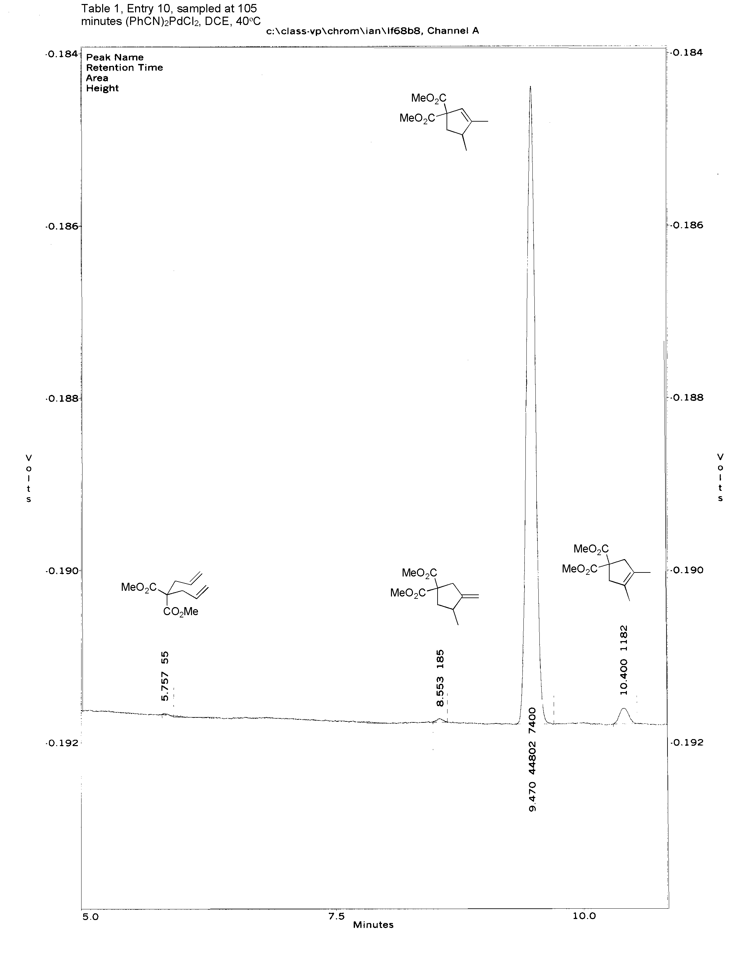
Preparative: A solution of 1a (0.256 g, 1.2mmol) in dry CHCl3 (25 cm3) was stirred at 40 °C for 15 minutes before addition of a solution of [(t-BuCN)2PdCl2] (20.7mg, 0.06mmol, 5 mol %) in CHCl3 (5 cm3) at 40oC via cannula. The mixture was strirred at 40 °C for 3 hours and then quenched by the addition of silica-gel (1g) and diethyl ether (60 cm3). After filtration through a pad of Celite, the filtrate was concentrated in vacuo. Purification by flash chromatography using hexane-ethyl acetate (12:1, v/v) gave the product as a clear oil (0.240 g, 96 %). δH (400 MHz, CDCl3) 1.06 (3H, d, 3J 12.7, CH3CH), 1.73 (3H, m, CH3C=CH), 1.88-2.00 (1H, m, CHHCE2), 2.62-2.82 (2H, m, CH3CH), 3.71 and 3.74 (6H, 2 x s, 2 x CO2CH3), 5.43 (1H, br s, C=CH). δC (75.45 MHz: CDCl3) 14.6 (CH3C=), 18.9 (CH3CH), 40.6 (CH2), 41.9 (CHCH3), 52.4 and 52.6 (2 x CO2CH3), 64.8 (C(CO2Me)2), 121.8 (CH=C), 150.3 (CH=CCH3), 172.0 and 172.5 (2 x CO2Me).

Table Regioselectivities and reaction times for cycloisomerisation of 1,6-diene 1a by 5 mol % [L2PdCl2] in different solvents at different temperatures.

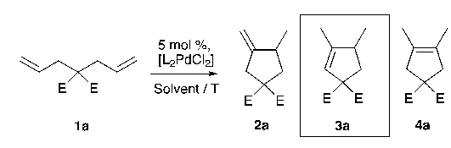

Entry La Solvent Temp Timeb Selectivityc
/ °C / h 3a / 2a + 4a

1 MeCN CHCl3 60 ≤ 0.1 > 20 / 1d
2 MeCN CHCl3 40 0.6 20 / 1
3 MeCN DCE 40 2 37 / 1
4 MeCN CH2Cl2 40 6 19 / 1
5 MeCN CHCl3 23 4 7 / 1
6 MeCN DCE 40 2 37 / 1
7 MeCN DCE 23 4 36 / 1
8 PhCN CHCl3 40 3 76 / 1
9 PhCN CHCl3 23 28 62 / 1
10 PhCN DCE 40 2 29 / 1
11 PhCN DCE 23 2.8 52 / 1
12 t-BuCN CHCl3 60 0.15 36 / 1
13 t-BuCN CHCl3 40 1.5 39 / 1
14 t-BuCN CHCl3 23 4 36 / 1
15 t-BuCN DCE 40 1.5 33 / 1
16 t-BuCN DCE 23 4 39 / 1
17 DMSO DCE 40 42e 110 / 1
18 DMSOf DCE 40 22g 99 / 1
_______________________________________________________________________
a) L = ligand in [L2PdCl2]. All reactions were conducted with [1a]0 = 0.045 M (± 0.002) and 5 mol % pro-catalyst. b) point at which GC analysis indicated > 99 % conversion of 1a. c) selectivity for the trisubstituted alkene isomer 3a relative to 2a and 4a (estimated by GC analysis, without correction factors). No other products above 0.5 % were evident by GC analysis - in most cases this threshold value was below 0.2 %. d) selectivity after 30 mins > 20 / 1; after 6 hrs, 1.7 / 1. e) 69 % conversion. f) The μ-halide dimer, [(DMSO)2Pd2(μ-Cl2)Cl2], was employed. g) 90 % conversion.

