Synthesis of [4,4'-H₂bipy][OsCl₆] 2: addition of a colourless solution of 4,4'-bipy (79 mg, 0.506 mmol) in H₂O (5 cm³) and aqueous HCl (5 cm³, 33%), to a boiling, dark green solution of K₂[OsCl₆] (238 mg, 0.495 mmol) in H₂O (20 cm³) caused the immediate formation of a dark red microcrystalline precipitate. The precipitate was filtered and the green filtrate was heated to reduce the volume. A second crop of small red crystals suitable for single crystal X-ray diffraction study were grown by slow cooling with simultaneous slow evaporation of the filtrate. Yield 165 mg (58.9%). Microanalytical data (%). Found: C, 21.01; H, 1.76; N, 4.70. Calculated: C, 21.41; H, 1.80; N, 4.99.
Synthesis of [4,4'-H₂bipy][PtCl₆] 3: addition of a colourless solution of 4,4'-bipy (93 mg, 0.596 mmol) in H₂O (10 cm³) and aqueous HCl (5 cm³, 33%), to a boiling, colourless solution of K₂[PtCl₆] (291 mg, 0.599 mmol) in H₂O (20 cm³) and HCl (20cm³, 33%) caused the formation of an orange microcrystalline precipitate. The precipitate was filtered and the filtrate was heated to reduce the volume. A second crop of crystals suitable for single crystal X-ray diffraction study were grown by slow cooling with simultaneous slow evaporation of the filtrate. Yield 276mg (71.5%). Microanalytical data (%). Found: C, 21.17; H, 1.60; N, 4.52. Calc.: C, 21.22; H, 1.78; N, 4.95.
Synthesis of [4,4'-H₂bipy][FeCl₅] 4: addition of a colourless solution of 4,4'-bipy (316 mg, 2.026 mmol) in HCl (10 cm³, 33%) to a yellow solution of FeCl₂ (258 mg, 2.036 mmol) in HCl (10 cm³, 33%) in air. Small yellow–green and red crystals were grown by slow evaporation of the solution. Hand selected red crystals [FeCl₅][4,4'-H₂bipy] yield 87 mg. Microanalytical data (%). Found: C, 30.09; H, 2.41; N, 6.36. Calc.: C, 30.69; H, 2.58; N, 7.16.
Synthesis of [4,4'-H₂bipy]Cl₂ 1: addition of a solution of 4,4'-bipy (792 mg, 5.077 mmol) in EtOH (80 cm³) and HCl (15 cm³, 33%) caused the immediate formation of a colourless microcrystalline precipitate. The precipitate was filtered and redissolved in hot H₂O. Colourless crystals were grown by slow cooling with simultaneous slow evaporation. Yield 701 mg (87.4%). Microanalytical data (%). Found: C, 51.90; H, 4.32; N, 12.03. Calc.: C, 52.42; H, 4.40; N, 12.23.

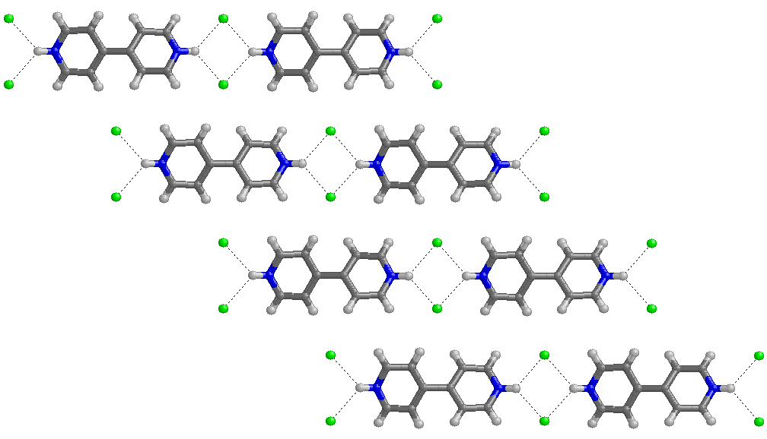

Fig. 1 Hydrogen bonded ribbons of type C in the crystal structure of [4,4'-H₂bipy]Cl₂ 1.

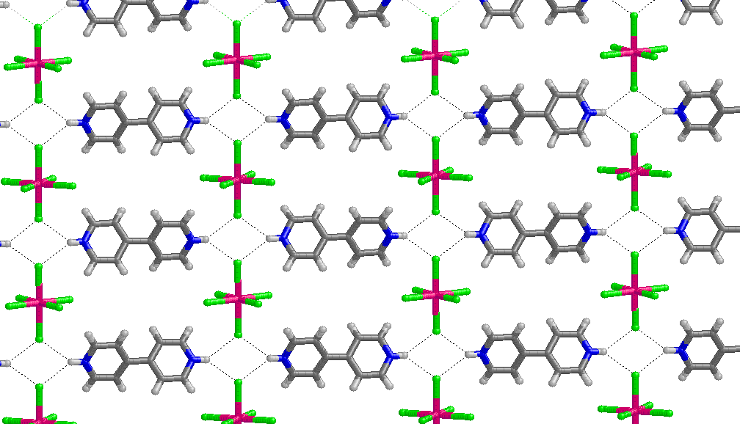

Fig. 2 A hydrogen bonded layer present within the crystal structure of [4,4'-H₂bipy][OsCl₆] 2. Compound 3 is isostructural with 2.

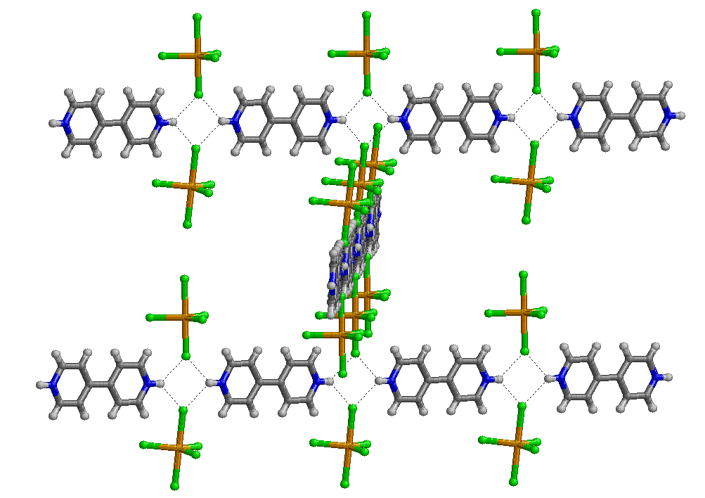

Fig. 3 A view of the hydrogen bonded ribbons present in the crystal structure of [4,4'-H₂bipy][FeCl₅] 4.

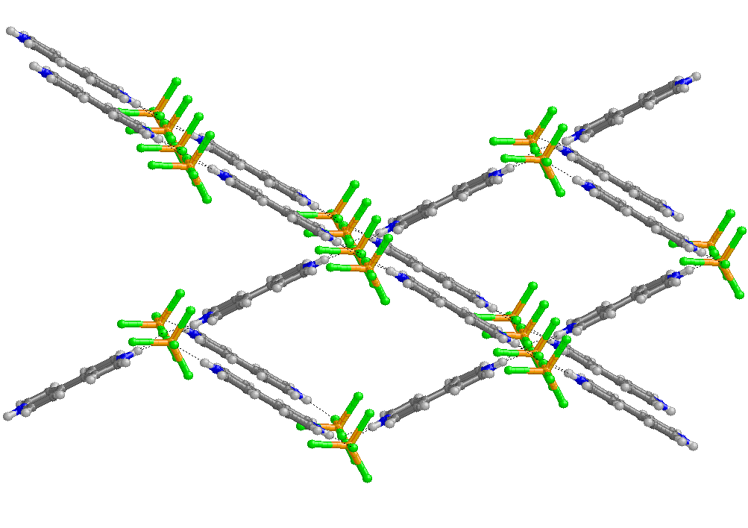

Fig. 4 A second view of the crystal structure of [4,4'-H₂bipy][FeCl₅] 4.

