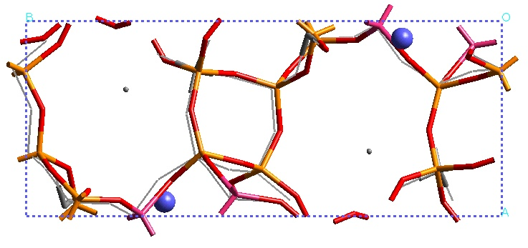

Supplementary 1.
The calculated dehydrated C1 structure and a comparison with the experimental framework structure (Al highlighted in grey and pink). Calculated Ca²⁺positions are shown in blue with the experimental positions shown as grey spheres.

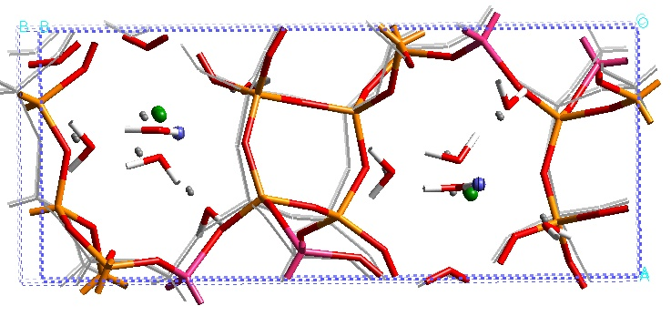

Supplementary 2.
The calculated hydrated C1 structure and a comparison with the experimental framework structure (Al highlighted in grey and pink). Calculated Ca²⁺positions are shown as green spheres with the experimental positions shown as blue spheres. Grey spheres show the experimental water oxygen positions.

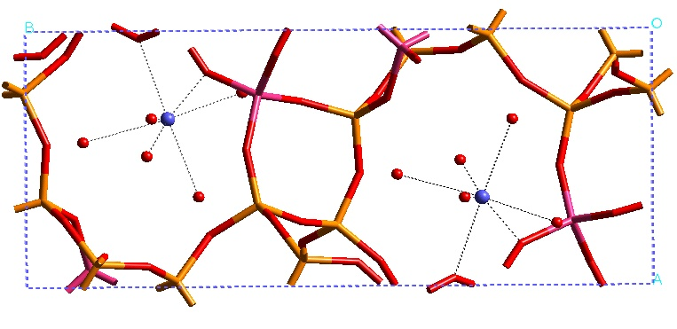

Supplementary 3.
The experimental structure of hydrated Goosecreekite highlighting the Ca²⁺ coordination sphere, which should be compared to our results given in Figure 2.

