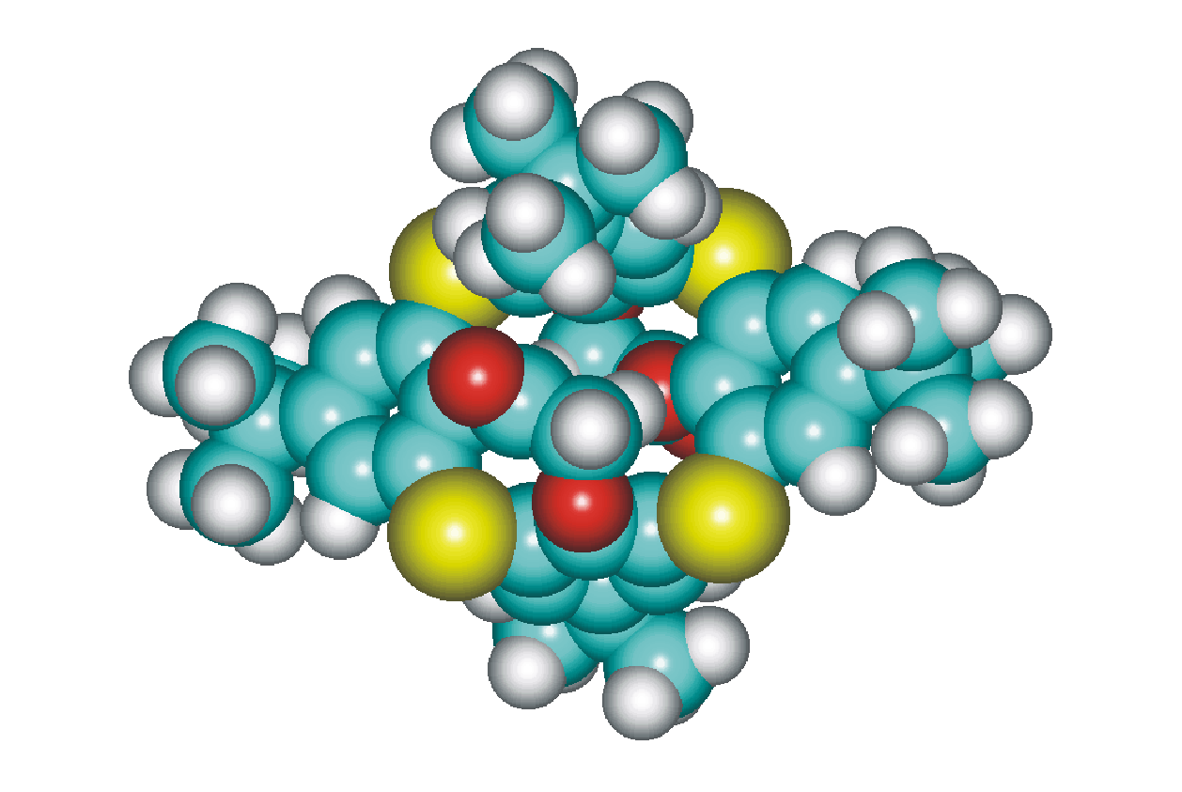
Fig. S2. Energy minimised structure of 6a (AM1).

