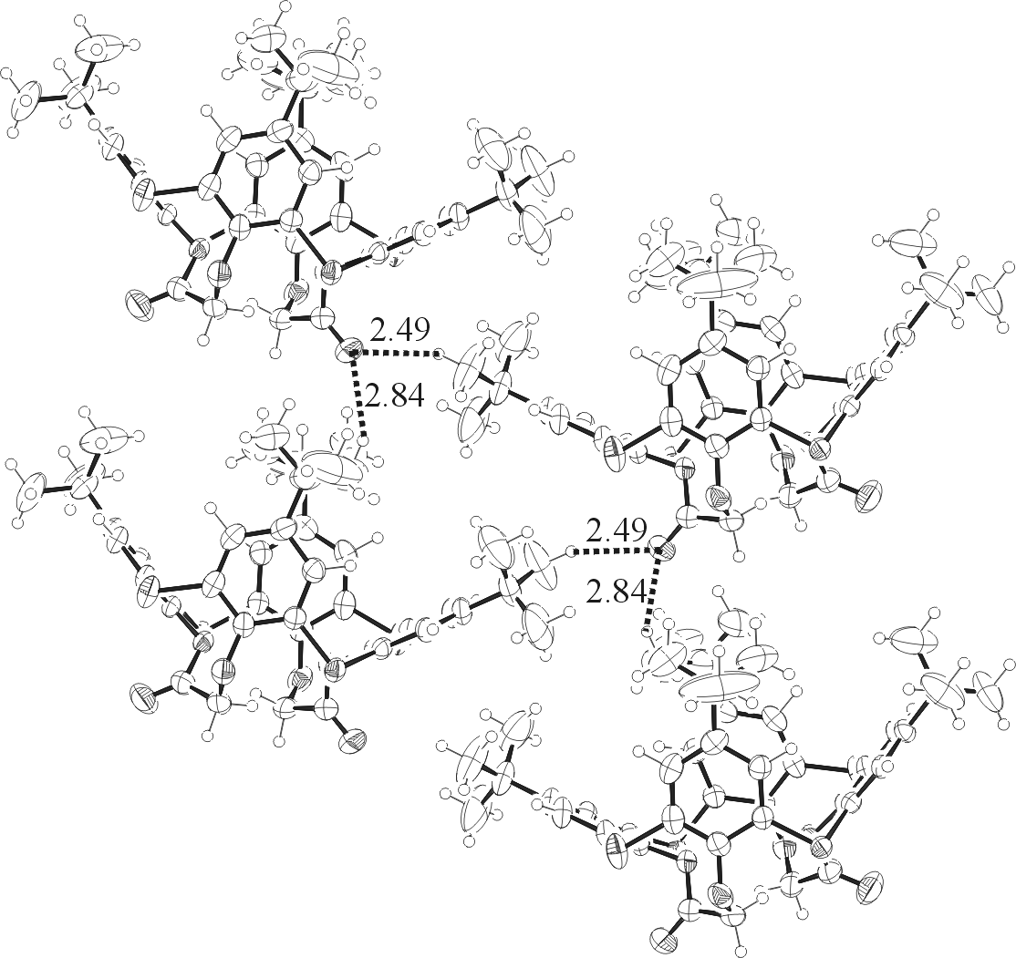

Fig. S4. Crystal packing of 5a demonstrating intermolecular hydrogen bonding network.

