Electronic Supporting Information for

A novel group of allenic hydrocarbons from five Australian (Melolonthine) beetles
Mary T. Fletcher,ª Matthew J. McGrath,ª Wilfried A. Konig,^{b} Christopher J. Moore,^{c} Bronwen W. Cribb,^{d} Peter G. Allsopp^{e} and William Kitching*ª
ª Department of Chemistry, University of Queensland, Brisbane, Australia. Fax: +61 7 3365 4299; Tel: +61 7 33653925; E-mail: kitching@chemistry.uq.edu.au
^{b} Institut fur Organische Chemie, Universitat Hamburg, Hamburg, Germany.
^{c} Department of Primary Industries, Brisbane, Australia.
^{d} Department of Zoology and Entomology, University of Queensland, Brisbane, Australia.
^{e} Bureau of Sugar Experiment Stations, Bundaberg, Australia.

1. Mass Spectra of pentacosadiene and heptacosadiene and McLafferty Rearrangements

Δ-^{9,10}-Pentacosadiene

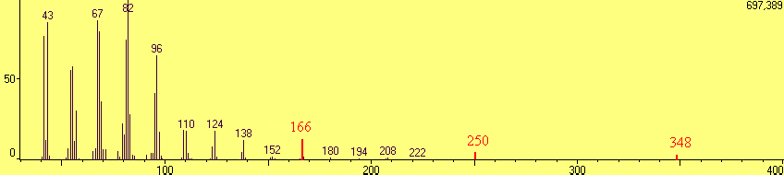
Δ-^{9,10}-Heptacosadiene

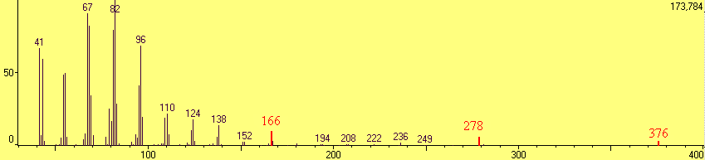

2. Enantioselective Gas Chromatography Traces of Δ^{-9,10-}Tricosadiene

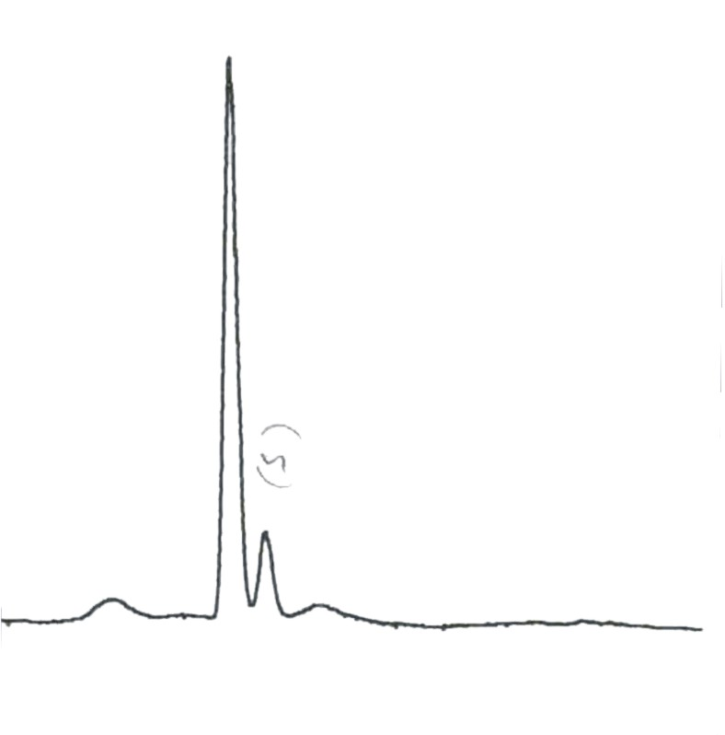

Synthetic (R)

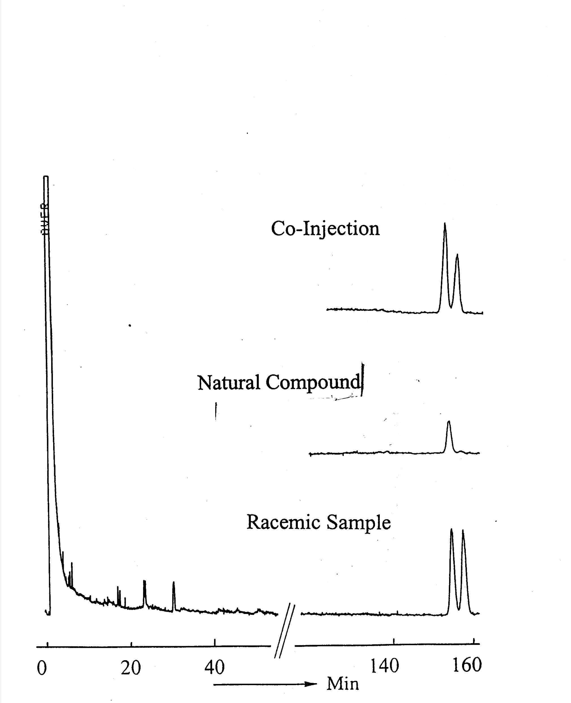

3. (R)-Δ-^{9,10}-Pentacosadiene 9 (scheme 4) (S)-Z-10-(Tributylstannyl)-pentacos-10-en-9-yl acetate (14mg, 0.022 mmol, 1 equiv.) was dissolved in dry DMSO (2mL) and a THF solution of TBAF (0.066mL, 1M, 0.066mmol, 3equiv.) was added via syringe. The reaction mixture was refluxed under nitrogen until TLC indicated complete conversion to the allene (less than 2 hours). The solution was diluted with brine (2mL) and extracted into ether (3x10mL). The organic layers were combined, dried over MgSO₄ and concentrated to yield the crude allene which was subjected to silica gel chromatography (hexane) to yield substantially pure (R)-Δ-^{9,10}-Pentacosadiene, 9 (5.4mg, 0.017mmol,77%). (72% ee by chiral GC). [α]_{D}²² -17⁰ (c, 0.54, CHCl₃). GCMS: 348 (1) (M⁺), 250 (6), 208 (3), 166 (15), 138 (13), 109 (19), 67 (83), 43 (100) ¹H NMR: (200MHz, CDCl₃): 5.04 (2H,m, H-9, H-11), 2.00 (4H, m, H-8, H-12), 1.23 (36H,br s) ,0.86 (6H, t, J=6.9Hz, 2xCH₃). ¹³C NMR: (50MHz. CDCl₃): 203.8 (C10), 90.9 (C9, C11), 31.9 (C8, C12), 29.7, 29.5, 29.5, 29.4, 29.3, 29.2, 29.1, 29.0, 22.7 (CH₂), 14.1 (C1, C25) (not all carbon signals resolved). Elemental analysis: Calcd. for C₂₅H₄₈ C: 86.21% H: 13.79%; found: C: 85.74% H: 14.16%. HREIMS: Calcd for C₂₅H₄₈: 348.3756 found: 348.3759.

4. (R)-Δ-^{9,10}-Tricosadiene: 77% ee by chiral GC. [α]_{D}²² -12⁰ (C, 0.27, CHCl₃). GCMS: 320 (2) (M⁺), 222 (9), 194 (4), 166 (21), 124 (20), 96 (66), 67 (100), 41 (87). ¹H NMR: (400MHz, CDCl₃) 5.04 (2H, m, H-9, H-11), 1.94 (4H, m, H-8, H-12), 1.24 (32H, br s), 0.86 (6H, m, 2xCH₂). ¹³C NMR: (100MHz, CDCl₃) 203.8 (C10), 90.9 (C9, C11), 31.9, 31.9, 29.7, 29.7, 29.5, 29.5, 29.4, 29.3, 29.2, 29.1, 29.0, 22.7 (CH₂), 14.1 (2xCH₃) (Not all carbon signals resolved). Elemental analysis: Calcd. for C₂₃H₄₄: C: 86.25% H: 13.75% found: C: 85.85% H: 13.89%. HREIMS: Calcd. for C₂₃H₄₄: 320.3436 found: 320.3447.

() − Δ-^{9,10}-Tetracosadiene: GCMS: 334 (1) (M⁺), 281 (1), 253 (3), 236 (7), 207 (13), 166 (22), 138 (20), 96 (72), 67 (100), 43 (91) 1H NMR: (400MHz, CDCl₃) 5.07 (2H, m, H-9, H-11), 1.97 (4H, m, H-8, H-12), 1.24 (34H, br s), 0.87 (6H, m, 2xCH₃). 13C NMR: (100MHz, CDCl₃) 203.8 (C10), 90.9 (C9, C11), 31.9, 29.7, 29.5, 29.4, 29.3, 29.2, 29.1, 29.0, 28.8, 26.8, 26.8, 22.7 (CH₂), 14.1 (C1, C24) (Not all carbon signals resolved). HREIMS: Calcd. for C₂₄H₄₆: 334.35995 found: 334.35986.

