A Novel Synthesis Route to Rare Earth Polyborates
(Supplementary Materials)

Peichao Lu, Yingxia Wang and Jianhua Lin*
State Key Laboratory for Rare Earth Materials Chemistry and Applications, College of Chemistry and Molecular Engineering, Peking University, Beijing 100871, P. R. China
Liping You
Laboratory of Electron Microscopy, Department of Physics, Peking University, Beijing 100871, P. R. China

Table of Contents

Part 1 Supplementary materials for H₃GdB₆O₁₂
Table 1-1 Crystallographic data of H₃GdB₆O₁₂
Table 1-2 Atomic coordinates of H₃GdB₆O₁₂
Table 1-3 Selected bond lengths and angles in H₃GdB₆O₁₂
Figure 1-1 Profile fit of the x-ray diffraction pattern for H₃GdB₆O₁₂
Figure 1-2 TGA and DTA curves of H₃GdB₆O₁₂
Figure 1-3 A projection of the crystal structure of H₃GdB₆O₁₂ (1) on [100] direction; the open small circles represent BO₄ and dark small circles represent BO₃ groups; the large circles are the rare earth atoms; the oxygen atoms are not shown in the figure for clarity.
Figure 1-4 IR spectrum of H₃GdB₆O₁₂ and GdB₅O₉

Part 2 Supplementary materials for GdB₅O₉
Table 2-1 crystallographic data of GdB₅O₉
Table 2-2 Atomic coordinates of GdB₅O₉
Table 2-3 Selected bond lengths and angles in GdB₅O₉
Figure 2-1 Profile fit of the x-ray diffraction pattern for GdB₅O₉ (there are some very weak reflection peaks (less than 2% of the main phase), which may originate from another phase in the decomposition product).

Part 1 Supplementary materials for H₃GdB₆O₁₂

Table 1-1 Crystallographic data of H₃GdB₆O₁₂
Molecular formula | H₃GdB₆O₁₂
Formula weight | 417.10
Crystal system | Rhombohedral
Space group | R3c (No.161)
Unit cell dimension | a = 8.4076(2) Å, c = 20.7427(5)Å,  V = 1269.81(5) Å³
Z | 6
Density (calculated) | 3.272 g/cm³
X-ray diffraction | Rigaku D/max-2000  Scan range/speed: 12-120º, 0.3º/min
Structure solution | Direct method, Sirpow92
Structure refinement | GSAS, Rietveld refinement
Residual value | Rp = 0.089, Rwp = 0.115

Table 1-2 Refined atomic coordinates in H₃GdB₆O₁₂
Atom | site | Atomic coordinates
Atom | site | x | y | z | Ui/Ue
Gd1 | 6a | 0 | 0 | 1/2 | 79(2)
O1 | 18b | 0.244(1) | 0.098(1) | 0.4254(4) | 168(9)
O2 | 18b | 0.137(1) | -0.201(1) | 0.3621(3) | 168(9)
O3 | 18b | 0.497(1) | 0.386(1) | 0.4150(5) | 168(9)
O4 | 18b | 0.011(1) | 0.605(1) | 0.1492(4) | 168(9)
B1 | 18b | 0.032(2) | 0.270(2) | 0.3674(7) | 74(28)
B2 | 18b | 0.068(2) | 0.690(2) | 0.0748(7) | 74(28)

Table 1-3 Selected bond length and angles in H₃GdB₆O₁₂
Vector Length Optr Cell Neighbor atom coordinates
GD1_O1 2.362(7) 1 0 0 0 .24350 .09814 .42540
GD1_O1 2.362(7) 2 0 0 0 -.09814 .14535 .42540
GD1_O1 2.362(7) 3 0 0 0 -.14535 -.24350 .42540
GD1_O3 2.394(9) 104 0-1-1 .22241 .05304 .58164
GD1_O3 2.394(9) 105 0 0-1 -.05304 .16937 .58164
GD1_O3 2.394(9) 106-1-1-1 -.16937 -.22241 .58164
GD1_O4 2.518(8) 201-1-1 0 -.32219 -.06120 .48251
GD1_O4 2.518(8) 202 0 0 0 .06120 -.26099 .48251
GD1_O4 2.518(8) 203-1 0 0 .26099 .32219 .48251
B1_O1 1.611(14) 2 0 0 0 -.09814 .14535 .42540
* B1_O2 1.247(14) 2 0 0 0 .20160 .33889 .36212
B1_O4 1.389(16) 104-1-1-1 -.07234 .27214 .31584
B2_O1 1.309(14) 102 0 0-1 .23519 .81202 .09207
B2_O2 1.513(14) 103 0 0-1 -.00556 .52937 .02879
B2_O3 1.529(16) 102 0 0-1 -.05304 .77759 .08164
B2_O4 1.666(15) 1 0 0 0 .01114 .60547 .14917

Angle Degrees atom 1 loc atom 3 loc
O1_B1_O2 127.9(13) 2 0 0 0 2 0 0 0
O1_B1_O4 110.9(18) 2 0 0 0 104-1-1-1
O2_B1_O4 120.6(32) 2 0 0 0 104-1-1-1
O1_B2_O2 132.1(11) 102 0 0-1 103 0 0-1
O1_B2_O3 108.2(12) 102 0 0-1 102 0 0-1
O2_B2_O3 114.5(11) 103 0 0-1 102 0 0-1
* We have not yet applied geometric constrained to rationalize the B-O bond distances and angles.

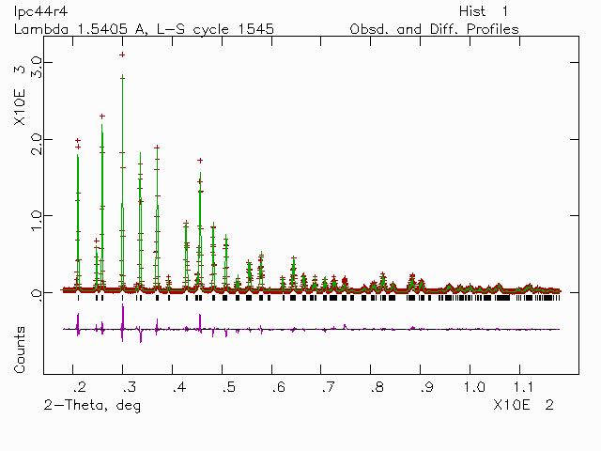

Figure 1-1

Figure 1-2

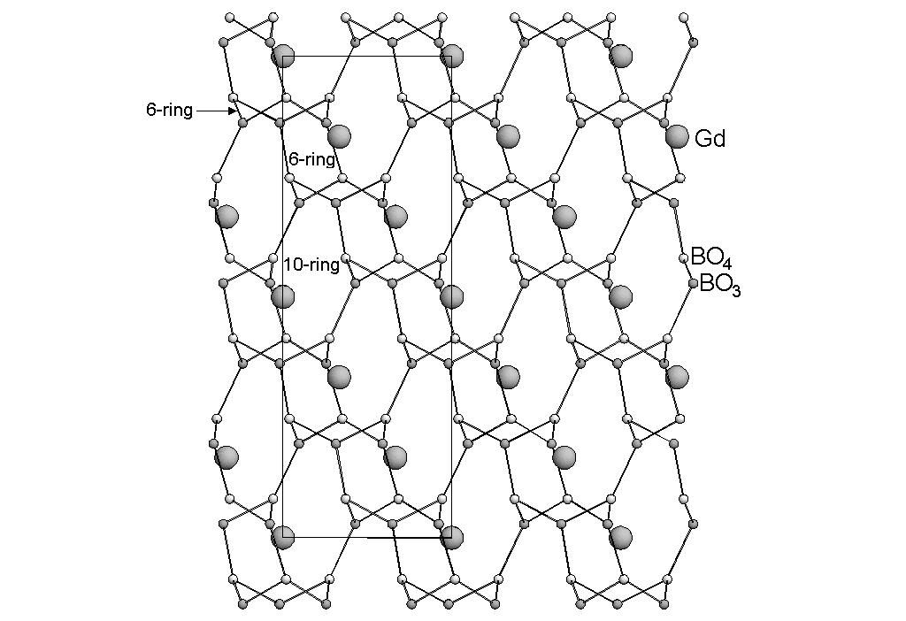

Figure 1-3

Figure 1-4

Part 2 Supplementary materials for GdB₅O₉

Table 2-1. Crystallographic data of GdB₅O₉
Molecular formula | GdB₅O₉
Formula weight | 355.30
Crystal system | Tetragonal
Space group | I4₁/acd (No.142)
Unit cell dimension | a = 8.2380(1) Å, c = 33.6372(6) Å,  V = 2282.80(6) Å³
Z | 16
Density (calculated) | 4.123 g/cm³
X-ray diffraction | Rigaku D/max-2000  Scan range/speed: 10-120º, 0.5º/min
Structure solution | Direct method, Sirpow92
Structure refinement | GSAS, Rietveld refinement
Residual value | Rp = 0.069, Rwp = 0.098

Table 2-2 Refined atomic coordinates of GdB₅O₉
Name X Y Z Ui/Ue*
GD1 .0000000(0) .2500000(0) .068839(27) 2(001) GD 1 1.000(0)
O1 -.5248(15) .4509(25) .0484(4) 1 O 2 1.000(0)
O2 .5000000(0) .2500000(0) -.00027(25) 2(001) O 3 1.000(0)
O3 -.2982(24) .2817(15) .05214(34) 1 O 4 1.000(0)
O4 -.1227(8) .3727(8) .1250000(0) 2(+-0) O 5 1.000(0)
O5 .2500000(0) .4201(15) .0000000(0) 2(010) O 6 1.000(0)
O6 .1663(11) .4876(9) .09218(24) 1 O 10 1.000(0)
B1 -.2290(21) .4790(21) .1250000(0) 2(+-0) B 7 1.000(0)
B2 -.6328(29) .3389(28) .0211(5) 1 B 8 1.000(0)
B3 -.3891(27) .4001(23) .0659(7) 1 B 9 1.000(0)

Table 2-3 Selected bond length and angles in GdB₅O₉

Vector Length Optr Cell Neighbor atom coordinates
GD1_O1 2.566(19) 7 0 1 0 -.02481 .54911 .04840
GD1_O1 2.566(19) 105-1-1-1 .02481 -.04911 .04840
GD1_O2 2.307(9) -7 1 0 0 .00000 .25000 .00027
GD1_O3 2.533(19) 1 0 0 0 -.29816 .28165 .05214
GD1_O3 2.533(19) 103-1 0-1 .29816 .21835 .05214
GD1_O4 2.369(6) 1 0 0 0 -.12268 .37268 .12500
GD1_O4 2.369(6) -6 0 1 1 .12268 .12732 .12500
GD1_B3 3.025(21) 7 0 1 0 .11091 .59990 .06591
GD1_B3 3.025(21) 105-1-1-1 -.11091 -.09990 .06591
GD1_O6 2.515(8) 1 0 0 0 .16625 .48760 .09218
GD1_O6 2.515(8) 103-1 0-1 -.16625 .01240 .09218
Vector Length Optr Cell Neighbor atom coordinates
B1_O4 1.239(24) 1 0 0 0 -.12268 .37268 .12500
B1_O6 1.428(14) 7-1 1 0 -.33375 .51240 .09218
B1_O6 1.428(14) -102-1 1 0 -.26240 .58375 .15782
Angle Degrees atom 1 loc atom 3 loc
O4_B1_O6 124.3(9) 1 0 0 0 7-1 1 0
O4_B1_O6 124.3(9) 1 0 0 0 -102-1 1 0
O6_B1_O6 111.4(18) 7-1 1 0 -102-1 1 0
Vector Length Optr Cell Neighbor atom coordinates
B2_O1 1.577(23) 1 0 0 0 -.52481 .45089 .04840
B2_O2 1.499(17) 1-1 0 0 -.50000 .25000 -.00027
B2_O3 1.550(23) 103-2 0-1 -.70184 .21835 .05214
B2_O5 1.372(18) 1-1 0 0 -.75000 .42012 .00000
Angle Degrees atom 1 loc atom 3 loc
O1_B2_O2 98.8(15) 1 0 0 0 1-1 0 0
O1_B2_O3 100.9(12) 1 0 0 0 103-2 0-1
O1_B2_O5 114.4(17) 1 0 0 0 1-1 0 0
O2_B2_O3 106.1(13) 1-1 0 0 103-2 0-1
O2_B2_O5 120.3(13) 1-1 0 0 1-1 0 0
O3_B2_O5 113.7(18) 103-2 0-1 1-1 0 0
Vector Length Optr Cell Neighbor atom coordinates
B3_O1 1.331(25) 1 0 0 0 -.52481 .45089 .04840
B3_O3 1.314(25) 1 0 0 0 -.29816 .28165 .05214
B3_O6 1.358(19) 7-1 1 0 -.33375 .51240 .09218
Angle Degrees atom 1 loc atom 3 loc
O1_B3_O3 123.8(19) 1 0 0 0 1 0 0 0
O1_B3_O6 110.8(19) 1 0 0 0 7-1 1 0
O3_B3_O6 122.9(21) 1 0 0 0 7-1 1 0

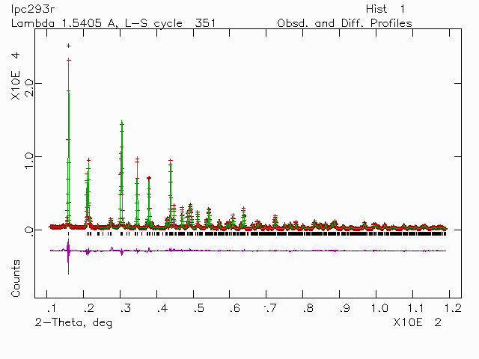

Figure 2-1

