Supporting Information
1. Synthesis
Reagents and condition: (a) NBS, HCO₂Me, AIBN, Δ, hv, 3h, 69%; (b) i. NaN₃, DMF, RT, 3h, ii.LAH, THF, 0°C, iii. Boc₂O, THF, aq. Na₂CO₃, RT, 3h, 70%; (c) i. aq. NaOH, MeOH, RT, ii. p-nitroaniline, NaNO₂, aq. HCl, MeOH, 0°C, 49%; (d) i. TFA, anisole. CH₂Cl₂, ii. p-nitrophenyl isothiocyanate, TEA, THF, RT, 70%; (e) i. TFA, anisole. CH₂Cl₂, ii. Phenyl isothiocyanate, TEA, THF, RT.70%.

Sensor 1
To a solution of the amine salt (105 mg, 0.2 mmol) in 10mL of DMF, prepared by acid promoted N-Boc removal of 5,¹ were added TEA (0.08 ml, 0.6 mmol) and p-nitro-phenyl isothiocyanate (71.5 mg, 0.4 mmol). After stirring the reaction mixture for 1 h, it was diluted with CH₂Cl₂, and washed with water. The organic extracts was dried over Na₂SO₄, concentrated, and then chromatographed (eluent gradient 15:1 to 10:1 CH₂Cl₂/MeOH) to give the desired product (85 mg, 65 %).
¹H-NMR (300 MHz, CDCl₃) δ 5.04-5.06 (d, 4H, ArCH₂NH), 7.88-7.91 (d, 4H, NHArH_{β}s), 7.99 (s, 2H, ArHs) 8.01-8.04 (d, 2H, NO₂ArH_{β}s), 8.19-8.22 (d, 4H, NHArH_{α}s) 8.38-8.41 (d, 4H, NO₂ArH_{α}s).
¹³C-NMR (300 MHz, acetone-d₆) δ 44.34, 122.14, 123.48, 124.72, 125.18, 126.18, 126.42, 143.68, 146.13, 148.78, 156.30, 158.24, 181.19.
MS (FAB) m/z 662.12 (M⁺).
Sensor 2
To a solution of the amine salt (105 mg, 0.2 mmol) in 10mL of DMF, prepared by acid promoted N-Boc removal of 5,¹ were added TEA (0.08 ml, 0.6 mmol) and phenyl isothiocyanate (54 mg, 0.4 mmol). After stirring the reaction mixture for 1 h, it was diluted with CH₂Cl₂, and washed with water. The organic extracts was dried over Na₂SO₄, concentrated, and then chromatographed (eluent gradient 15:1 to 10:1 CH₂Cl₂/MeOH) to give the desired product (76 mg, 67 %).
¹H-NMR (300 MHz, acetone-d₆) δ 4.99-5.01 (d, 4H, ArCH₂NH), 7.14-7.19 (t, 1H, NHArH_{γ}s), 7.33-7.38 (t, 4H, NHArH_{β}s), 7.50-7.52 (d, 4H, NHArH_{α}s) 8.01 (s, 2H, ArHs) 8.06-8.09 (d, 2H, NO₂ArH_{β}s), 8.41-8.44 (d, 2H, NO₂ArH_{α}s).
¹³C-NMR (300 MHz, acetone-d₆) δ 44.25, 123.50, 124.30, 125.29, 125.87, 127.22, 129.25, 139.45, 148.74, 156.47, 181.50.
MS (FAB) m/z 572.12 (M⁺).

2. UV-vis titration
All stock solutions were prepared in chloroform. The spectra were collected on a Beckman DU-650 UV/Vis spectrophotometer. Anion binding titrations were carried out by monitoring changes in the UV-vis absorption band at λ_{max} of free sensors 1 and 2 as a function of added anion concentration. The resulting decrease in the absorbance intensity was fitted as decribed by Conners.²

(a) (b)
Fig. S 1. UV-vis titration (a) of 1 with H₂PO₄⁻n-Bu₄N⁺ in CHCl₃. [1] = 5 x 10⁻⁵ M constant, [H₂PO₄⁻] = 0 equiv. -30 equiv. of 1 (b) of 2 with H₂PO₄⁻n-Bu₄N⁺ in CHCl₃. [2] = 1.5 x 10⁻⁵ M constant, [H₂PO₄⁻] = 0 equiv. -30 equiv. of 2

Binding Constants (M⁻¹):
ε_{sensor 1} = 22000, ε_{sensor 2} = 24000

 | AcO⁻ | F- | H₂PO₄⁻ | Cl⁻ | Br⁻ | HSO₄⁻ | I⁻
Sensor 1 | > 10⁶ | > 10⁶ | > 10⁶ | > 10⁶ | > 10⁶ | > 10⁶ | > 10⁶
Sensor 2 | > 10⁶ | > 10⁶ | > 10⁶ | 7.0 x 10⁴ | 3.4 x 10² | NDª | NDª
ª No detectable binding. (all error range : ±17%)
3. Color changes of 1
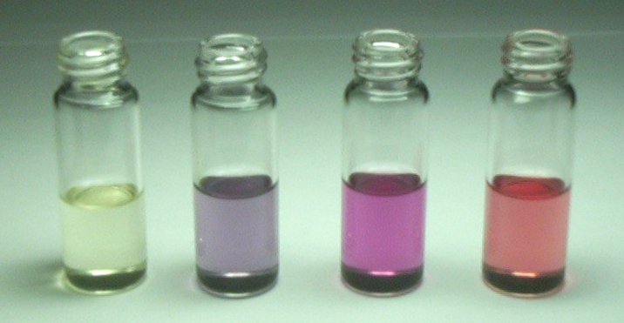
(a) (b) (c) (d)
Fig. S 2. Color changes of 1 in CHCl₃. [1] = 5 x 10⁻⁵ M, [anion] = 40 equiv. (a) 1 (b) 1 + F⁻ (c) 1 + H₂PO₄⁻ (d) 1 + AcO⁻.

References
- D. H. Lee, K. H. Lee and J.-I. Hong, Org. Lett., 2001, 3, 5-8.
- K. A. Conners, Binding Constants, John Wiley and Sons, New York, 1987.

