Supporting material 1. ¹H-NMR of PLGA-g-PEG in CDCl₃

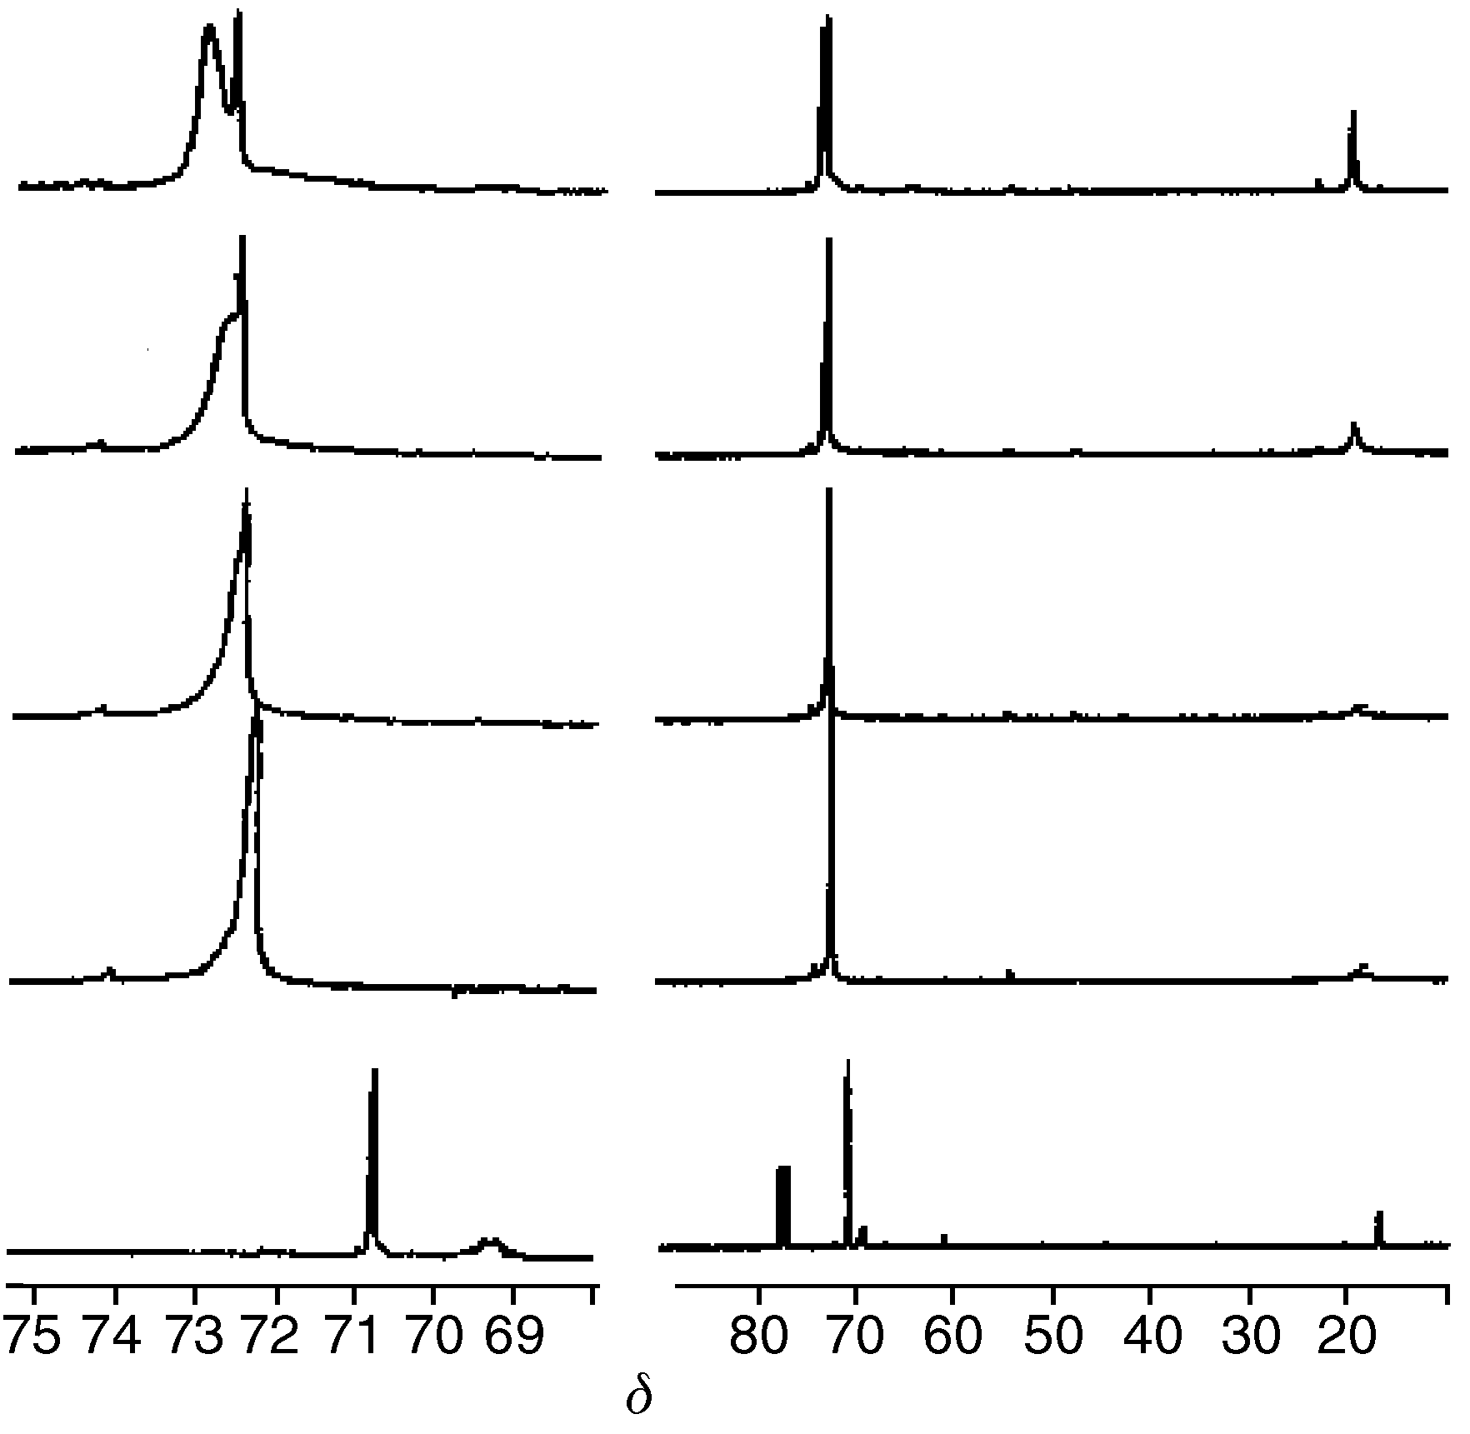

13C-NMR (75 MHz) spectra of 25 wt% PLGA-g-PEG copolymer in D2O as a function of temperature. The zoomed spectra around δ 73 are shown to the left. The sample was equilibrated for 15 minutes at each temperature before measurement. 20 oC (sol phase), 33 oC (just above sol-to-gel transition), 40 oC (gel phase), and 50 oC (syneresis) are the various measured temperatures. ¹³C-NMR spectrum in CDCl₃ at room temperature is also shown as a reference.

