Supplemental Material:

1. FTIR of (a) 1 and (b) 2, in dry KBr at room temperature.

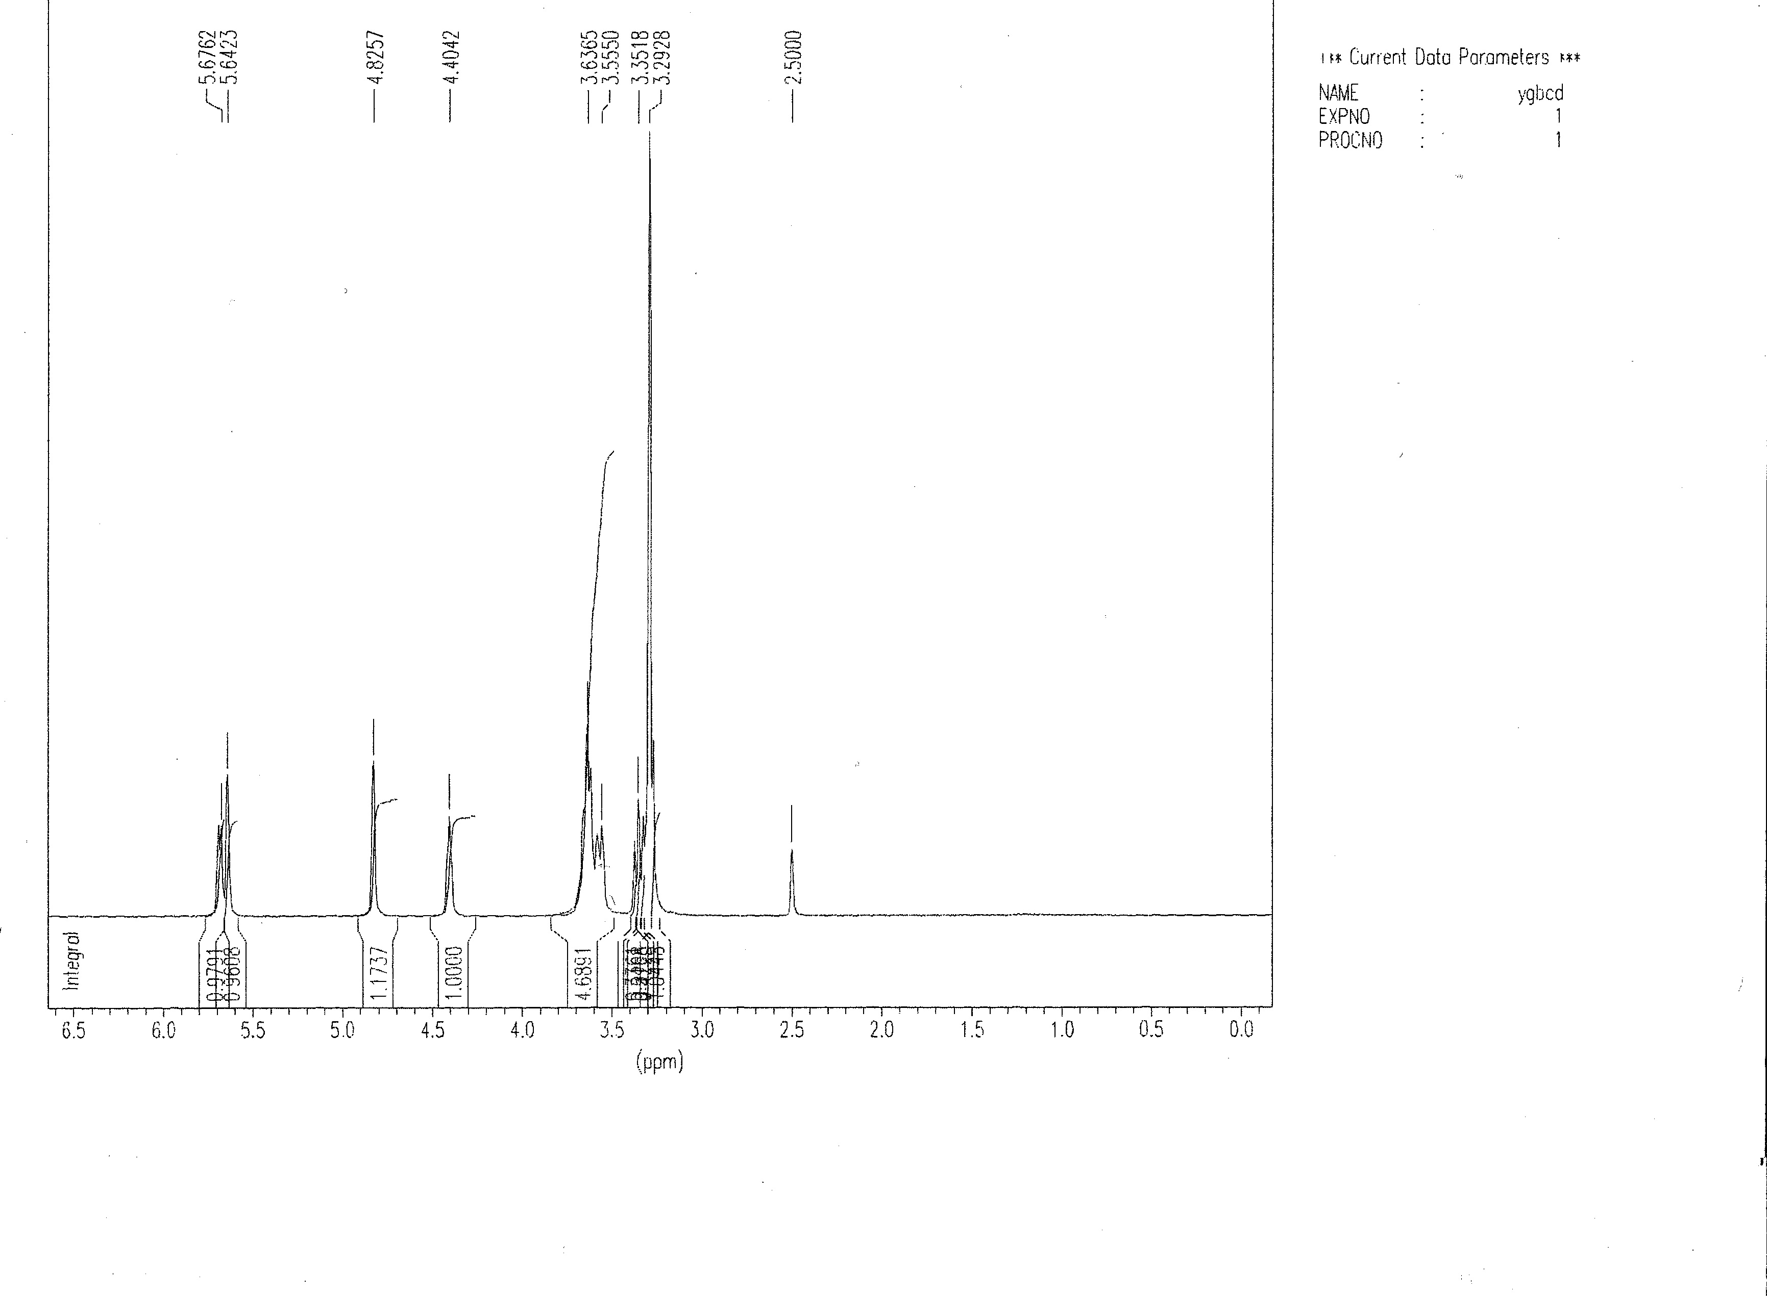
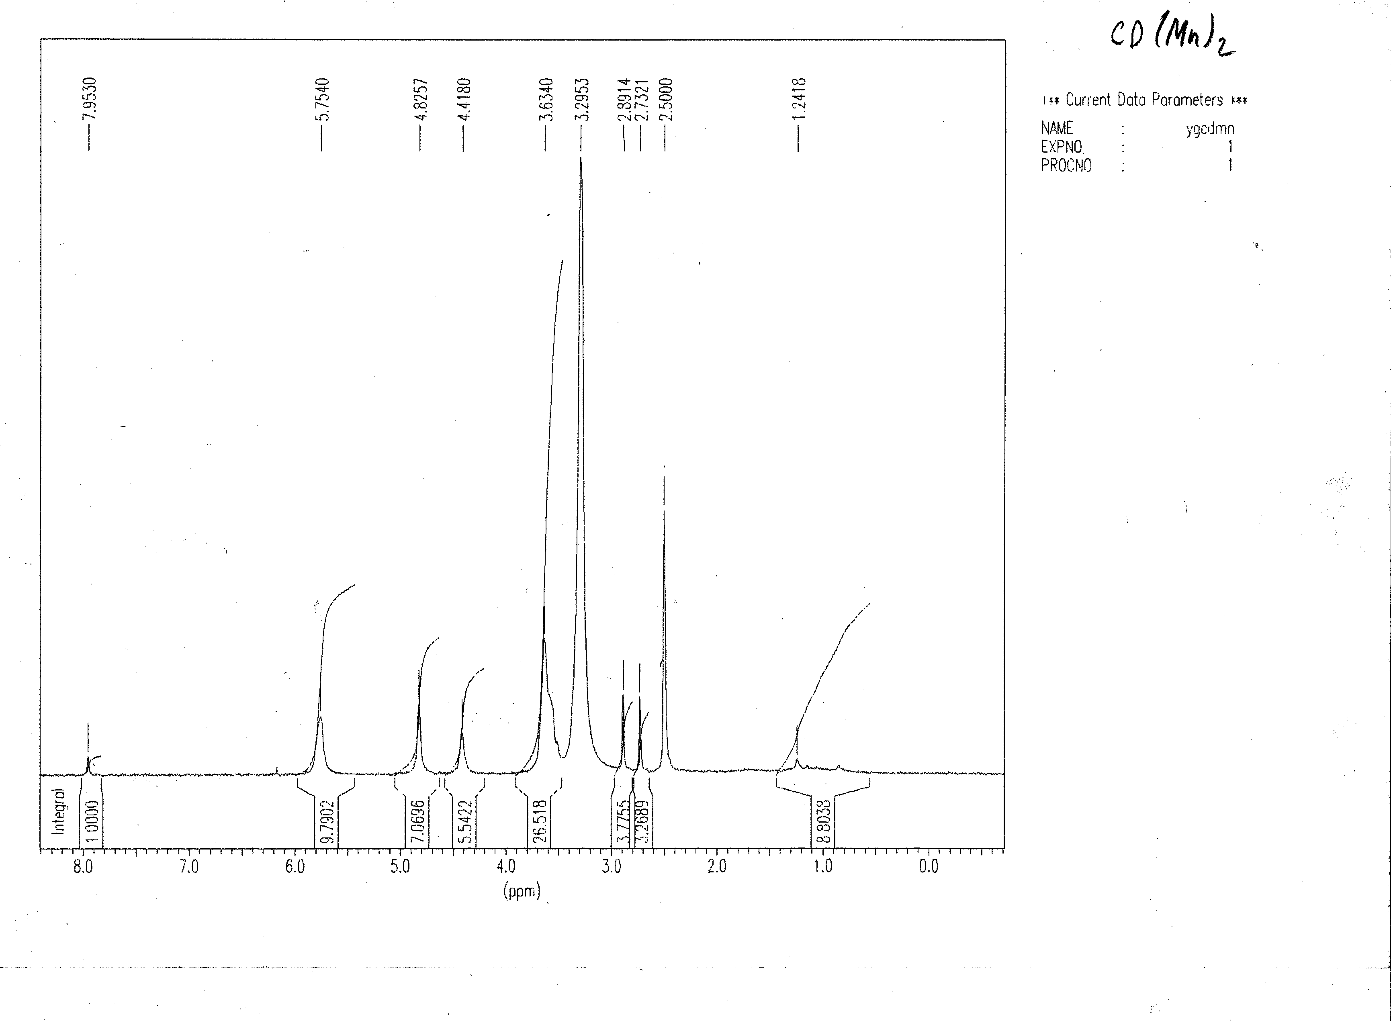
400 MHz ¹HNMR spectrum of β-CD in d₆-DMSO.
400 MHz ¹HNMR spectrum of Mn₂β-CD in d₆-DMSO.
2. NMR of β-CD and Mn₂-CD (Nair and Dismukes Complex).
3. Electronic Spectroscopy of Mn₂β-CD in DMF.
4. 500 MHz ¹HNMR data, solvent d₆-DMSO

Compound | β-cyclodextrin |  |  |  |  |  |  |  |  |  |  | 2,2’-bipyridine |  |  |  |  | 5-amino-1,10-phenanthroline
DMSO-d₆ | H-1 | H-2 |  | H-3 |  | H-4 |  | H-5 |  | H-6 |  | H-3/3’ |  | H-4/4’ | H-5/5’ | H-6/6’ | H-2 | H-3 | H-4 | H-6 | H-7 | H-8 | H-9 | NH₂
 |  |  |  |  |  |  |  |  |  |  |  | d |  | t | t | d | d | t | d | s | d | t | d | s
βCD  βCDphen  RuβCDphen 2  Mn₂RuβCDphen 1  [Ru(bpy)₂(NH₂phen)]²⁺ | 4.85  4.79  4.84  4.59  --- | 3.29-3.31  3.28-3.30  3.20-3.40  2.90-3.30  --- |  | 3.65-3.67  3.65-3.66  3.60-3.70  3.35-3.50  --- |  | 3.33-3.35  3.33-3.35  3.20-3.40  2.90-3.30  --- |  | 3.57-3.61  3.56-3.60  3.60-3.70  3.31-3.50  --- |  | 3.61-3.63  3.59-3.61  3.60-3.70  3.35-3.50  --- |  | ---  ---  8.40-8.65  8.47-8.76  8.30-8.50 |  | ---  ---  8.10-8.25  7.81-8.04  8.00-8.20 | ---  ---  7.35-7.60  7.19-7.40  7.30-7.50 | ---  ---  7.65-7.90  7.60-7.80  7.77-7.97 | ---  8.67  8.96  8.62  8.64 | ---  7.47  7.82  7.73  8.02 | ---  8.40  8.07  8.10  8.13 | ---  6.86  6.96  6.87  6.96 | ---  7.72  8.23  8.12  8.03 | ---  7.10  7.13  7.19  7.42 | ---  8.40  8.31  8.20  8.06 | ---  ---  ---  ---  6.86
 | OH-2 |  | OH-3 |  | OH-6 |  | H-4’ | H-5’ | H-6’ |  | -NH-βCD
βCD  βCDphen  RuβCDphen  Mn₂RuβCDphen | 5.60-5.85  5.40-6.00  5.60-5.82  5.75-6.00 |  | 5.60-5.85  5.40-6.00  5.60-5.82  5.75-6.00 |  | 4.35-4.60  4.40-4.60  4.40-4.60  4.40-4.60 |  | ---  2.29  2.30  2.49 | ---  2.17  2.16  2.20 | ---  1.88  1.74  2.20 |  | ---  2.67  2.70  2.63

