Supplementary Information

A kinetically controlled molecular switch based on bistable [2]rotaxane

Jae Wook Lee, Kyungpil Kim, and Kimoon Kim*
National Creative Research Initiative Center for Smart Supramolecules and Department of Chemistry, Division of Molecular and Life Sciences, Pohang University of Science and Technology, San 31 Hyojadong, Pohang 790-784, Republic of Korea
Fax: 82-54-279-8129; E-mail: kkim@postech.ac.kr

Scheme S1

Synthesis of 3
A solution of compound 2 (0.165 g, 0.281 mmol) and 1,6-diiodohexane (1.90 g, 5.62 mmol) in acetonitrile (16 mL) and DMF (4 mL) was stirred for 24 h at 60°C. After removing acetonitrile, diethyl ether was added to the resulting solution to precipitate. The precipitate was collected by decantation and washed with methylene chloride to provide the pyridinium intermediate. A solution of the pyridinium intermediate and 4, 4’-bipyridine (0.44g, 2.81 mmol) in acetonitrile (24 mL) and DMF (8 mL) was stirred for 24 h at 60°C. After removing acetonitrile, ethyl acetate was added to the resulting solution to precipitate. The precipitate was collected by filteration and washed with ethyl acetate and diethyl ether to provide compound 3 (0.48g, 92% yield). ¹H NMR (D₂O) δ 1.46 (br, 8H), 1.62 (br, 4H), 2.07 (m, 8H), 2.68 (t, 4H), 4.68 (m, 4H), 4.75 (m, 4H), 4.84 (br, 4H), 5.18 (br, 4H), 7.31 (br, 10H), 8.04 (br, 4H), 8.15 (d, 4H), 8.76 (d, 4H), 9.00 (d, 4H), 9.10 (d, 4H), 9.34 (d, 4H).

Synthesis of ‘string’ (4)
A solution of compound 3 (0.470 g, 0.298 mmol) and iodomethane (0.423g, 2.98 mmol) in acetonitrile (20 mL) and DMF (10 mL) was stirred for 24 h at 60°C. After removing acetonitrile, diethyl ether was added to the resulting solution to precipitate. The precipitate was collected by decantation and washed with methylene chloride to provide the bis-viologen compound. A solution of the bis-viologen compound in 30% HBr-AcOH was stirred for 2 h at room temperature. Addition of diethyl ether to the resulting solution precipitated solid which was dissolved with water. This was filtered to remove insoluble material and the clear solution was concentrated which afforded a residue. Crystallization of the residue from acetonitrile and diethyl ether provided compound 4 (0.296g, 84% yield). ¹H NMR (D₂O) δ 1.52 (br, 8H), 1.96 (br, 4H), 2.13 (br, 8H), 3.34 (br, 4H), 4.54 (s, 6H), 4.71 (m, 12H), 8.19 (d, 4H), 8.42 (d, 4H), 8.59 (d, 4H), 9.03 (m, 8H), 9.20 (d, 4H); ESI-MS: m/z: 130.1 [M+6H]⁶⁺, 155.9 [M+5H]⁵⁺, 194.7 [M+5H]⁴⁺.

Synthesis of [2]rotaxane (1)
A suspended solution of string 4 (133 mg, 0.094 mmol) and cucurbituril (83 mg, 0.069 mmol) in water (10 mL) was stirred for 24 h at room temperature and for 10 h at 60°C. The volume of the solution was reduced to about 2 mL by evaporation and then addition of EtOH to the resulting solution precipitated [2]rotaxane 1 (146 mg, 87% yield). ¹H NMR (D₂O) δ 0.73 (br, 4H), 1.52 (br, 8H), 2.13 (br, 8H), 2.65 (br, 4H), 4.37 (m, 12H), 4.52 (s, 6H), 4.73 (m, 12H), 5.78 (m, 24H), 8.55 (m, 12H), 9.03 (d, 8H), 9.12 (d, 4H); ESI-MS: m/z: 440.0 [M+4H]⁴⁺, 592.0 [M+3H]³⁺.

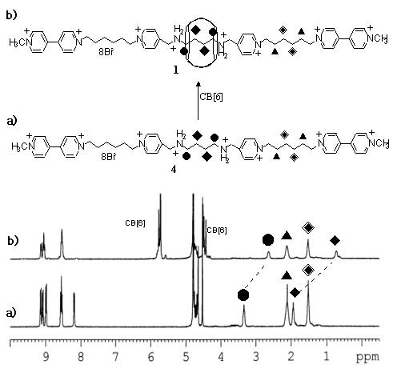

Fig. S1 ¹H-NMR spectra of (a) string 4 and (b) [2]rotaxane 1 in D₂O at 25℃.

